GREENWOOD PUBLIC SCHOOL, ADITYAPURAM
OUR MOTTO - DEVELOPMENT WITH DELIGHT
SYLLABUS FOR THE MONTH OF APRIL (2020-21)
CLASS-NURSERY
SUBJECTS |  | ACTIVITY+USE OF ICT | PARENTS INVOLVEMENT
English | Rhymes: - Twinkle Twinkle, Easy to Bed.  Written – Letters Patterns- Sleeping lines  Standing lines , Slanting lines  Workbook- Page No. 2 to 5.  Sentence structure – I am a Boy/ Girl  Vocabulary Building- School, Bus, Bag, Book, Pencil, Eraser, Sharpener.  Recognition –Alphabets A, B, C, D | 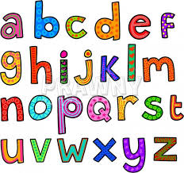 | Help your child in learning rhymes and written work
Hindi | Oral : dfork,¡ & मछली aaaaaaaaaaa, आम |  okD; jpuk & eSa ,d yMdk ] yMdh gWwA  Loj: & v & bZ तक  Written : vkMh & frjNh js[kk,sa] xksykdj ,oa  v/nxksykdkj lajpuk,sa |  W Workbook : 3 to 6  Recognition : अक्षर – v ] vk ] b ] bZ | 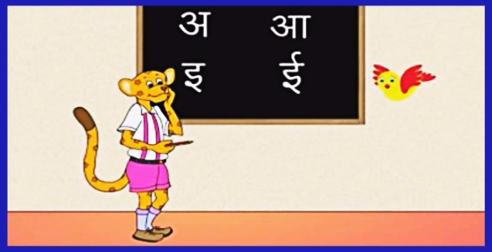 | dfork,sa ;kn djok,Wa rFkk o.kksaZ dh igpku fp=ksa +}kjk djok,W!
Maths | Oral : Counting- 1-5.  Concepts : Big – small, Fat – thin  Written: Curves and lines.  Workbook- 2 to 5 |  | Motivate your child in counting objects and learning tables.  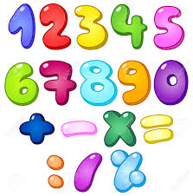
Drawing | Page no. 4, 5.
G.K. | Oral : Colours Name- Red, Blue, Green, Yellow, black  Fruits Name-Apple, Mango, Banana, Grapes, Orange. | PPT on Colours | Help your child to recog. the colours
V.E. | I love my family | PPT on Family | Make your child learn the names of family members.
Physical Education | Fun games- Running, Jumping, hopping |  | Take your child to a park and play some games.
Language Development | This is my school. |  | Help your child to develop good habits
Conversation | English Conversation  Q-1. What is your name?  Ans-My name is ……………  Q-2. How are you?  Ans-I am fine, thank you.  Q-3. How old are you?  Ans-I am 3 years old. | Hindi Conversation  प्रश्न 1- आपकk uke D;k gS ?  उत्तर - esjk uke ------------------ gSA  प्रश्न 2- आप कितने वर्ष के हैं ?  उत्तर - मैं तीन वर्ष का हूँ ।  प्रश्न 3- vki dSls gS\  उत्तर - eSa vPNk / vPNh हूँ / | Help your child in learning Conversation .
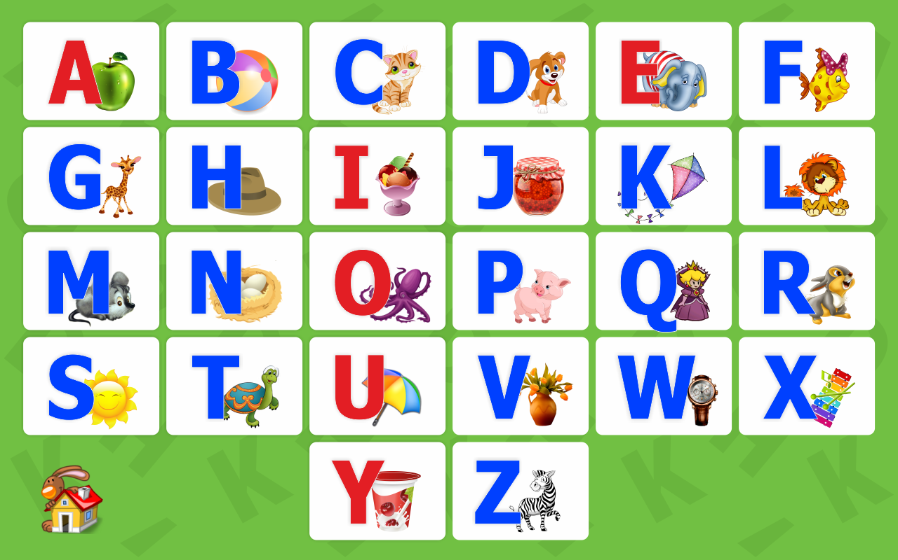
ALBHABETS
ACTIVITIES BLOG
- Free hand colouring
- Finger Printing strokes
- Tearing & Pasting of paper activity
A B C Song
A B C D E F G
Come and Sing along with me
H I J K L M N O P
Tell me what you want to be
Q R S T U V W X Y Z
Now I know my A B C

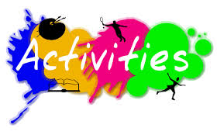

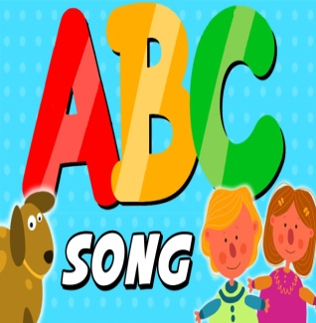

GREENWOOD PUBLIC SCHOOL, ADITYAPURAM
OUR MOTTO - DEVELOPMENT WITH DELIGHT
SYLLABUS FOR THE MONTH OF APRIL (2020-21)
CLASS-L.K.G.

SUBJECTS |  | ACTIVITY+USE OF ICT | PARENTS INVOLVEMENT
English | Oral:  Rhymes- Jack and Jill, Two Little Hands, Hand washing.  Reading: The Alphabet (A-Z).  Vocabulary Building: I, my, we, he, she, you.  Written: Capital Letters (A-Z), Dictation fill ups, Write the first letter of the picture, Match the following. | PPT on letters a-i (small cursive) | Help your child in learning rhymes and written work
Hindi | Oral : dfork,¡ & घटा , सैनिक , जाग गई है भोर |  Reading – वर्णमाला -स्वर (अ से v% तक ) और व्यंजन क से M+ तक |  Written : स्वर वर्ण (अ से v% तक ), जोड़ी बनाइये, चित्र पहचानकर अक्षर लिखें , खाली स्थान भरें | | Extra marks  o.kZekyk p ls u rd vkSj dfork,sa!  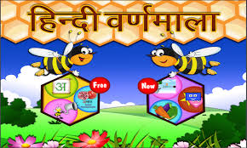 | dfork,sa ;kn djok,Wa rFkk o.kksaZ dh igpku fp=ksa +}kjk djok,W!
Maths | Oral : Counting 1-50, Table of 2, Big/small, Long /Short, Thick and Thin.  Written : Forward Counting 1-30, Dictation Backward counting from 10-1, Book Page No. 3-15. | Extra marks  Videos on Number Names | Help your child in learning tables.
G.K. | Oral : Wild Animals, Birds, Fruits. | PPT on Myself
Language Development | Action words:- Writing, Eating, Jumping, Running and drinking.
V.E. | Always Speak the truth. |  | Motivate your child to speak the truth
Drawing | Flower and Cupcake.
Physical Education | Running , Hopping and Jumping  Fun Games.
Conversation | English Conversation  Q-1 What is your name?  Ans- My name is______.  Q-2 What is your Father’s name?  Ans- My Father’s name is__________.  Q-3 What is your Mother’s name?  Ans- My Mother’s name is__________.  Q-4 In which class do you study?  Ans- I study in Class L.K.G.  Q-5 How old are you?  Ans- I am__years old.  Q-6 What is the name of your Class teacher?  Ans- My Class teacher’s name is_________. | Hindi Conversation  प्रश्न 1- vkidk D;k uke gS\  उत्तर esjk uke ---------------- gSA  प्रश्न 2- vkids ikik dk D;k uke gS\  उत्तर esjs ikik dk uke श्री ----------------------- gSA  प्रश्न 3- vkidh eEeh dk D;k uke gS\  उत्तर esjh eEeh dk uke श्रीमती ----------------- gSA  प्रश्न 4- vki fdl d{kk esa i<+rs gSa\  उत्तर eSa d{kk L.K.G. esa i<+rk gw¡@i<+rh gw¡A  प्रश्न 5. आप कितने वर्ष के हैं ?  उत्तर मैं ________ वर्ष का हूँ | Help your child in learning conversation Que/Ans
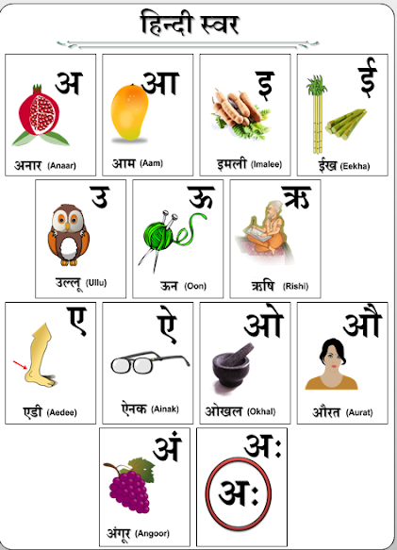
ACTIVITIES BLOG
1. English Recitation Competition
2. Water colouring competition.
3. Earth day celebration. (Leaf Printing Activity)
4. Mother’s Day card.

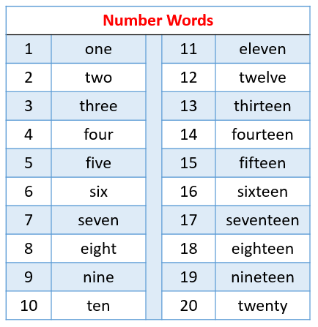

GREENWOOD PUBLIC SCHOOL, ADITYAPURAM
OUR MOTTO - DEVELOPMENT WITH DELIGHT
SYLLABUS FOR THE MONTH OF APRIL (2020-21)
CLASS-U.K.G.

SUBJECTS |  | ACTIVITY+USE OF ICT | PARENTS INVOLVEMENT
English | Oral:-Rhymes- My Kite, Ducks. A to Z.  Written: Small Cursive letters a - z, capital cursive letters A-Z.  Reading: Book page no. 3, 4.  Workbook: Page no. 2 to 7. |  | Help your child in learning rhymes and written work
Hindi | मौखिक : कविताएँ- लाल टमाटर , चूँ-चूँ चूहा , स्वर एवं व्यंजन वर्ण ।  लिखित : स्वर वर्ण अ से अ: तक , व्यंजन वर्ण क से ज्ञ तक , दो अक्षर , तीन अक्षर एवं चार अक्षर वाले शब्द ।  अभ्यास पुस्तक - पृष्ठ क्रमांक -3 से 9 । |  | dfork,sa ;kn djok,Wa rFkk o.kksaZ dh igpku fp=ksa +}kjk djok,W ।
Maths | Oral: Counting from 1-50, Tables of 2 and 3, Numbers name 1-10.  Written: Counting from 1-50, Tables of 2 and 3, Numbers name 1-10.  Workbook: Page no. 3 to 9. |  | Motivate your child in counting objects and learning tables.
EVS | Oral: Celebrating festivals, My Family. | PPT on given topics.
G.K. | Oral: My Family, Parts of body. | PPT on fruits & flowers.
Drawing | Page no.1 to 4.
Vocabulary Building | School, Class-room, Table, Chair and Black-board. |  | Motivate your child to help others
V.E | Obey your elders.
Physical Education | Fun Games.
Language Development | Welcome to our class, Nice to meet you, Have a nice day.
Conversation | English Conversation ( Myself )  Q-1. What is your name?  Ans- My name is_______.  Q-2. What is your father’s name?  Ans-My Father’s name is Mr.________.  Q-3. What is your mother’s name?  Ans- My Mother’s name is Mrs.__________.  Q-4. How old are you?  Ans- I am___years old.  Q-5. What is the name of your school?  Ans- The name of my school is Greenwood Public School.  Q-6. In which class do you study?  Ans- I study in Class U.K.G. | Hindi Conversation  प्रश्न-1 vkidk uke D;k gS \  उत्तर- esjk uke ---------------- gSA  प्रश्न-2 vkids ikik dk uke D;k gS \  उत्तर- esjs ikik dk uke श्री ----------------------- gSA  प्रश्न-3 vkidh eEeh dk uke D;k gS \  उत्तर- esjh eEeh dk uke श्रीमती --------------- gSA  प्रश्न-4 vki fdrus वर्ष ds gS \  उत्तर- मैं ______ वर्ष का हूँ  प्रश्न-5 vki ds fo|ky; dk uke D;k gS \  उत्तर- मेरे fo|ky; का नाम ग्रीनवुड पब्लिक स्कूल हैं  प्रश्न-6 vki fdl d{kk esa i<+rs gSa\  उत्तर eSa d{kk यू.के.जी esa i<+rk gw¡@i<+rh gw¡A | Help your child in learning conversation.  Month of the Year  January  February  March  April  May  June  July  August  September  October  November  December
English song – Tell me why?
Can you tell me the reason why?
The grass is green
And blue is the sky.
The birds have wings
But not you and I?
Can you tell me the reason why?
ACTIVITIES BLOG
1. English Recitation.
2. Handwriting competition.
3. Paper plate clock
4. Earth Day Celebration (Leaf printing & making garden flags)
5. Story Telling.

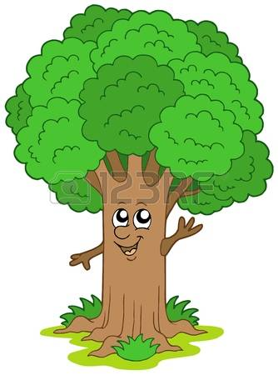

Days of the Week
Sunday , Monday , Tuesday , Wednesday , Thursday, Friday and Saturday

