GREENWOOD PUBLIC SCHOOL, ADITYAPURAM
OUR MOTTO-DEVELOPMENT WITH DELIGHT
CLASS-VII SUBJECT- MATHS

TERM-1 SYLLABUS

Exercise 7.1

Complete the following statements:
- Two line segments are congruent if . Solution:-
Two line segments are congruent if they have the same length.

Among two congruent angles, one has a measure of 70º; the measure of the other angle is .
Solution:-
Among two congruent angles, one has a measure of 70º; the measure of the other angle is 70º.
Because, if two angles have the same measure, they are congruent. Also, if two angles are congruent, their measure are same.

When we write ∠A = ∠B, we actually mean . Solution:-
When we write ∠A = ∠B, we actually mean m ∠A = m ∠B.

Give any two real-life examples for congruent shapes. Solution:-
The two real-life example for congruent shapes are,
- Fan feathers of same brand.
- Size of chocolate in the same brand.
- Size of pens in the same brand

If ΔABC ≅ ΔFED under the correspondence ABC ↔ FED, write all the corresponding congruent parts of the triangles.
Solution:-
Two triangles are congruent if pairs of corresponding sides and corresponding angles are equal.
All the corresponding congruent parts of the triangles are,
∠A ↔ ∠F, ∠B ↔ ∠E, ∠C ↔ ∠D Correspondence between sides:
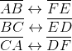

If ΔDEF ≅ ΔBCA, write the part(s) of ΔBCA that correspond to
(i) ∠E (ii) (iii) ∠F (iv) Solution:-
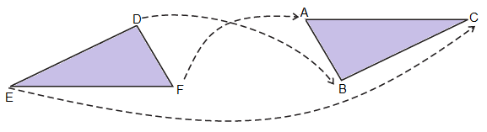
From above the figure we can say that, The part(s) of ΔBCA that correspond to,
(i) ∠E ↔ ∠C (ii)
(iii) ∠F ↔ ∠A (iv)

Exercise 7.2

Which congruence criterion do you use in the following?
- Given: AC = DF AB = DE
BC = EF
So, ΔABC ≅ ΔDEF
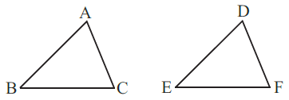
Solution:-
By SSS congruence property:- Two triangles are congruent if the three sides of one triangle are respectively equal to the three sides of the other triangle.
ΔABC ≅ ΔDEF

Given: ZX = RP RQ = ZY
∠PRQ = ∠XZY
So, ΔPQR ≅ ΔXYZ
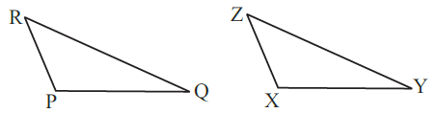
Solution:-
By SAS congruence property:- Two triangles are congruent if the two sides and the included angle of one are respectively equal to the two sides and the included angle of the other.
ΔACB ≅ ΔDEF

Given: ∠MLN = ∠FGH
∠NML = ∠GFH
∠ML = ∠FG
So, ΔLMN ≅ ΔGFH

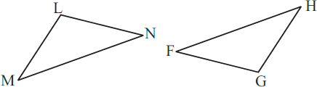

Solution:-
By ASA congruence property:- Two triangles are congruent if the two angles and the included side of one are respectively equal to the two angles and the included side of the other.
ΔLMN ≅ ΔGFH

Given: EB = DB AE = BC
∠A = ∠C = 90º
So, ΔABE ≅ ΔACD
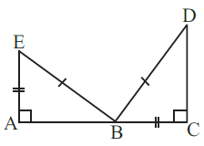
Solution:-
By RHS congruence property:- Two right triangles are congruent if the hypotenuse and one side of the first triangle are respectively equal to the hypotenuse and one side of the second.
ΔABE ≅ ΔACD

You want to show that ΔART ≅ ΔPEN,
- If you have to use SSS criterion, then you need to show
- AR = (ii) RT = (iii) AT =

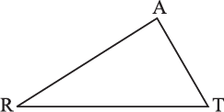
Solution:-
We know that,
SSS criterion is defined as, two triangles are congruent if the three sides of one triangle are respectively equal to the three sides of the other triangle.
∴ (i) AR = PE
- RT = EN
- AT = PN

If it is given that ∠T = ∠N and you are to use SAS criterion, you need to have
- RT = and (ii) PN =
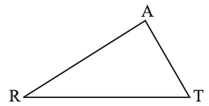
Solution:-
We know that,
SAS criterion is defined as, two triangles are congruent if the two sides and the included angle of one are respectively equal to the two sides and the included angle of the other.
∴ (i) RT = EN
- PN = AT

If it is given that AT = PN and you are to use ASA criterion, you need to have
(i) ? (ii) ?
Solution:-
We know that,
ASA criterion is defined as, two triangles are congruent if the two angles and the included side of one are respectively equal to the two angles and the included side of the other.
Then,

- ∠ATR = ∠PNE
- ∠RAT = ∠EPN

You have to show that ΔAMP ≅ ΔAMQ.
In the following proof, supply the missing reasons.
Steps | Reasons
(i) PM = QM | (i) …
(ii) ∠PMA = ∠QMA | (ii) …
(iii) AM = AM | (iii) …
(iv) ΔAMP ≅ ΔAMQ | (iv) …
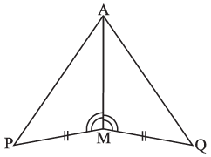
Solution:-
Steps | Reasons
(i) PM = QM | (i) From the given figure
(ii) ∠PMA = ∠QMA | (ii) From the given figure
(iii) AM = AM | (iii) Common side for the both triangles
(iv) ΔAMP ≅ ΔAMQ | (iv) By SAS congruence property:- Two triangles are congruent if the two sides and the included angle of one are respectively equal  to the two sides and the included angle of the other.

- In ΔABC, ∠A = 30º, ∠B = 40º and ∠C = 110º In ΔPQR, ∠P = 30º, ∠Q = 40º and ∠R = 110º
A student says that ΔABC ≅ ΔPQR by AAA congruence criterion. Is he justified? Why or Why not?
Solution:-
No, because the two triangles with equal corresponding angles need not be congruent. In such a correspondence, one of them can be enlarged copy of the other.

In the figure, the two triangles are congruent. The corresponding parts are marked. We can write ΔRAT ≅ ?

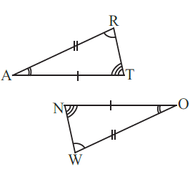
Solution:-
From the given figure, We may observe that,
∠TRA = ∠OWN
∠TAR = ∠NOW
∠ATR = ∠ONW
Hence, ΔRAT ≅ ΔWON

Complete the congruence statement:
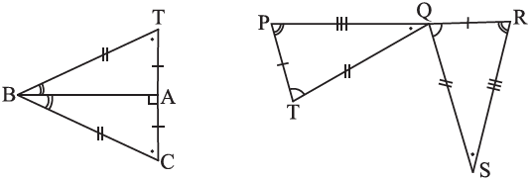
ΔBCA ≅ ΔQRS ≅
Solution:-
First consider the ΔBCA and ΔBTA From the figure, it is given that,
BT = BC
Then,
BA is common side for the ΔBCA and ΔBTA Hence, ΔBCA ≅ ΔBTA
Similarly,

Consider the ΔQRS and ΔTPQ From the figure, it is given that
PT = QR TQ = QS PQ = RS
Hence, ΔQRS ≅ ΔTPQ

In a squared sheet, draw two triangles of equal areas such that
- The triangles are congruent.
- The triangles are not congruent.
What can you say about their perimeters? Solution:-
(ii)
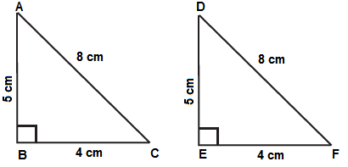
In the above figure, ΔABC and ΔDEF have equal areas. And also, ΔABC ≅ ΔDEF
So, we can say that perimeters of ΔABC and ΔDEF are equal.

(ii)
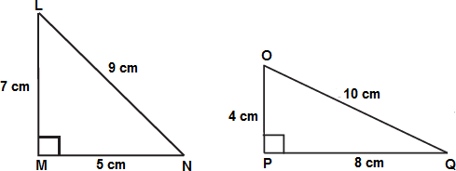
In the above figure, ΔLMN and ΔOPQ

ΔLMN is not congruent to ΔOPQ
So, we can also say that their perimeters are not same.

Draw a rough sketch of two triangles such that they have five pairs of congruent parts but still the triangles are not congruent.
Solution:-
Let us draw triangles LMN and FGH.
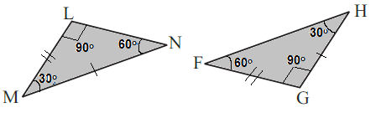
In the above figure, all angles of two triangles are equal. But, out of three sides only two sides are equal.
Hence, ΔLMN is not congruent to ΔFGH.

If ΔABC and ΔPQR are to be congruent, name one additional pair of corresponding parts. What criterion did you use?
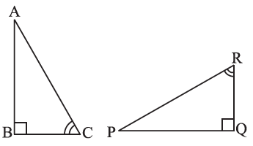
Solution:-
By observing the given figure, we can say that
∠ABC = ∠PQR
∠BCA = ∠PRQ
The other additional pair of corresponding part is BC = QR
∴ ΔABC ≅ ΔPQR

Explain, why ΔABC ≅ ΔFED

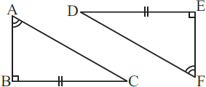

Solution:-
From the figure, it is given that,
∠ABC = ∠DEF = 90º
∠BAC = ∠DFE BC = DE
By ASA congruence property, two triangles are congruent if the two angles and the included side of one are respectively equal to the two angles and the included side of the other.
ΔABC ≅ ΔFED

