GREENWOOD PUBLIC SCHOOL, ADITYAPURAM
OUR MOTTO-DEVELOPMENT WITH DELIGHT
CLASS-VII SUBJECT- SOCIAL SCIENCE
TERM-1 SYLLABUS
History
Chapter -3
Delhi Sultanate

New Words
- Mahajanapada
- Suppress
- Dominated
- Consolidated
- Tughlaqabad
- Behest
- Successors
- Iqtadar
- Indo – Islamic
- comprehensible

Glossary
- Behest - someone’s order or command.
- Iqta – Provinces of sultanate.
- Walis – Head of provinces.
- Garrison town – a fortified settlement with soldiers.

Very Short Answer Type Questions
Q1. What is the literal meaning of mosque ?
Ans - It refers to a place where a muslim prostrates in reverence to Allah.
Q2. For how many years the Suri dynasty rule?
Ans –The Suri dynasty rule for only 15 years.
Q3. What is called the qibla ?
Ans – The direction towards which Muslims turn while offering prayer or namaz.

Short Answer Type Questions
Q1. Why was Raziya, daughter of Sultan Iltutmish removed from the throne of Delhi ?
Ans – In 1236, Sultan iltutmish’s daughter Raziya became the Sultan. Minhaj-i-Siraj the chronicler of that time recognized that she was better qualified that her brothers to rule the kingdom but as per the rules and norms of Gender distinctions and birthright he was not comfortable with a female becoming the ruler, even the nobles were not happy. She was removed from the throne in 1240.
Q2 .Why did the rulers of the Delhi Sultanate fail to control the hinterlands initially ?
Ans – Because of the following reasons:-
- Long distance
- Rebellion and war
- Challenge of Mongol Invasions from Afganistan
- Rebellions of Governors.
Long Answer Type Questions
Q1. What was the iqta system ? Explain.
Ans – The term ‘iqta’ means the land or land revenue assigned by the ruler to an individual on certain conditions. The Sultans divided the empire into a number of tracts called iqtas (or provinces ), which were assigned to the military leaders. The holder of an iqta was called the iqtadar , but he was not the owner of the land. He maintained law and order in the iqta and collected the land revenue on the behalf of the state. Out of the land revenue collected, the iqtadar met the cost of administration. He was allowed to keep a part of the income for his own expenses. He sent the balance, if any , to the state treasury. There were three important taxes-n first,on cultivation called kharaj ( usually half of the produce ), the second on cattle,and the third on houses.

H.O.T.S
Q. What is hinterland?
Ans – The lands adjacent to a city or part that supply it with goods and services.

Activity
Q. Write the names of some historical buildings along with the pictures which are located in your city.

Mohammad-Gaus-Tomb Gwalior fort
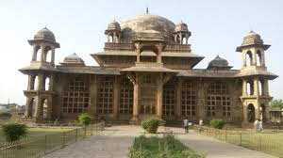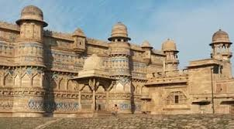
Saas Bahu Temple Jai Villas Palace
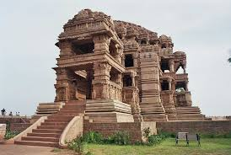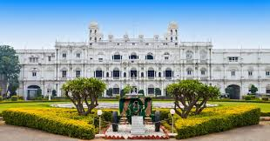

Chapter 4
The Mughal Empire

New Words
- Anarchy
- Tottering
- Primogeniture
- Regent
- Meddle
- Malpractice
- Dogma
- Inheritable
- Pictorial
- Legacy

Glossary
- Anarchy – a state of disorder due to absence of stable government
- Primogeniture – a practice by which the first- born child occupies the throne.
- Meddle – to interfere
- Malpractice – negligence of professional behavior or wrong practice.

Very Short Answer Type Questions
Q1. Who wrote Baburnama ?
Ans – Babur.
Q2. What was the full name of Babur ?
Ans – Zahir – ud – din – Muhammad Babur.
Q3. Who lost the first battle of khanua ?
Ans – Rana Sanga

Short Answer Type Questions

Q1. Who were the Mughals ?
Ans – The Mughals traced their lineage to two powerful rulers. On the mother side, they were direct descendants of the Mongol warrior, Genghais Khan and on the father’s side, they claimed to be the successors of Timur, who was the ruler of vast kingdom which comprises present day area of Iraq, Iran and large parts of central Asia.

Q2. Highlight Sher Shah Suri’s achievements as a ruler.
Ans – The notable achievements of Sher Shah Suri were introduction of land revenue system and restoring of peace and order. He struck gold , silver and copper coins of a uniform standard made from fine quality. To improve trade and commerce, he restored the road that extended from Indus River in the west to Sonargaon in Bengal. Today we know this as the Grand Trunk Road. He builds rest houses or sarais for travelers at a distance of every eight kilometers. To identify the state’s share in land produce instead of relying on random estimation. The land was divided into different categories based on the quality of produce.

Long Answer Type Question

Q1. Write a note on the revenue collection system of Akbar.
Ans – The main source of income for the empire was land revenue. The land revenue system was known as zabt. The intermediaries who collected the revenue on behalf of the government were called the zamindars. Raja Todar Mal, who was the revenue minister under Akbar, devised a system in which all the cultivable land was first of the quality of land and the quantity of produce. The peasants had to pay land revenue mostly in cash. Since the right to collect revenue was given to zamindars, there were many instances where zamindars exploited the peasants. Sometimes, this also resulted in rebellions.

H.O.T.S
Q. Which central provinces were under the control of the Mughals?
Ans- Delhi ,Lahore, Agra, Panipat , Mathura , Marwar , Chittor , Deccan , Marwar and Ajmer.

Chapter – 5
Architecture In Medieval India
(G.D)
New Words
- Hybrid
- Obliquely
- Commemorate
- Embellish
- Pietra dura
- Kiosk
- Dragged
- Garbhagriha
- Gopurams
- Mandalams

Glossary
- Hybrid – a thing made by combining two different elements.
- Obliquely – slanting
- Kiosk – a small building in a garden, open from all sides.
- Gopuram – a gateway to the temple.

