GREENWOOD PUBLIC SCHOOL, ADITYAPURAM
OUR MOTTO-DEVELOPMENT WITH DELIGHT

CLASS-VIII SUBJECT- SOCIAL SCIENCE
TERM-1 SYLLABUS
HISTORY
CHAPTER-2
ESTABLISHMENT OF COMPANY’S POWER
Key term
1. Lucrative- profitable
2. Imperialism – A policy of extending a country’s influence and power over another country
3 . Subjugate – to bring under control
4. Cadre – to formally surrender to another
5. Mercantile – A business enterprise that makes profit primarily through trade buying goods cheap and selling them at higher prices .
6. Impeachment- A trial by the House of Lords in England for charges of misconduct brought against a person in the House of Commons

Difficult words :
1. Mercantile
2. Farman
3. Puppet
4 . Territory
5. Nawabs
6 .Battle
7.Confederacy
8. Paramountcy
9. Impeachments
10. Matchlocks
Date line:
1 .1498 – Vasco – de – gamma a Portuguese explore discovered the sea route to India
2 .1650 -1750 – to period when Europeans entered India traders
3 .1757 - The battle of Plessey took place Bengal
4 .1764 – The battle of buxar took place Orissa
5. 1790-1792 – The third battle between the company and Mysore
6 .1850 – Sambalpur was annexed Orissa
7. 1857 - The great revolt broke out in India
VERY SHORT ANSWERS:
Q 1 . WHO defeated the British forces in the first Anglo Mysore war ?
Ans . Hider Ali defeated the British forces in the first Anglo Mysore war .
Q.2 Who became the governor general of Bengal in 1772 ?
Ans . In 1772 warren hasting became the new governor general of Bengal
Q .3 Where the French east India company established their settlements in India ?
Ans . The French east India company setup their settlements in Bengal and Kerala . karaikal and poducherry in the Indian ocean in 1664
Q 4 . WHERE did the English east India established their first trade settlements in India ?
Ans. The English east India company established their first trade settlements in India at sutra Hugli
Q 5 . Why was Awadh annexed by the Britishers ?
Ans . Awadh was annexed on the pretext of misgovernance by the britishers .
SHORT ANSWER :
Q.1 Discuss the causes of the three Anglo Martha wars ?
Ans. After the 1770 the power struggle among the Maratha chiefs intensified taking advantage of their disunity the British interfere in the internal affairs this led to the three Anglo Maratha between 1770 and 1818 .
LONG Question and ANSWER
Q1 What are the conseques of battle of the buxer ? how did it affects the Indian rulers ?
And. In 1765, the treaty of Allahabad was singed among Sirajuddualah, shah –a –lam and Robertclive , accordingly to this –
The English east India company got Diwani of Bengal from the mughal emperor shah-A- lam .They collected revenue from Bengal , bihar & Orissa.
The mughal emperor would receive an annual tribute of 26 lakh rupees & resided in the fort of Allahabad under the protection of british.
The nabab of awadh was made to pay an identity of 50 lakh rupee and the company promised him to help incase of attack on his territory.
Robert clive introduced one deal government system in Bengal under this system , the nawab had all the responsibilities.

CHAPTER-3
RULING THE COUNTRYSIDE
KEYTERMS :
1 Countryside - Rural areas
2 Ryote – cultivators
3 Indigo – A plant that produces rich blue colour dye
4 Satta - A contract or an agreement
5 Mahal –A village or a group of villages
6 Bigha – A unit or measurement of land
7 Vat –A fermenting or storage vessel .
8. Planter- one who owns or mange a plantation field
9 Coffer -A small chest for keeping valuables
10 Deliberation - Long and careful discussion
Difficult words-
- Abandon
- Hereditary
- Tenants
- Terrible
- Evicted
- Mortgaged
- Assessments
- In different
- Impoverishing
- Agitation
DATE LINES
- 12 Aug 1765 - the mughal emperor appointed the east India company as the diwan of Bengal

- 1793- lord Cornwallis introduced the permanent settlements

- 1770 -A terrible famine that hit Bengal

- 1859 -the indigo cultivators rebelled

- 1819 – 1826 - Thomas munro was the governor of madras
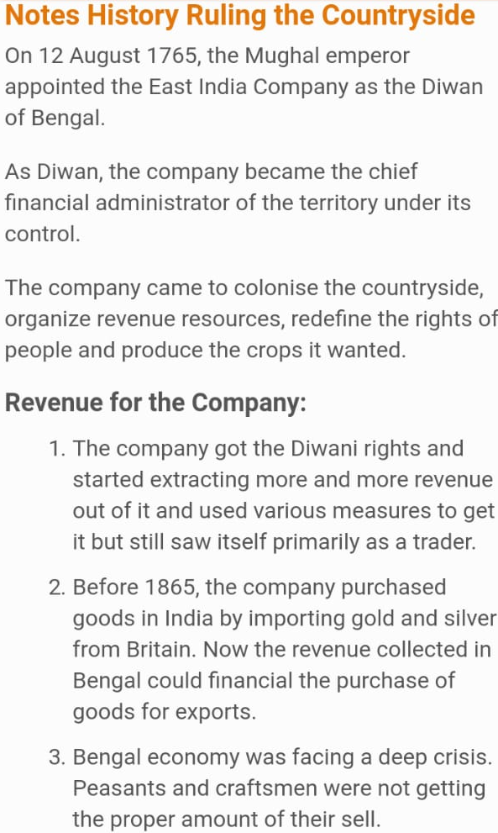

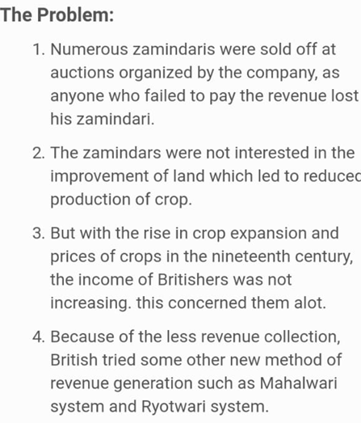
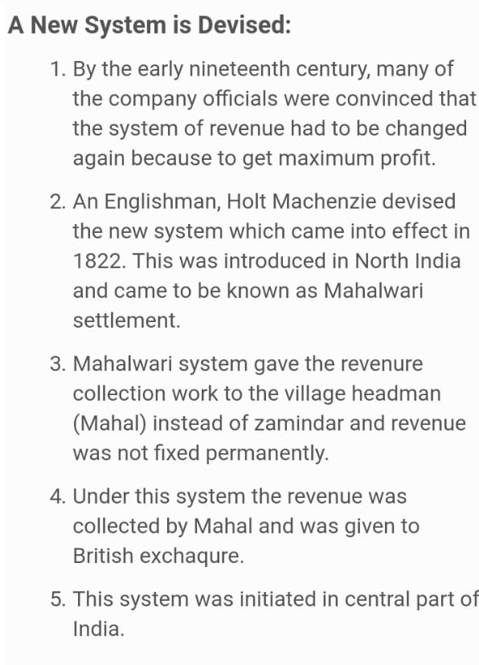

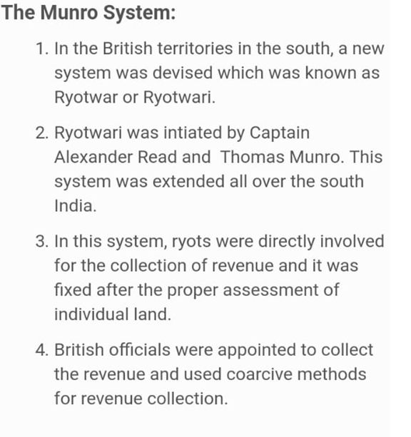
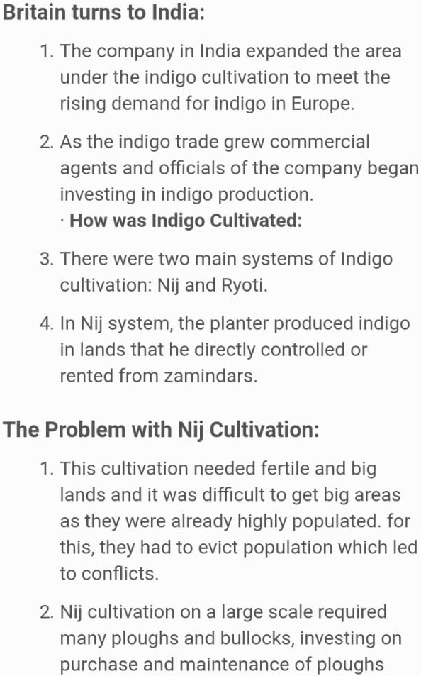
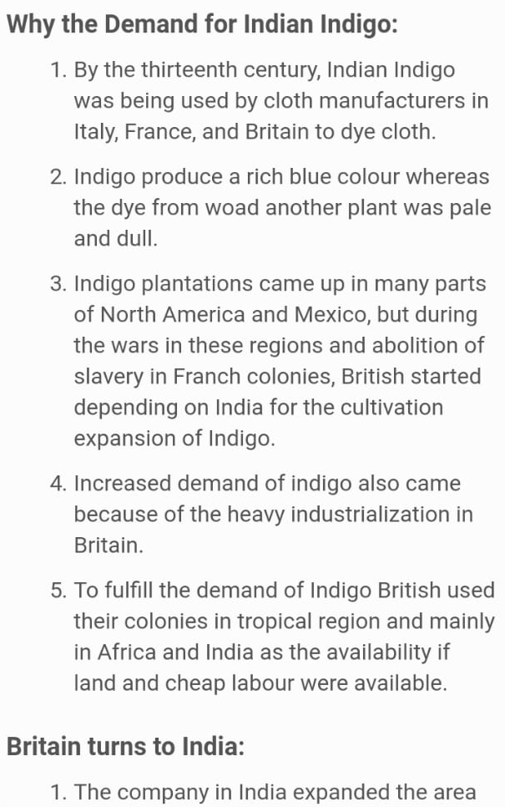
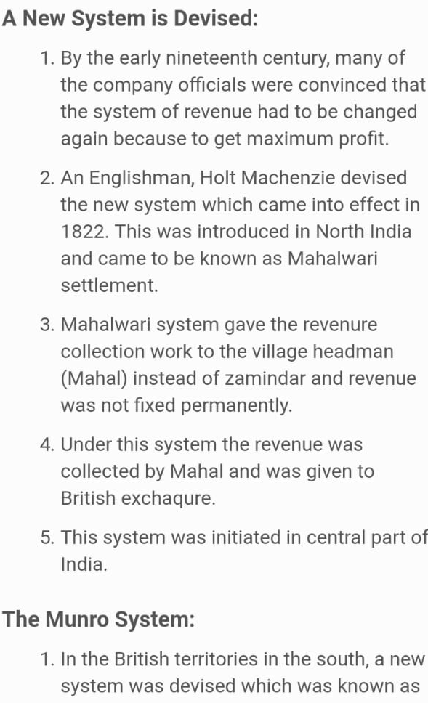
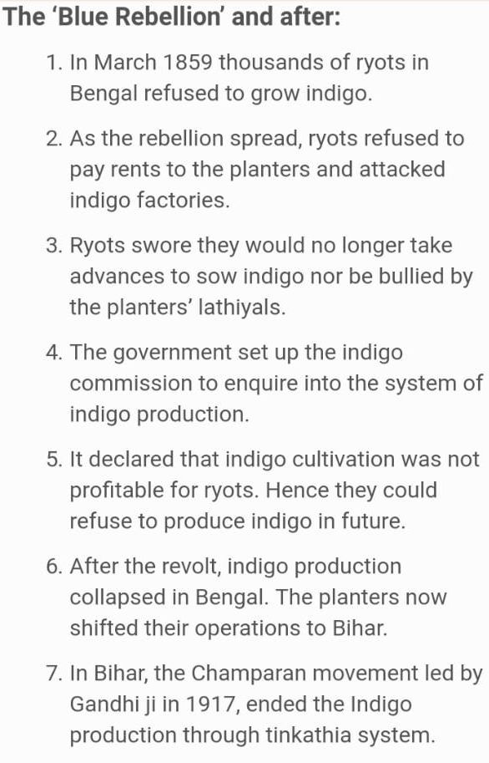

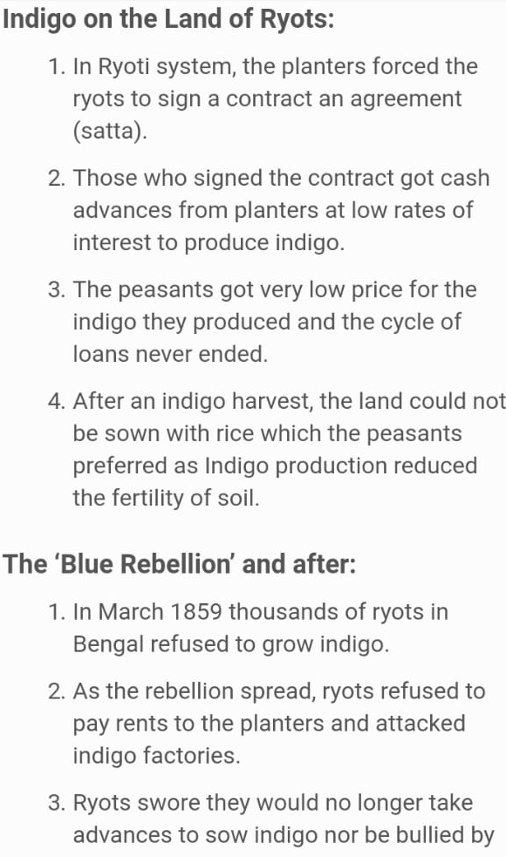

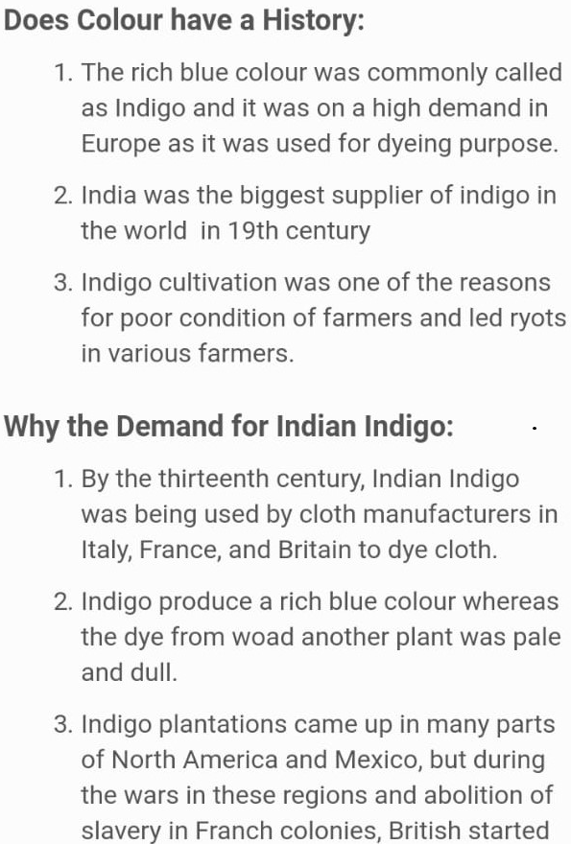

Chapter -4
THE UPRISING OF 1857
KEYTERM
1.Manifest-to appear or become evident
2.Sporadic-occasional or irregular
3.Mutiny-when soldiers as a group disobey their officers in the army
4.Sepoys-Indian soldiers under British or other European orders
5.Revolt-to protest in often violently against the person or people in power
Difficult words:-
1.Stationed
2.Sepoys
3.Encourage
4.Initiative
5.Missionary
6.Reformer
7.Rebellion
8.Mutiny
9.Garrison
10.Reinforcement
Date lines:-
1.29th mar 1857-mangal pandey soldier was hanged to death for attacking his officer in Barrack pore.
2.10th may 1857-sepoyes rushed to Delhi from Meerut.
3.September 1857- Delhi was recaptured from the rebel forces .
4.November 1862-Bahadur shah zafar died in the Rangoon jail.
Long answers :-
Q1. Discuss the reason for the failure of the revolt of 1857?
Ans. There are many reasons that were responsible for the failure of the revolt of 1857:
- The revolt did involve all sections of Indian society .many like Scindia ,Holkar,Nizam and other rulers and biog zamindars refused to join the rebellion.
- Modern educated Indians did not join the revolt .They felt only the British could take India forward.
- Different groups joining the rebellion had a lot of weekness ,example –lack of centralized leadership ,organization ,excellent system of communication
- Most of the rebels fought with weapons like, shords and pikes while the British have superior weapons and techniques suffered from insufficient finances while the British had immense wealth and excellent system of communication.
- Due to lack of common action of plan and unity the revolt started before the fixed date 31st May 1857 as a result entire plan was disorganized.
Q2.what were the major causes for the revolt of 1857?
Ans. Immediate causes: Introduction of the Enfield rifle in 1856 to train the Indian soldiers
. Use of greased cartridges made from fat of cow and pig .This hurt the religious sentiments of Indian soldiers
Political cause: Lord Dalhousie’s policy of annexation and the Doctrine of lapse had made the Indian angry and insecure.
.Rani of Jhansi ,Laxmibai was not allowed to adopt the son
Economic causes: High taxes under high revenue policies Peasants were high revenue policies .Peasants were improvised craftsmen and artisans became unemployed .
Social and Cultural causes –Indian were treated as inferior race .The British considered themselves as a superior race. Spread of British culture artisans missionaries .Taxes on religious places.
Military causes: High post and Handsome salaries were given to the British .Indian soldiers work inside British this caused frustration amongst Indians .
.The spark that led to a mutiny in several sepoy companies was the issue of new gun powder cartridges for the Enfield from cow and pig fat. February ,1857.A rumor was spread that cartridges were made.

