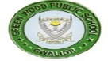
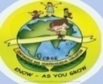
GREENWOOD PUBLIC SCHOOL, ADITYAPURAM
OUR MOTTO-DEVELOPMENT WITH DELIGHT

TERM-II SYLLABUS
CLASS-1
SUBJECT-E.V.S
CHAPTER-8
MY HOME
Difficult Words:-
1.Bricks
2. Cement
3. Mud
4. Straw
5. Flats
6. Kitchen
7. Drawing
8. Slept
9. Might
10. Think

Q/Ans:-
Q1. Why do we need a house?
Ans. We need a house to live in.
Q2. How does a house protect us?
Ans. A house protects us from heat, cold, rain,
Storm and thieves.
Q3. Write the name of different types of rooms.
Ans. 1. Drawing room
2. Dining room
3. Kitchen
4. Bedroom
5. Bathroom
Q4. What is a home?
Ans. The house in which we live is called a
home.
Q5. What are pucca houses?
Ans. Pucca houses are made of bricks and
cement.
Q6. What are kuchcha houses?
Ans. Kuchcha houses are made of mud and
Straw or dry grass.
HOTS:-
Q1. Why does a good home have windows and
ventilators?
Ans. A good home has windows and ventilators
to let in fresh air and sunlight.
Choose the correct option:-
Q.1 The place where your mother cooks food.
(a) Bedroom
(b) Dining room
(c) Kitchen
Q.2 The place where you sleep in your house.
(a) Drawing room
(b) Bedroom
(c) Dining room
clean and airy
Q3. A good house should be _________.
(a) Dirty and sunny
(b) Dirty and airy
(c) Clean and airy
dustbin
Q4. We must throw garbage in a _________.
(a) Pot
(b) Dustbin
(c) Bucket
Q5. Touching electrical switches and plugs with
bad habit
wet hands is a ___________.
(a) Bad habit
(b) Good safety habit
(c) None of the above

ACTIVITY
Paste pictures of different types of rooms and write their names
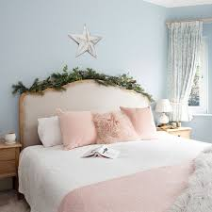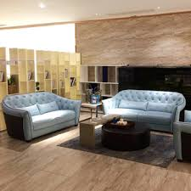
DRAWING ROOMROOM
BEDROOM
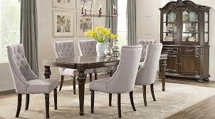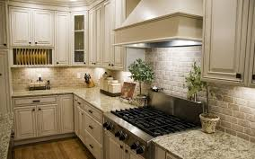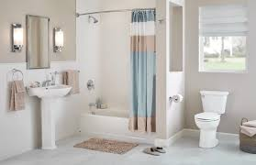
BATHROOM
KITCHEN
DINING ROOM

CHAPTER-9
MY SCHOOL
Difficult Words:-
1.Learn
2. Lessons
3. Teacher
4. Principal
5. Library
6.Office
7. Write
8. Paint
9. Dance
10. Brings

Q/Ans:-
Q1. Why do we go to school?
Ans. We go to school to learn.
Q2. How do you go to school?
Ans. I go to school by bus.
Q3. What do we learn in school?
Ans. We learn to read, write, sing, dance and
draw in school.
Q4. Write the activities you have in your school?
Ans. We have many activities in our school like
1. Singing
2. Dancing
3. Art and Craft
4. Games and sports

HOTS:-
Q1. Name a few things you carry in your school
bag.
Ans. 1. Books
2. Notebooks
3. Pencil
4. Sharpner
5. Eraser
6. Ruler
7. Tiffin
8. Water Bottle
ACTIVITY
Make teacher’s day card and paste it in your notebook
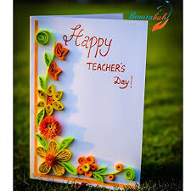

Chapter-10
Plants around us
Difficult Words:-
1. Strong
2. Often
3. Bushy
4. Branches
5. Shrubs
6. Soft
7. Straight
8. Climbers
9. Cactus
10. Deserts
Q/Ans:-
Q1. What are trees?
Ans. Big and strong plants are called trees.
Q2. What are shrubs?
Ans. Plants which are smaller than trees are
called shrubs.
Q3. What are climbers?
Ans. Plants that need support to grow are
called climbers.
Q4.Write any two uses of plants.
Ans. 1. Plants give us food.
2. Plants give shelter to birds and animals Choose the correct answer:-
Trees
Q1. ________ are big, tall and strong plants.
(a) Trees
(b) Shrubs
(c) Herbs
Q2. Shrubs are smaller than trees and have a
bushy
_________ look.
(a) Colourful
(b) Bushy
(c) Soft
herb
Q3. A tomato plant is a _________.
(a) Herb
(b)Shrub
(c) Tree
creepers
Q4. _________ are plants which have weak stems
and cannot stand straight on their own.
(a) Shrubs
(b) Herbs
(c) Creepers
fruits
Q5. Plants give us ________ to eat.
(a) Shade
(b) Fresh air
(c) Fruits
ACTIVITY
Label the parts of a plant
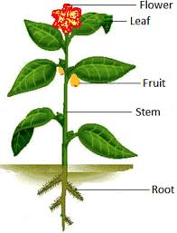
CHAPTER-11
ANIMALS AROUND US
Difficult Words:-
1. Chase
2. Animals
3. Farm
4. Guards
5. Share
6. Must
7. Stay
8. Most
9. Feathers
10. Domestic
Q/Ans:-
Q1. What are farm animals?
Ans. Animals which live on a farm are called farm
animals.
Q2. What are wild animals?
Ans. Animals which live in the forests are called
wild animals.
Q3. What are pets?
Ans. Pets are the animals that we keep at home.
They are tamed.
Name the following:-
Q1. Two domestic animals.
Ans. 1. Cow
2. Goat
Q2. Two water animals.
Ans. 1. Fish
2. Crocodile
Q3. Two wild animals.
Ans. 1. Bear
2. Deer
Q4. Two pet animals.
Ans. 1. Cat
2. Dog
Q5. Two Birds
Ans. 1. Parrot
2. Sparrow
Q6. Two Insects
Ans. 1. Butterfly
2. Ant
HOTS:-
Q1. Which is the largest animal on the land?
Ans. Elephant is the largest animal on the land.
One word Questions:-
1. Where does a dog live?
Ans. Kennel
2. Where are the cows kept?
Ans. Shed
3. Where does a lion live?
Ans. Den
4. What does a camel have on its back to store
water?
Ans. Hump
5. What is the long nose of an elephant called?
Ans. Trunk

ACTIVITY
Collect pictures of domestic and wild animals and paste them
Domestic Animals Wild Animals
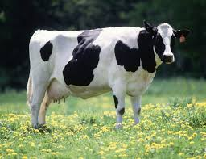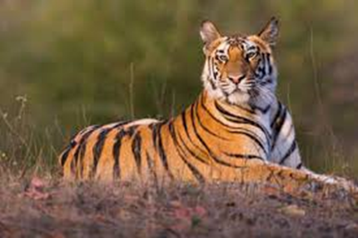
TIGER
COW
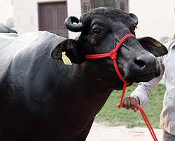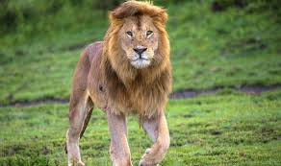
LION
BUFFALOW
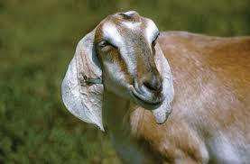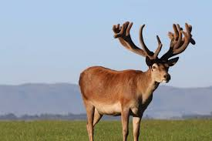
DEER
GOAT

CHAPTER-12
RULES FOR SAFETY
Difficult Words:-
1.Safety
2. Hurt
3. Candle
4. Knife
5. Scissors
6. Sharpen
7. Socket
8. Shock
9. Always
10. Lean
Q/Ans:-
Q1. What is safety?
Ans. Safety means protecting ourselves from
getting hurt.
Q2. Write two safety rules we should follow at
home?
Ans. 1. Do not play with fire.
2. Do not play with sharp objects.
Q3. What should we do if we get hurt?
Ans. We should take first aid and call a doctor.
Q4. Write two safety rules on the road.
Ans. 1. Always cross the road at a Zebra
crossing.
2. Always walk on the footpath.
HOTS:-
Q1. What will happen if we do not follow the
safety rules?
Ans. If we do not follow safety rules, we can hurt
ourselves and others.

ACTIVITY:-
Colour the traffic lights and write what each light means
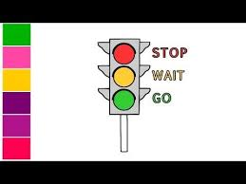
1.Red for STOP
2.Green for GO
3.Yellow for HURRY UP

CHAPTER-13
THE EARTH AND THE SKY
Difficult Words:-
1. Earth
2. Mountains
3. Rise
4. Covered
5. Oceans
6. Breathe
7. Rainbow
8. Shine
9. Lake
10. Plains
Q/Ans:-
Q1. Where do we all live?
Ans. We all live on the Earth.
Q2. What is the shape of the Earth?
Ans. The Earth is round in shape.
Q3. Where do you see the Sun, the Moon and the
Stars ?
Ans. We see the Sun,the Moon and the Stars in
the Sky.
Q4. What does the Sun gives us?
Ans. The Sun gives us light and heat.
Q5. When do we see Stars?
Ans. We see the Stars at night.
HOTS
Q1.Why do the stars look so small?
Ans. Stars look small because they are very far
from us.
Choose the correct answer:-
round
Q1.The Earth is __________ in shape.
(a) Round
(b) Square
(c) Triangular
light
Q2. The Earth gets heat and __________ from the
Sun.
(a) Light
(b) Rain
(c) Stars
Q3. In winters we love to play in the Sun as we
warmth
get ___________.
(a) Wet
(b) Frozen
(c) Warmth
Q4. The band of seven colours in the sky is
rainbow
known as ___________.
(a) Rainbow
(b) Milky Way
(c) Light
moon
Q5. The _________ keeps changing its shape.
(a) Moon

(b) Sun
(c) Earth

ACTIVITY
Colour the rainbow given below:-

CHAPTER-14
HOW EARLY PEOPLE LIVED
Difficult Words:-
1. Ago
2. Human beings
3. Forests
4. Caves
5. Cover
6. Tools
7. Stone
8. Taste
9. Butter
10. Wheel
Q/Ans:-
Q1. Where did early people live?
Ans. Early people lived in forests and caves.
Q2. Why did the early people eat meat without
cooking?
Ans. The early people ate meat without
cooking because they did not know about fire and its uses.
Q3. What food did the early man eat?
Ans. The early man ate the meat of animals.
Q4. What did the early people wear?
Ans. The early people wore skin of animals and
leaves.
ACTIVITY
Draw tools of early man
