GREENWOOD PUBLIC SCHOOL, ADITYAPURAM
OUR MOTTO-DEVELOPMENT WITH DELIGHT
CLASS-I SUBJECT- MATHS
TERM-2 SYLLABUS
CHAPTER – 6
GEOMETRICAL SHAPES
Circle , Sphere

- A circle has no corners.
- A circle is a shape that is made up of a curved line.

Triangle

- It is a triangle.
- It has three corners and three sides.
- A triangle with all three equal sides is called an equilateral triangle.
Square , Cube
- It is a square.
- All its sides are equal
- It has four sides and four corners.

Rectangle , Cuboid

- It is a rectangle.
- The opposite sides are equal
- The opposite sides of a rectangle have the same length and are parallel.
Oval

An oval is any curve that looks like an egg or an ellipse.
Cylinder

A cylinder has one curved face , two plane faces and no edges.

CHAPTER – 7
MEASUREMENT
- The size , length or amount of something established by measuring.
- Length is measured in metre and centimeter.
- Weight is measured in grams and kilograms.
- Capacity is measured in millilitres and litres.
1 m = 100 cm
1 kg = 1000 gm
1 l = 1000 ml
M .C . Q
Tick the correct option
1) The length of a notebook can be measured in
Ans. a. handspan b. pace c. foot span
2) We measured the height of a long pole in
Ans. a. digit b. centimetre c. metre
3) Weight tells us how ________ an object is
Ans. a. heavy b. long c. short

ACTIVITY
Draw a straight line of 5 cm , 8 cm and 10 cm with the help of scale.
A__________________B
5 cm
A_______________________B
8 cm
A_________________________________B
10 cm

CHAPTER – 8
MEASUREMENT OF TIME
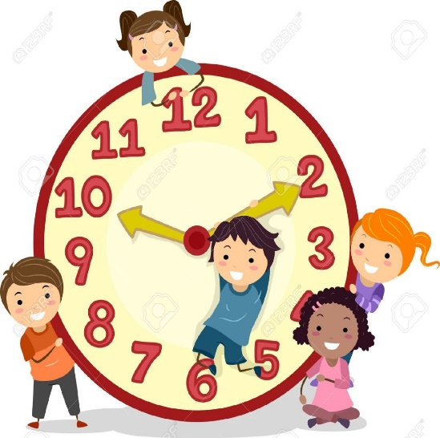
- A clock tells us the time.
- A clock has two hands.
- Long hand tells us minute.
- Short hand tells us hours.
- The face of a clock is called the dial.

- February has 28 or 29 days.
- Some months have 30 days. April , June , September , November.
- Some months have 31 days. January , March , May , July , August , October , December.
MONTHS NAME
January July
February August
March September
April October
May November
June December

DAYS OF THE WEEK
Monday
Tuesday
Wednesday
Thursday
Friday
Saturday
Sunday

M .C . Q
- How Many Days Are There In A Week?
Ans. Seven Days
- Which Is The Last Day Of The Week?
Ans. Sunday
- Which Is The First Day Of The Week?
Ans. Monday
- How Many Months Are There In A Year?
Ans. 12 Months
- How Many Days Are There In A Year?
Ans. 365 Days
- How Many Minutes Are There In One Year?
Ans. 60 Minutes
- How Many Hours Are There In One Day?
Ans. 24 Hours

CHAPTER – 9
MULTIPLICATION
- Multiplication is repeated addition.
- ‘×’ is the Symbol of multiplication.
- Multiplication is a way of adding same number repeatedly.
FILLIN THE BLANKS
8×2=16
4×6=28
7×8=56
8×8=64
9×3=27
6×5=30
3×8=24
2×4=8
5×5=25
REPEATED ADDITION FROM
- 2 + 2 + 2 + 2 = 8
- 3 + 3 + 3 = 9
- 4 + 4 + 4 = 12
- 6 + 6 + 6 + 6 + 6 = 35
- 9 + 9 + 9 + 9 + 9 + 9 = 54

MULTIPLY
2 3 5 2 2 4 3 2 3 8 4 2
× 2 × 2 × 2 × 4 × 1 × 4

______ ______ ______ ______ ______ ______
4 6 10 4 4 8 12 8 3 8 16 8
______ ______ ______ ______ ______ _______

2 2 2 2 3 3
× 3 × 4 × 3
________ ________ _______
6 6 8 8 9 9
________ ________ _______

WORD MEANINGS
Q) There are 5 flowers in a shopping mall. Each floor has 48 shops. How many shops are there in them all?
Solve: Floors in a shopping mall = 5
Shops on each floor = 48
48 × 5 = 240
Q) There are 7 days in a week. How many days are there in 52 week
Solve: Number of weeks = 5 2
Number of days in each week = × 7
Thus , total number of days ______
364
______
CHAPTER -11
PATTERNS
Q.Complete the patterns
a. OA OAOAOAOA
b. A V A V A V
c.MW MW MWMWMW

Q. Fill the missing numbers:
a) 2 4 68 10 12 14
b) 1 3 5 7 9 1113
c) 3 6 9 12 15 1821
d) 5 10 152025 30 35
e) 1020 30 40 50 60 70

CHAPTER – 12
DIVISON
- Divison is a way of subtracting the same number repeatedly.
- ‘ ÷ ’ is the symbol of divison.
FILLUPS
30÷ 6 = 5
63 ÷ 7 = 9
16 ÷ 4 = 4
48 ÷ 8 = 6
21 ÷ 3 = 7
36 ÷ 9 = 4
DIVIDE
2)14(7 7)35(5 8)64(8 5)20(4 4)28(7
14 35 64 20 28
_______ _______ ______ _______ ______
0 0 0 0 0 0 0 0 0 0
________ _______ _______ _______ ______

6)54(9 9)81(9 3)12(4 8)40(5
54 81 12 40
______ _______ ______ ________
- 0 0 0 0 0 0 0
______ ______ ______ ________

WORD PROBLEMS
Q. 74 books are to be packed equally in 8 bundles. How many books will be there in each bundle? How many books will be left?
Ans . Total number of books = 74
Packed equally in 8 bundles
8)74(9
72
______
02
______
The books are packed in one bundle = 9
Total books will be left = 2

Q. There are 45 girls in 5 sections of class 2. If each sections has same number of girls, how many girls are there in each section?
Ans. Total number of girls = 45
Number of sections = 5
5)45(9
45
______
0 0
______
So, each section has 9 girls.

