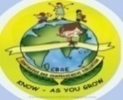
GREENWOOD PUBLIC SCHOOL, ADITYAPURAM
OUR MOTTO-DEVELOPMENT WITH DELIGHT
CLASS- VII SUBJECT- HISTORY
TERM-2 SYLLABUS
Chapter -6
TOWNS TRADERS AND CRAFTSPERSONS
DIFFICULT WORDS
1. Gopuram 2. Kottam 3. Equisite 4. Demon 5. Emporium 6. Negotiate 7. Hampi 8. Prosperous 9. Dutch 10. Liberty
KEYWORDS:
1. Apprentice: trainee, someone who is learning a skill
2. Alloy: a metal made by combining two or more metals
3. Ornate: highly decorated
4. Emporium: A place where goods from diverse prodution centres are brought and sold.
VERY SHORT ANSWER TYPE QUESTIONS:
Q1. Name the types of towns developed in all parts of country in medieval India.
Ans. Commercial towns, court towns and temple towns developed in all parts of the country in the medieval India.
Q2. What is Nagara and Mahanagara?
Ans. Nagara was a common term for a town, while the term Mahanagara applied to a city.
Q3. Name some of the prominent merchants of India during the 17th century.
Ans. Virji Vohra from Surat, Malaya Chetti from the Coromandal Coast, and Abdul Gaffar were some of the prominent merchants of India during 17th century.
SHORT ANSWER TYPE QUESTIONS:
Q1. Which type of activities took place in karkhanas?
Ans. The karkhana supplied a variety of commodities to the royal household. It is believed that Muhammad bin tughlaq employed 4000 workers to produce silk fabric for the royal robes of honour. Hundreds of craft persons were engaged in gold embroidery on expensive fabrics called zardosi.
Q2. Who were the seths and beoparies?
Ans. The middle class in mediaeval India consisted of mainly merchants, professionals and officials. Indian merchants for export in wholesale and retail trade. The wholesale traders were called Seth's or vohras, while the retailers were known as beoparies or banks. In South India, the Chettis formed a wealthy trading community.
LONG ANSWER TYPE QUESTIONS:
Q1. India is a major textile hub in medieval period. Justify the statement.
Ans. The medieval period saw the rise and growth of trade and commerce in India. Textiles formed one of the major industries. Cotton, silk, carpets velvet and satin were major products. Dhaka was famous for special kind of cotton cloth called the Muslin.
Indian textiles become very popular in England in the later part of the 17th century. The principle centres of cotton manufacturing was spread throughout the country . Ahmedabad in Gujarat, Burhanpur in Khandesh, and other cities in Bengal, Kashmir, Lahore were some important centres. Use of silk and woolen textile was confined to the wealthy classes. Thus, textile weaving was a large industry in India.
Q2. Write a short note on court towns.
Ans. Rulers lived in court towns. The rulers would held their Darbar in these towns. Such a town mostly served as the capital of a kingdom or an Empire. Sometimes, coatings were shifted from one place to another. For example, Mohammed bin tughlaq shifted his capital from Delhi to Devagiri or Daulatabad and Akbar moved his capital from Agra to Fatehpur Sikri. Some of the important towns in South India such as Madurai, Thanjavur, Badami, Kanchi and Vengi were capital towns of different dynasties. The towns were centres of political affairs and trade. Many court towns such as Kanauj, Lahore, Delhi , Agra, Fatehpur Sikri emerged during the medieval period.
HOTS:
Q1. What do you understand by the word 'Heritage site'.
Ans. Word Heritage site are designated by UNESCO for having cultural, historical and scientific or the other form of significance. They could be ancient ruins or historical structures, buildings, cities, deserts, forests, islands, monuments, mountains etc.
ACTIVITY
On the outline map of India shade the important trading town of the medieval period:
1. Surat 2. Hampi 3. Masulipatnam
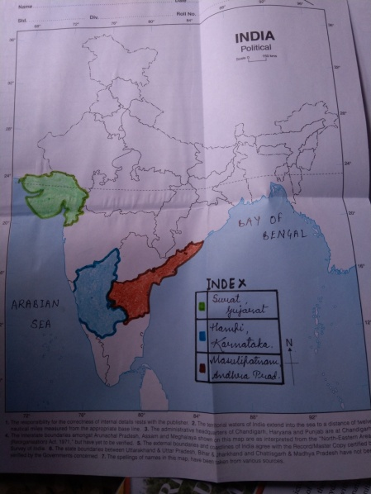

CHAPTER 7
TRIBALS, NOMADS AND SETTLED COMMUNITIES
DIFFICULT WORDS:
1. Prescribed 2. Numerous 3. Nomadic 4. Clans
5. Varna 6. Caravans 7. Pastrol 8. Dominant
9. Centralised 10. Ahoms
KEYWORDS:
1. Indelible: something that cannot be eliminated, forgotten or changed
2. Varna: The term refers to social classes in brahmanical books
3. Clan: A clan is a group of families of households claiming decent from common ancestor. Tribal organisation is often based on kinship or clan loyalties.
VERY SHORT ANSWER TYPE QUESTIONS:
Q1. What made Garha Katanga a rich state?
Ans. Garha Kantaga earned huge wealth by trapping and exporting wild elephants to other kingdoms. This made it rich.
Q2. Who introduced new ways of rice cultivation.
Ans. Ahoms introduced new ways of rice cultivation.
Q3. Who was the founder of Ahom dynasty?
Ans. King Sukaphaa laid the foundation of Ahom dynasty in Assam.
SHORT ANSWER TYPE QUESTIONS:
Q1. Mention some special features of tribal societies.
Ans. Special features of tribal societies are as follows:
1. They did not follow the social rules and rituals which brahmins prescribed.
2. They were not divided into many unequal classes.
3. Members of the society were United by kinship bonds.
Q2. How did new Jatis emerge in the Indian society.
Ans. With the arrival of new groups from the Northwest frontiers, such as the Shakas, the Hunas and the Kushanas, more people began to be assimilated within the existing varna system, resulting in the emergence of new jatis or castes. The brahmins began to recognise several editions communities as a separate jatis as well. Thus, the jatis became the new basis of organisation of society.

LONG ANSWER TYPE QUESTIONS:
Q1. Write a brief note on administrative system of the Gond kingdom.
Ans. The administrative system of this Kingdom was being centralised. The Kingdom was divided into garhs. Each garh was controlled by a particular Gond clan. This was further divided into units of 84 villages called Chaurasi. The Chaurasi was sub divided into barhots which were made up of 12 villages each.
Q2. Write a short note on Banjaras.
Ans. The Banjaras, the Nomadic tribal community in North India, played an important role in trading activities in the medieval era. They moved in caravans known as tandas specialised in carrying goods in bulk. They travelled long distances with thousands of oxen, loading goods in carts in sending them in towns. Alauddin Khilji use the banjaras to transport grains to the city markets. They also transported food grains for the Mughal army during military campaigns.

ACTIVITY
On the political map of India, label the given tribes location:
Ahoms Gond Cheros Koyas

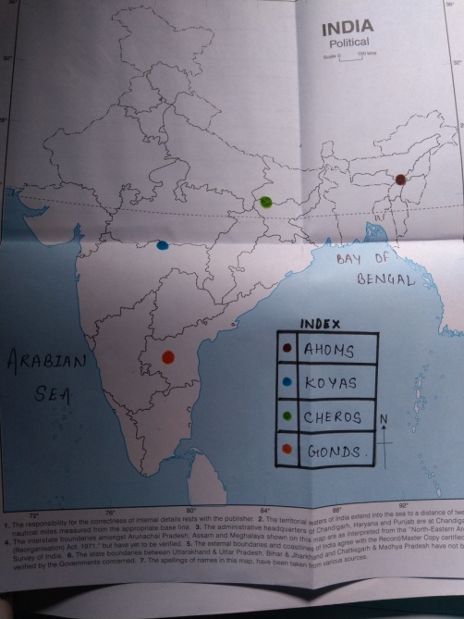

CHAPTER 9
FLOWERING OF REGIONAL CULTURES
DIFFICULT WORDS:
1. Immemorial 2. Intermixing 3. Distinctive 4. Aspirations
5. Gesture 6. Literature 7. Intricate 8. Miniature
9. Assurance 10. Proclaimed
KEYWORDS:
1. Static: something that does not change
2. Vernacular: the language of local dialect spoken by the ordinary people of a country or region
3. Metamorphose: transform
4. Narrative: a spoken or written version of events , experiences whether true or fictitious
VERY SHORT ANSWER TYPE QUESTIONS:
Q1. Who compiled the Adi Granth, holy scripture of the Sikhs.
Ans. Guru Arjun Dev compiled the Adi Granth, the holy scripture of the Sikhs.
Q2. Name some of the important schools of painting.
Ans. Some of the important schools of painting were Mewar, Marwar, Bundi- Kota and Kishangarh.
Q3. What were Satras?
Ans. Satras were the monasteries established in the Vaishnavite tradition of Assam and surrounding areas.
SHORT ANSWER TYPE QUESTIONS:
Q1. What is a miniature painting?
Ans. Miniatures are small sized paintings. Generally done in watercolor on the cloth or paper. The earliest miniatures were on palm leaves or wood.
Q2. Name all the six dance forms that are encourage as classical.
Ans. Six classical dance forms are:
1. Kathak - North India
2. Bharatanatyam - Tamil Nadu
3. Kathakali - Kerala
4. Odissi - Odisha
5. Kuchipudi - Andhra Pradesh
6. Manipuri - Manipur
LONG ANSWER TYPE QUESTIONS:
Q1. Write a short note on Marwar School of Painting.
Ans. Unlike the typically styled Mughal trends, this school developed its own style of depiction of royalty. Jodhpur was one of the most important centres of Marwar school of painting. the most important Jodhpur paintings are portraits of the royal family and the nobility. Paintings of this school depict well-built males with big moustaches and huge turbans. The important centres of Marwar painting work were Bikaner ,Jodhpur and Jaisalmer.
CHAPTER 10
NEW POLITICAL FORMATION IN THE 18TH CENTURY
DIFFICULT WORDS:
1. Significant 2. Reshaped 3. Invention 4. Overlapping
5. Asserted 6. Ambition 7. Evident 8. Privileged
9. Alliance 10. Struggle

KEYWORDS:
1. Alliance: union
2. Archive: library or collection of records.
3. Mobility: upper class
4. Privilege: advantage
5. Subject: people ruled by the king.

VERY SHORT ANSWER TYPE QUESTIONS:
Q1. What were the effects of Aurangzeb's long war in the Deccan.
Ans. Aurangzeb fought a long war in Deccan. As a result, the military and financial resources of his Empire got depleted. The successors of Aurangzeb were not at all efficient. The efficiency of the imperial administration broke down.
Q2. Name the three states that were carried out in the old Mughal provinces in the 18th century.
Ans. The three states that were carried out in the old Mughal provinces in the 18th century were:
Awadh, Bengal and Hyderabad
SHORT ANSWER TYPE QUESTIONS:
Q1. What were the offices held in Sa'adat Khan?
Ans. Sa'adat Khan held the combined offices in Subadri, Diwani and Faujdari. In other words, he was responsible for managing the political and military affairs of the provinces of Awadh.
Q2. How did the last Mughal emperors lose their control over their nobles?
Ans. The efficiency of the imperial administration broke down. It became increasingly difficult for the last Mughal emperors to keep a check on their powerful mansabdars. Nobles appointed as governors ( subdars) open control the officers or revenue and military administration ( diwani and faujdari) as well. This gave them extra ordinary political economic and military powers in the vast region of the Mughal Empire. as the governors consolidated their control over the provinces the periodic recession of revenue to the capital declined.
LONG ANSWER TYPE QUESTIONS:
Q1. Discuss the administrative system under Shivaji.
Ans. The administrative system under Shivaji was a great success. Ki hardik council of ministers called the ashtnapradhana, uses to conceal him on all important matters. The council consists of the following ministers:
1. Peshwa ( Head of councils and administration incharge)
2. Senapati ( Army's commander in chief)
3. Nyayadhish ( Incharge of justice)
4. Amatya ( Incharge of finance)
5. Pant Sachin ( General secretary)
6. Sumemta ( Foregn affairs)
7. Mantri ( Head of intelligence)
8. Dandadhyaksha ( Incharge of religious matters)
ACTIVITY
On the outline map of India, mark the external boundaries under the rule of Mughals.
