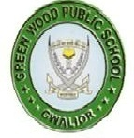
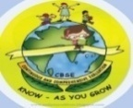
GREENWOOD PUBLIC SCHOOL, ADITYAPURAM
OUR MOTTO - DEVELOPMENT WITH DELIGHT
SYLLABUS FOR THE MONTH OF JANUARY (2018-19)
CLASS-L.K.G.
SUBJECTS |  | ACTIVITY+USE OF ICT | PARENTS INVOLVEMENT
English | Oral : Rhymes- Teddy Bear –Teddy Bear and Little Miss Muffet.  Reading –Sounds of vowel (a,e,i,o,u) use of He/She , My /Your , This/That , In/On/Under and My Self  Written : Sound words , use of this/that , he/she , my/your , in/on/ under and my self . | PPT on letters d-i (small cursive)  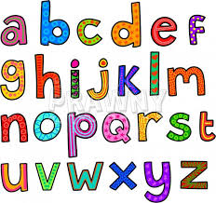 | Help your child in learning rhymes and written work
Hindi | Oral : dfork,¡ & फुलझड़ियाँ ] कहानी &सारस और लोमड़ी, पठन &पाठन ] दो तीन और चार वर्णो से बने शब्द , मेरा परिचय !  Written : चार वर्णों से बने शब्द , दो -तीन और चार शब्दों से बने वाक्य , खाली स्थान भरें चित्र पहचानकर नाम लिखें और Jqrys[k ! | Extra marks  o.kZekyk p ls u rd vkSj dfork,sa!  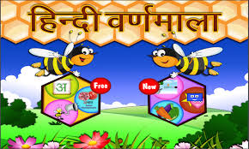 | dfork,sa ;kn djok,Wa rFkk o.kksaZ dh igpku fp=ksa +}kjk djok,W!
Maths | Oral : Number names 1-20, tables 2-5 Time counting 1-200 , Indian coins  Written : Counting151-200 ,table 2-5 numbers name 11-20, addition , counting 1-150 , subtraction and time | Extra marks  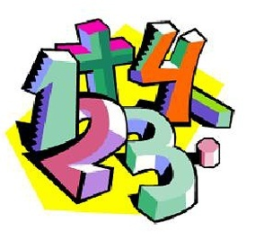  Videos on Number Names | Motivate your child in counting objects and learning tables.  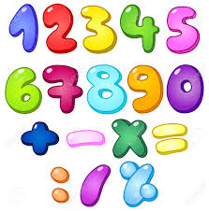
G.K. | Oral : Transport , our festivals and places of worship. | PPT on colour chart and opposites | Help your child to recog. the colours
Music / Dance | Patriotic Song
V.E. | Never tell a lie |  | Motivate your child not to tell lies
Art & Craft | Bird , Robot , leaf , sun and cloud
Sports | Races
Language Development | Sit on the chair , Put on your clothes , Sit straight , Don’t litter , don’t put your feet on the table. | 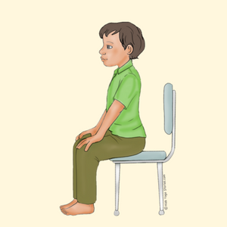 | Help your child to develop good habits
Conversation | English Conversation  1. Name the National flag of India?  Ans- Tricolour  2. How many colours does the Indian National Flag have.  Ans-There are three colours in Indian National flag  3. Name National Song.  Ans-Vande Mataram  4. When do we celebrate Republic Day?  Ans- 26th January | Hindi Conversation  प्रश्न-हमारे राष्ट्रध्वज में कितने रंग होते है ?  उत्तर-तीन रंग होते है  प्रश्न-हमारा राष्ट्रगान कौन सा है ?  उत्तर -"जन- गण-मन "  प्रश्न-हमारे राष्ट्रगान की रचना किसने की ?  उत्तर-कवि रविंद्रनाथ टैगोर  प्रश्न-हमारे राष्ट्रीय प्रतीक कौन -कौन से है ?  उत्तर -हमारे राष्ट्रीय प्रतीक राष्ट्रध्वज , राष्ट्रगान , राष्ट्रगीत और राष्ट्रमुद्रा है ! | Help your child in learning conversation Que/Ans  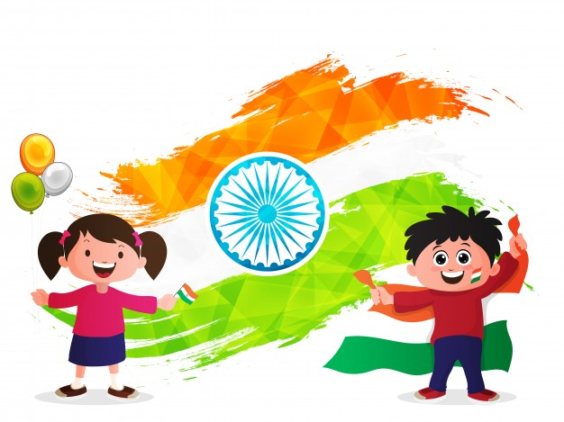

Activity Planner
Health and Wellness  Performing Arts  Eco-club Activity | Yoga  Group Dance  Cleaning the classroom | Literary and Creative | Speech on Republic Day

