GREENWOOD PUBLIC SCHOOL, ADITYAPURAM
OUR MOTTO - DEVELOPMENT WITH DELIGHT
SYLLABUS FOR THE MONTH OF JANUARY 2017-18
CLASS-U.K.G.
SUBJECTS |  | ACTIVITY+USE OF ICT | PARENTS INVOLVEMENT
English | Oral : Tea pot ,There was an old Woman  Reading –Page No.60,61,62,63,64  Written : They-Their, use of where , use of when , Action +ing , The circus show | 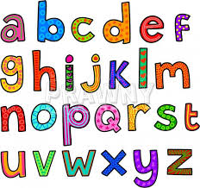 | Help your child in learning rhymes and written work
Hindi | Oral : dfork,sa & चुन्नू & मुन्नू ] बिस्कुट का पेड़ ] परियों की रानी कंप्यूटर !  Reading – Page No-48,49,50,51,52,53  Written : चंद्र बिंदु की मात्रा ( ) , “अ:” की मात्रा ( : ) _ की मात्रा ( ) , र - रेफ ( ) की मात्रा , र -पदेन की मात्रा ( ) संयुक्त अक्षर वाले शब्द , निबंध (माँ ) , विलोम शब्द , एकवचन से बहुवचन ! | Extra marks  dfork,sa!  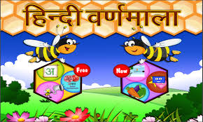 | dfork,sa ;kn djok,Wa rFkk o.kksaZ dh igpku fp=ksa +}kjk djok,W!
Maths | Oral : Table of 10 , Number names and clock.  Written : Time , Indian coins , patterns , skip counting. | Extra marks | Motivate your child in counting objects and learning tables.
EVS | Oral: L-13 Weather ,L-14 The Sun ,The moon and the Stars.  Written : L-13 Weather , L-14 The Sun ,The moon and the Stars.  Different types of seasons , Animals and their young ones , Animals Homes. | 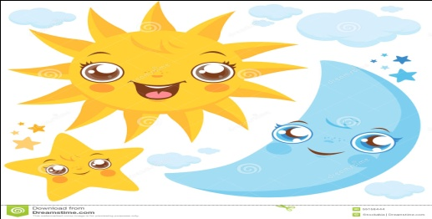
G.K. | 1.When do we celebrate kite festival.  Ans 14th of January  2.Which month is running now.  Ans.January  3.Do you have a pet?  Ans-……………………….  4.Who is your best friend?  Ans-My best friend is ……………  5.Which is your favourite colour/food?  Ans-My favourite colour is ………. / food is ………. | PPT on colour chart and opposites  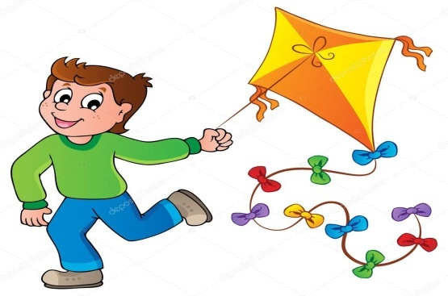 | Help your child to recog. the colours
Music / Dance | Patriotic Song
V.E. | 1.Do not waste food and water.  2.Be honest with your work. |  | Motivate your child to help others
Drawing | Hen , Garden , Rabbit , Engine.
Sports | Races + Aerobics.
Language Development | Discussion about your class-room |  | Help your child to develop good habits
Conversation | English Conversation  1.What does the red light tell us?  Ans-The red light tells us to stop.  2.What does the green light tell us?  Ans-The green light tells us to go.  3.What does the yellow light tell us?  Ans-The yellow light tells us to get ready?  4.How many months are there in a year.  Ans-There are twelve months in a year.  5.A place where people go for study.  Ans-School  6.A place where people go to worship.  Ans-Temple  Hindi Conversation  प्रश्न 1- एक वर्ष में कितने महीने होते है ?  उत्तर-एक वर्ष में बारह महीने होते है !  प्रश्न 2- हम पूजा करने कहा जाते है ?  उत्तर-हम पूजा करने मंदिर में जाते है! | प्रश्न 3- हम अध्ययन करने कहाँ जाते हैं?  उत्तर-हम अध्ययन करने विद्यालय में जाते है!  प्रश्न 4- लाल बत्ती हमको क्या सन्देश देती हैं ?  उत्तर-लाल बत्ती हमको रुकने का संकेत देती हैं !  प्रश्न 5- हरी बत्ती हमको क्या सन्देश देती हैं ?  उत्तर-हरी बत्ती हमको आगे बढ़ने का संकेत देती हैं !  प्रश्न 6- पीली बत्ती हमको क्या सन्देश देती हैं ?  उत्तर-पीली बत्ती हमको तैयार होने का संकेत देती हैं ! | Help your child in learning conversation Que /Ans
Activity Planner
Work Education  Health and Wellness  Performing Arts  Eco-club Activity | Box making with ice-cream  Preparation of First AID box)  Patriotic Song & Dance  Collage Making on “Save Trees” | Literary and Creative | 5 lines on Republic Day

