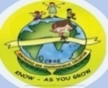
GREENWOOD PUBLIC SCHOOL, ADITYAPURAM
OUR MOTTO - DEVELOPMENT WITH DELIGHT
SYLLABUS FOR THE THIRD EVALUATION 2017-18
CLASS-II
SUBJECTS | BOOKS | LESSONS | SKILLS | ACTIVITY+USE OF ICT | PARENTS INVOLVEMENT
ENGLISH | New Pathways | Ch-8: The Three Sleepy men  Ch-9: Two Little Kittens  Ch-10: The Shell | Self awareness read, Understand | Extra Marks | Give your child regular loud reading practice.
 | Writing Skills | My Country India , My Garden  Sick leave Application, Dialogue Writing |  | Extra Marks
 | Speaking Skills | Story- Elephant and Friends
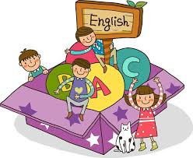 | Grammar & Composition | Definition of noun, pronoun, verb, adverb, adjective  L-10Verbs +ing  L-11Preposition (in ,on, under)  L-12 Linking words (or, but , and)  L-13Sentences  L-4Articles (A, An, The)  L-1Naming words | Clarity and Apply | Extra marks  Sentences,  Punctuation Marks,  Short Forms, Confusing words  Rhyming words,  Synonyms  Opposites  Comprehension  Composition | Read Moral Based Stories
 | Group Recitation | Laughing Song , William Blake | Recite, Appreciate
HINDI | iBu dkS”ky | vifBr x|ka”k ] vifBr i|ka”k | mPpkj.k 'kfDr
 | ys[ku dkS”k y | xk¡/kh th ¼fuca/k½] çkFkZuk i= | vfHkO;fDr dk Lrj
 | ekSf[kd {kerk | dfork & lh[kks | Lej.k 'kfDr
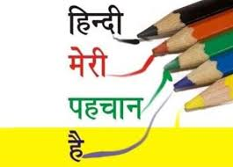 | xqyeksgj | ikB&13: pksj idMk x;k  ikB&14: lh[kks  ikB&15: LoPNrk  ikB&16: आइजक न्यूटन  ikB&17: अकबर बीरबल | ckSf)d fodkl {kerk |  | vfHku; ds lkFk dfork ;kn djok,¡  izfrfnu lqys[k dk vH;kl djok,¡
 | O;kdj.k | laKk] loZuke] fØ;k] lekukFkhZ 'kCn] fyax cnyksA foykse 'kCn] opu cnyks] fo’ks"k.k dh ifjHkk"kk]fo'ks"k.k ] fxurh ¼1&50½ A | O;kdjf.kd Kku + Hkkf"kd Kku
 | Jo.k dkS”ky | d`".k&lqnkek ] f'k{kkizn dgkuh lqukdj muls iz”u iwNuk | Lej.k 'kfDr
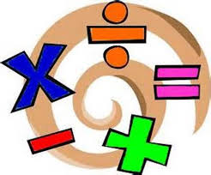  MATHEMATICS | Smart Maths | Ch-3: Addition (3-digit Numbers)  Ch-11: Measuring length  Ch-12: Measuring weight  Ch-13: Measuring capacity  Ch-14: Money  Ch-15: Multiplication  Ch-16: Division | Identify,  Build,  Logical Thinking,  Decision Making | ICT- Extramarks  Videos on Money & Multiplication | Help your child to identify the difference between weight, capacity and length.  Help your child in buying the items and calculate the amount to be paid.
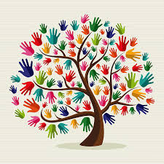  E.V.S. | Discovering E.V.S. | Ch-13: Natural & Man made things  Ch-14: Weather & Season  Ch-15: Time  Ch-16: How we Travel  Ch-17:Keeping in touch  Ch-18: Our Country – G.D  Ch-19: Celebrating Together (G.D)  Ch-6: Plants Around Us | Awareness,  Critical Thinking,  Interpretation | Extra Marks  Videos on the related topics | Take your child to any historical monument and give him/her information about it.  Discuss with your child about the various modes of transportation
COMPUTER | Active Computer | Ch-2: Parts of the Computer  Ch-5: Typing on the Computers  Ch-6: More on paint |  | Practical based on given topics
ART & CRAFT |  | Making a paper bag / Origami
P.E. |  | Athletic Events
G.K. | Knowledge | General Intelligence and Reasoning , Sports Arts and Entertainment
VALUE EDUCATION &  LIFE SKILLS | Up and Aware | L-9:Vegetables Patch  L-10: Together we can  L-11: Diamond Ring  L-12: The Young Boy | Creative Thinking, Problem Solving |  | Talk with your child on the importance of cleanliness.

