GREENWOOD PUBLIC SCHOOL, ADITYAPURAM
OUR MOTTO - DEVELOPMENT WITH DELIGHT
SYLLABUS FOR THE MONTH OF APRIL (2019-20)
CLASS-NURSERY
SUBJECTS |  | ACTIVITY+USE OF ICT | PARENTS INVOLVEMENT
English | Theme- Myself  Sentence structure - I am a boy/girl.  Written – Letters Patterns- Sleeping lines  Standing lines , Slanting lines  Vocabulary Building- Family, Mother, Father, Sister,  Brother  Rhymes :- Johny - Johny, Twinkle Twinkle  Recog –Alphabets A, B, C, D | 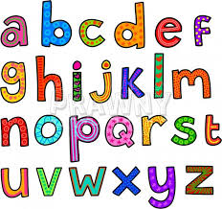 | Help your child in learning rhymes and written work
Hindi | Oral : dfork,¡ & आलू - कचालू] ] मछली  okD; jpuk & eSa ,d yMdk ] yMdh gWwA  Loj & v & bZ  Written : vkMh & frjNh js[kk,sa] xksykdj ,oa  v/nxksykdkj lajpuk,sa  Recog : अक्षर – v ] vk ] b ] bZ | 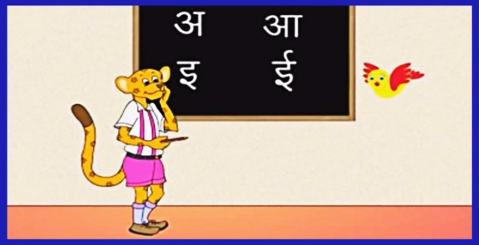 | dfork,sa ;kn djok,Wa rFkk o.kksaZ dh igpku fp=ksa +}kjk djok,W!
Maths | Oral : Counting 1-5 counting  Concepts : Big – small  Fat – thin  Written: Curves and lines. |  | Motivate your child in counting objects and learning tables.  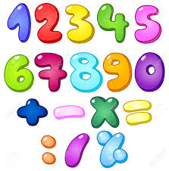
Drawing | Page no. 2, 3
G.K. | Oral : Colours- Red, Blue, Green, Yellow, black  Fruits Apple , Mango , Banana , Grapes. | PPT on Colours | Help your child to recog. the colours
Music | School Prayer , National Anthem | PPT on ABC Song
Dance | Flowers in the garden (song)
V.E. | I love my family | PPT on Family | Make your child learn the names of family members.
Physical Education | Fun games- Running, Jumping, hopping  Walk in line , On the circle. |  | Take your child to a park and play some games.
Language Development | School , Class , Teacher , Bus. |  | Help your child to develop good habits
Conversation | English Conversation  1.What is your name?  Ans-My name is ……………  2.How are you?  Ans-I am fine, thank you.  3.How old are you? ?  Ans-I am 3 years old. | Hindi Conversation  प्रश्न 1- आपकk uke D;k gS ?  उत्तर - esjk uke ------------------ gSA  प्रश्न 2- vki fdrus o’kZ ds gS?  उत्तर - eS rhu o’kZ ds gSA  प्रश्न 3- vki dSls gS\  उत्तर - eSa vPNk / vPNh gwW / /kU;okn | Help your child in learning Conversation .
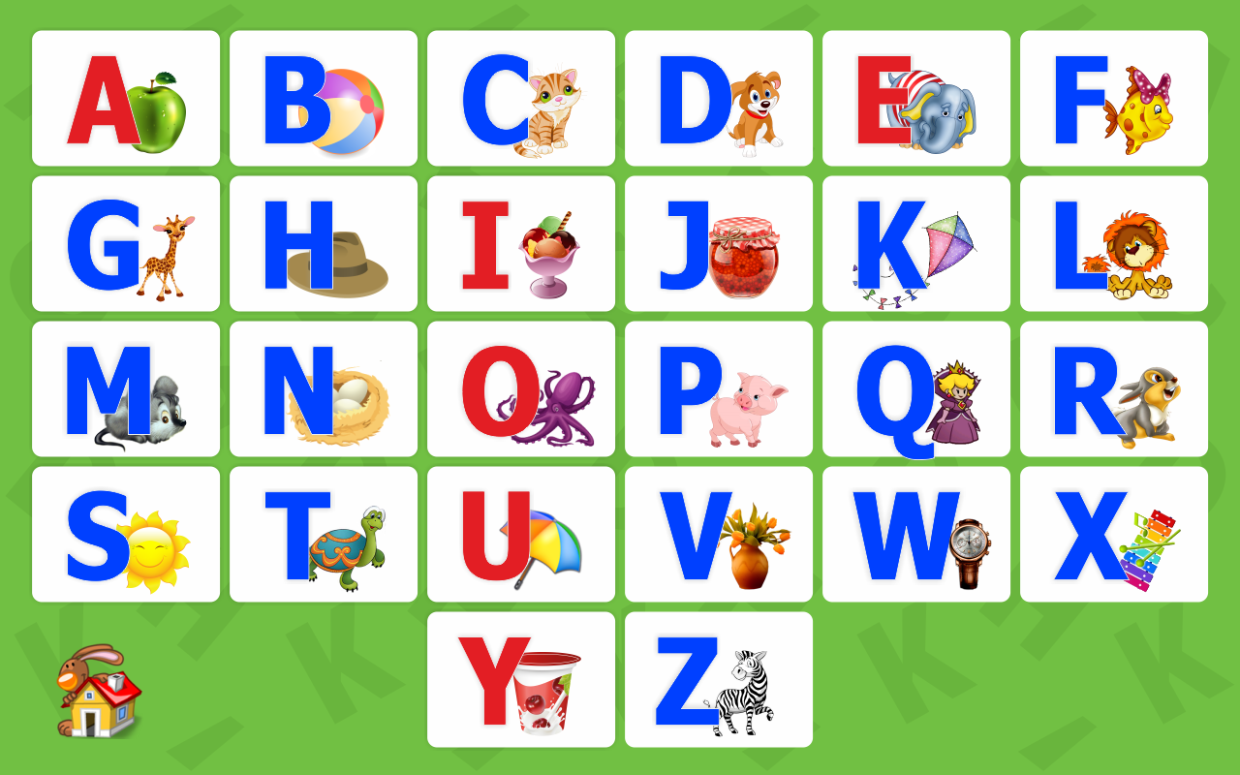
ALBHABETS
ACTIVITIES BLOG
- Free hand colouring
- Finger Printing strokes
- Tearing & Pasting of paper activity
A B C Song
A B C D E F G
Come and Sing along with me
H I J K L M N O P
Tell me what you want to be
Q R S T U V W X Y Z
Now I know my A B C

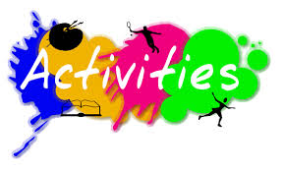

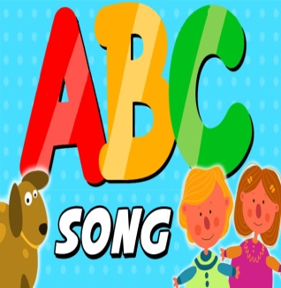

GREENWOOD PUBLIC SCHOOL, ADITYAPURAM
OUR MOTTO - DEVELOPMENT WITH DELIGHT
SYLLABUS FOR THE MONTH OF APRIL (2019-20)
CLASS-L.K.G.
SUBJECTS |  | ACTIVITY+USE OF ICT | PARENTS INVOLVEMENT
English | Oral : Rhymes-Little Betty Blue and Two Little Dicky Birds.  Reading : English Introductory (pg no. 3-5). (Consonants and vowels chart)  Written : Capital letters (A-Z), Dictation, Match the following, Write the first letter of the picture, fill in the missing letters, vowels and consonants. | PPT on letters a-i (small cursive) | Help your child in learning rhymes and written work
Hindi | Oral : dfork,¡ & बिल्ली मौसी और माता पिता !  Reading – स्वर (अ से v% तक ) व्यंजन क से M+ तक ! और शब्द यात्रा पेज न. २ से 6 तक  Written : स्वर (अ से v% तक ), जोड़ी feykb, , चित्र पहचानकर अक्षर लिखें , खाली स्थान भरे , श्रुतलेख | Extra marks  o.kZekyk p ls u rd vkSj dfork,sa!  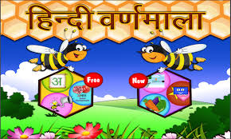 | dfork,sa ;kn djok,Wa rFkk o.kksaZ dh igpku fp=ksa +}kjk djok,W!
Maths | Oral : Counting 1-50, table of 2, Big/small, tall/ Short, Long /Short, Fat /Thin, Heavy /Light.  Funtastic Maths page no. 5-9  Written : Forward Counting 1-50, Fill in the missing numbers, Dictation count and write, what number comes before ,after and in between. | Extra marks  Videos on Number Names | Help your child in learning tables.
G.K. | Oral : Parts of the body, Myself, Fruits, Vegetables. | PPT on Myself | Make your child learn Myself.
Computer | Parts of computer.
Music | Gayatri Mantra , English and Hindi prayer.
Dance | Flowers in the garden (song)
Language Development | Action words, Writing, Eating, Jumping, Reading and drinking.
V.E. | Don’t waste food and water. |  | Motivate your child to speak the truth
Drawing | Colour the cube and cone (pg 2,3)
Physical Education | Running , Hopping and Jumping  Walk in line , On the circle.
Conversation | 1.What is the full name of B.R Ambedkar?  Ans Bhimrao Ramji Ambedkar  2.When do we celebrate Baisakhi?  Ans We celebrate Baisakhi on 14th April.  3.Where is God?  Ans God is everywhere.  4.What must you say when you come to school in the morning?  Ans We must say Good Morning to all.  5.What must you say when you hurt someone?  Ans I must say sorry. | Hindi Conversation  1- vkidk D;k uke gS\  m0 esjk uke ---------------- gSA  2- vkids ikik dk D;k uke gS\  m0 esjs ikik dk uke ----------------------- gSA  3- vkidh ekrk dk D;k uke gS\  m0 esjh ekrk dk uke -------------------- gSA  4- vki fdl d{kk esa i<+rs gSa\  m0 eSa d{kk L.K.G. esa i<+rk gw¡@i<+rh gw¡A | Help your child in learning conversation Que/Ans
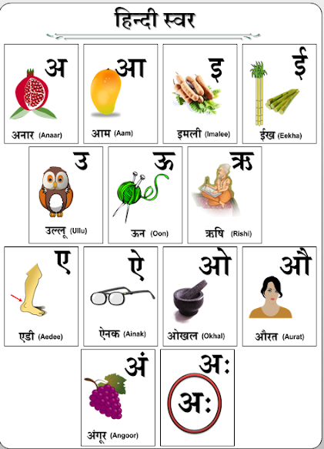
ACTIVITIES BLOG
1. English Recitation Competition
2. Water colouring competition.
3. Earth day celebration. (Leaf Printing Activity)
4. Mother’s Day card.

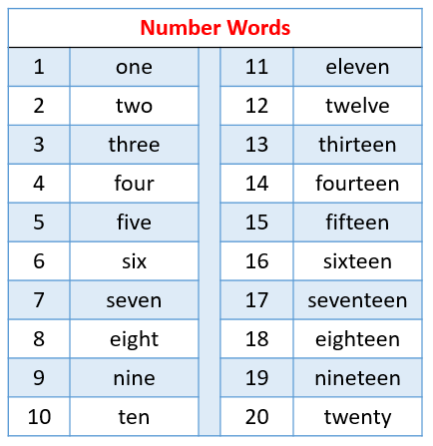

GREENWOOD PUBLIC SCHOOL, ADITYAPURAM
OUR MOTTO - DEVELOPMENT WITH DELIGHT
SYLLABUS FOR THE MONTH OF APRIL (2019-20)
CLASS-U.K.G.
SUBJECTS |  | ACTIVITY+USE OF ICT | PARENTS INVOLVEMENT
English | Oral:-Rhymes- Teddy Bear.  Words of (a,e,i,o,u)  Reading –Revision of Alphabets.  Written :Capital cursive (A to Z),Small cursive (a to z)  Recognition:- Alphabets ( A to Z )  In book- Revision of Alphabets, pg no. 4,word meanings -5,6,7. |  | Help your child in learning rhymes and written work
Hindi | Oral : dfork,sa & pank xksy ] Mkfd;kA  Reading : o.kZekyk ] Loj ] O;atu ] nks v{kj ds 'kCnA  Written : o.kZekyk ] Loj ¼ v ls v%½ O;atu ¼d ls K½ nks ]rhu ]pkj v{kj ds 'kCnA  Loj ys[ku % ist 2 ls 11 rd  Jqrys[k & o.kZekyk ] fcuk ek=k ds 'kCn ] nks ]rhu ]pkj v{kj ds 'kCnA  Recognition: o.kksZ dks igpkuuk A | Extra marks  dfork,sa! | dfork,sa ;kn djok,Wa rFkk o.kksaZ dh igpku fp=ksa +}kjk djok,W!
Maths | Oral : Number names (1-20), Table of 2,3  Counting 1-100  Written : : Number names (1-20), Table of 2,3  Counting 1-100  Maths Primer- page no. 4,5,6,7 |  | Motivate your child in counting objects and learning tables.
EVS | Oral: My Family- family members ,pet animals. | PPT on given topics. | Help your child to recog. the colours, fruits & flowers.
G.K. | Parts of body , 5 Fruits & 5 Flowers name | PPT on fruits & flowers. | Help your child read the calendar.
Music | School Prayer , National Anthem
Dance | Flowers in the garden (song)
V.E. | I love my school. |  | Motivate your child to help others
Drawing | Page no.3, 4 and 5
Sports | Running , Hopping & jumping.
Language Development | May I drink water, Please give me a pencil, Please open my lunch box, Tie my shoelaces. | Story: The clever fox
Conversation | English Conversation ( Myself )  1. What is your name?  2. What is your father’s name?  3. What is your mother’s name?  4. How old are you?  5. Where do you live?  6. In which class do you study?  7. What is the name of your school?  8. What is your favourite food/fruit?  9. Which is your favourite colour? | Hindi Conversation  - vkidk uke D;k gS \  - vkids ikik dk uke D;k gS \  - vkidh eEeh dk uke D;k gS \  - vki fdrus o’kZ ds gS \  - vki dgkW jgrs gS \  - vki fdl Dykl es iMrs gS \  - vki ds fo|ky; dk uke D;k gS \  - vkidh tUe frFkh D;k gS \  ACTIVITIES BLOG  1. English Recitation.  2. Handwriting competition.  3. Paper plate clock  4. Earth Day Celebration (Leaf printing & making garden flags)  5. Story Telling. | Help your child in learning conversation.

English song – Tell me why?
Can you tell me the reason why?
The grass is green
And blue is the sky.
The birds have wings
But not you and I ?
Can you tell me the reason why?
