****GREENWOOD PUBLIC SCHOOL, ADITYAPURAM**

**OUR MOTTO - DEVELOPMENT WITH DELIGHT**

**SYLLABUS FOR THE MONTH OF SEPTEMBER (2019-20)**

**CLASS-NURSERY**

|  |  |  |  |
| --- | --- | --- | --- |
| **SUBJECTS** |  | **ACTIVITY+USE OF ICT** | **PARENTS INVOLVEMENT** |
| **English** | **Oral(Rhymes) :** Rain Rain , I see the Moon  **Written** :Alphabets F,G,H,I,J  **Workbook:** Page No. 14-17  **Recognition Alphabets:** A to J | C:\Users\123\Desktop\TC\cartoon-kids-with-abcdef-letters-vector-19913776.jpgC:\Users\123\Desktop\images\maxresdefault.jpg | Help your child in learning rhymes and written work |
| **Hindi** | **Oral : dfork,¡ &** vke ] ckny xjts A  **Written** : स्वर अ-,s तक  **Recognition Alphabets:** स्वर अ-,s तक  **Workbook:** Page no 12-17 | C:\Users\123\Desktop\images\hqdefault.jpg | dfork,sa ;kn djok,Wa rFkk o.kksaZ dh igpku fp=ksa +}kjk djok,W! |
| **Maths** | **Oral :** Counting 1-20 , Table of 2  **Written**: Digit 6,7,8  **Recognition Digit :**1-10  **Workbook:** Page no 12-17 | C:\Users\123\Desktop\images\maxresdefault (5).jpg | Motivate your child in counting objects and learning tables. |
| **Drawing** | Page no 6-10 |  |  |
| **G.K.** | **Body Parts -**Eyes , Nose , Ears , Hands , Legs……  **Pet animals –C:\Users\123\Desktop\images\chess.jpg** Cat , Dog , Cow , Donkey , Horse. | PPT on Body parts and pet animals.  C:\Users\123\Desktop\images\pics-of-cartoon-fruits.jpg | Help your child to recog. the body parts. |
| **Music / Dance** | Western song + Dance |  |  |
| **V.E.** | Respect your elders | C:\Users\123\Desktop\images\school-building-md.pngPPT on School | Talk to your child about the school |
| **Physical Education** | PT Drill / Fun Games |  | Take your child to a park and play some games. |
| **Language Development** | (Action words ) – Sleeping , Crying , Standing , Laughing / Forward / Backward |  |  |
| **Conversation** | **English Conversation**  **1. How old are you?**  Ans-I am three years old.  **2. In which class do you study?**  Ans-I study in nursery class.  **3.Where do you live?**  Ans-I live in Gwalior  **3.What is the name of your class teacher?**  Ans-My class teacher’s name is Mrs. Kusuma. | **Hindi Conversation**  **प्रश्न 1-** आप कितने वर्ष के हैं ?  **उत्तर -** मैं तीन वर्ष का / की हूँ !  **प्रश्न 2-** आप किस कक्षा मेँ पढ़ते हैं ?  **उत्तर -** मैं नर्सरी मेँ पढ़ता / पढ़ती हूँ !  **प्रश्न 3-** आप किस शहर में रहते हैं?  **उत्तर** - मैं ग्वालियर शहर में रहता / रहती हूँ! | Help your child in learning Conversation Que/Ans |

**Things that we see in the sky**

**Moon**



**Sun**





**Stars**

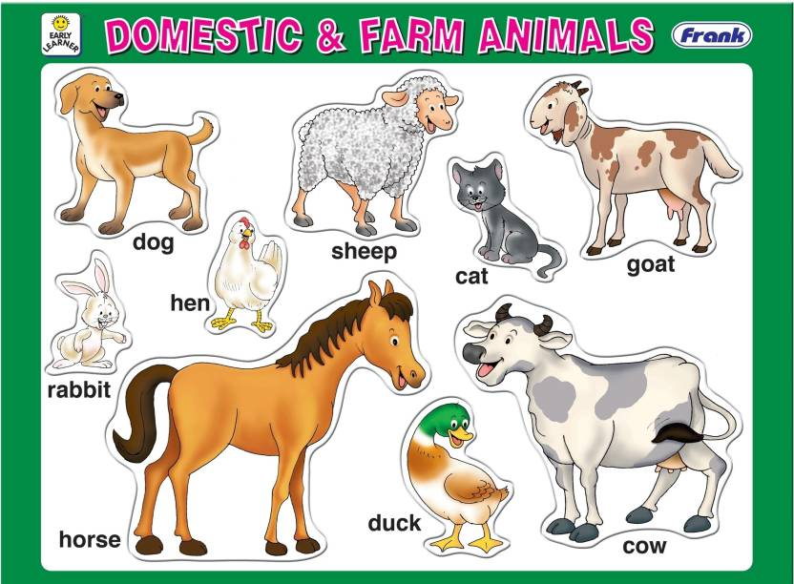

**Stars of August Month**

****

1. Niharika Bajoriya

2. Vaishnavi Tomar

3. Parash Mangroniya

****GREENWOOD PUBLIC SCHOOL, ADITYAPURAM**

**OUR MOTTO - DEVELOPMENT WITH DELIGHT**

**SYLLABUS FOR THE MONTH OF SEPTEMBER(2019-20)**

**CLASS-L.K.G**

|  |  |  |  |
| --- | --- | --- | --- |
| **SUBJECTS** |  | **ACTIVITY+USE OF ICT** | **PARENTS INVOLVEMENT** |
| **English** | **Oral:-Rhymes-** Tick-Tock- Tick-Tock, The Sun  **Reading –**Alphabet sounds- H-M  **Written:** Small cursive letters (m-s), Write the correct letter for each picture, Circle the objects that begin with the letter ‘m’, Match the pictures with letters, Dictation.  **Vocabulary Building:** Classroom, table, teacher, chair, bench. | **C:\Users\123\Desktop\images\45092984-stock-vector-happy-school-kids-with-alphabet-blocks.jpg** | **Help your child in learning rhymes and written work** |
| **Hindi** | **मौखिक**: **कविताएँ –** एक कौआ प्यासा, छोटी बच्ची और खिलौने  **पठन- पाठन**- व्यंजन वर्ण – प से o rd और १ से १० तक हिंदी की गिनती  **Written**: व्यंजन वर्ण - प से o rd जोड़ी बनाएं चित्र पहचानdj उसका पहला अक्षर लिखें १ से १० तक हिंदी की गिनती , श्रुतलेख ! | **C:\Users\123\Desktop\images\images.jpg** | dfork,sa ;kndjok,WarFkko.kksaZ dh igpkufp=ksa +}kjkdjok,W! |
| **Maths** | **Oral :** Counting 1-100, table of 2 and 3 number names 1-10, Group activity ( unit-1) fantastic maths.  **Written :**Counting 1- 100, Table of 3 number names 1-5, Dictation what comes before, after and in between unit -1 page no 15-19. | **C:\Users\123\Desktop\images\download (1).jpg** | **Motivate your child in counting objects and learning tables.** |
| **G.K. Oral** | Oral- Colours and shapes describing words | **C:\Users\123\Desktop\images\800px_COLOURBOX20120355.jpgC:\Users\123\Desktop\images\download (4).jpg** | **Visit a park with your child and show different types of flowers** |
| **Drawing** | Page no 8 and 9 (Rocket and sunflower) |  |  |
| **Music / Dance** | National Anthem + Welcome song + Dance |  |  |
| **V.E.** | Don’t hurt anyone |  | **Motivate your child to help others** |
| **Physical Education** | Athletic Events / Fun Games |  | **Take your child for a nature walk.** |
| **Language Development** | Have a bath daily, wear clean clothes, wash your hands before and after meal, Brush your teeth twice a day. Keep your nails trimmed. |  |  |
| **Conversation** | **English Conversation**  **Q.1 When do we celebrate teachers day?**  Ans- 5th September  **Q.2 When do we celebrate Hindi Diwas?**  **Ans-** We celebrate Hindi Diwas on 14th September.  **Q.3Who was Dr. SarvepalliRadhakrishna?**  Ans- He was the 2nd President of India. | **Hindi Conversation**  **प्र1: शिक्षक दिवस कब मनाया जाता है?**  **उत्तर-**शिक्षक दिवस ५ सितम्बर को मनाया जाता है !  **प्र2: हिंदी दिवस कब मनाया जाता है?**  **उत्तर -** हिंदी दिवस १४ सितम्बर को मनाया जाता है !  **प्र3: हमारे देश के दूसरे राष्ट्रपति का क्या नाम था?**  **उत्तर** हमारे देश के दूसरे राष्ट्रपति का नाम डॉ. सर्व पल्ली राधा कृष्ण नथा ! |  |

**पेड़**

पेड़ फूल फल देते हमको

धूप लगे तो छाँव

इनके कारण साफ हवा है

हरा भरा है गाँव

ये देते हमको लकड़ी रखना इनका ध्यान

पेड़ लगाना मत पहुंचना

तुम इनको नुकसान

**Stars of August Month (LKG-B)**

1. Aman Rajak

2. Aryan Singh Gurjar

3. Abhay Bhadoriya

**Stars of August Month (LKG-A)**

1. Anavi Rajawat

2. Anup Solanki

3. Dev Solanki

****GREENWOOD PUBLIC SCHOOL, ADITYAPURAM**

**OUR MOTTO - DEVELOPMENT WITH DELIGHT**

**SYLLABUS FOR THE MONTH OF SEPTEMBER(2019-20)**

**CLASS-U.K.G**

|  |  |  |  |
| --- | --- | --- | --- |
| **SUBJECTS** |  | **ACTIVITY+USE OF ICT** | **PARENTS INVOLVEMENT** |
| **English** | **Oral:-Rhymes-** I have a tooth brush and Incy Wincy spider, opposites.  **Reading –**Page no – 14 to 18  **Written:** Chapter – 19 to 26, words with ‘ck’ sound, use of ‘this and that’ use of ‘it’ use of ‘that and those’ use of ‘this and these’ use of ‘what is this’, ‘what is that’ use of is this, is that and yes. Workbook – Page no – 09 to 16.  **Vocabulary Building:** Class – room, Chalk, Library, office. | **C:\Users\123\Desktop\images\45092984-stock-vector-happy-school-kids-with-alphabet-blocks.jpg** | **Help your child in learning rhymes and written work** |
| **Hindi** | **मौखिक**: **कविताएँ –** आज मंगलवारहै एवं वर्षा रानी  **पठन- पाठन**- पेज न. 17 से 25 !  **Written**: पाठ 10 से12 - ऋ , ए , ऐ की मात्रा, प्रश्न / उत्तर चित्र देखकर नाम लिखिए , मात्राएं लगाकर सही शब्द बनाइये !  **Workbook-** पेज न. 7 से 10 | **C:\Users\123\Desktop\images\images.jpg** | dfork,sa ;kndjok,WarFkko.kksaZ dh igpkufp=ksa +}kjkdjok,W! |
| **Maths** | **Oral :** Counting 200-300, table of 6 and 7 number , shapes.  **Written :** Numbers names 31-50, tables of 6 and 7, shapes, put the sign ( > < =) and counting from 151 – 300.  **Workbook-** Page no – 15 to 20 | **C:\Users\123\Desktop\images\download (1).jpg** | **Motivate your child in counting objects and learning tables.** |
| **E.V.S** | **Oral –** Living and Non- Living things and our helpers.  **Written** – Chapter – 5 to 7 means of transport, Our earth, Plants and Parts of plants. |  |  |
| **G.K. Oral** | **Oral**- Birds names, sea animals and festivals. | **C:\Users\123\Desktop\images\800px_COLOURBOX20120355.jpgC:\Users\123\Desktop\images\download (4).jpg** | **Visit Zoo with your child and show different types of animals.** |
| **Drawing** | Page no 11 to 14 |  |  |
| **Music / Dance** | Hello song , If you are happy you know / Western song |  |  |
| **V.E.** | Share your things. |  | **Motivate your child to help others** |
| **Physical Education** | Fun games |  | **Take your child for a nature walk.** |
| **Language Development** | Have a bath daily, wear clean clothes, wash your hands before and after meal, Brush your teeth twice a day. Keep your nails trimmed. |  |  |
| **Conversation**  **Stars of August Month (UKG-A)**  1. Nitin Kumar  2. Kush Pachori  3. Devraj Gurjar  4.Bhawana Bhadouriya | **English Conversation**  **Q.1 Why do we celebrate Ganesh Chaturthi?**  Ans- Lord Ganesha’s birthday is celebrated as Ganesh Chaturthi.  **Q.2 Who is the mother of Shri Ganesha?**  **Ans-** Goddess Parwati is the mother of Shri Ganesha.  **Q.3 Why do we celebrate teachers day?**  Ans- Dr. Sarvepalli Radhakrishna birthday is celebrated as a teacher day.  **Q.4 When was he born?**  **Ans-**He was born on 5th September 1888.  **Stars of August Month (UKG-B)**  1. Amrita Gurjar  2. Ananya Gurjar  3. Aman Gurjar  4.Shubham Singh | **Hindi Conversation**  **प्र1: गणेश चतुर्थी का त्यौहार कब मनाया जाता है?**  **उत्तर-**गणेश चतुर्थी का त्यौहार भादों मास की चतुर्थी को मनाया जाताहै !  **प्र2:डॉ. सर्व पल्ली राधा कृष्णन के जन्मदिन को किस रूप मे मनाया जाताहै?**  **उत्तर -** शिक्षक दिवस के रूप मे  **प्र3"सोने की चिड़िया " किस देश को कहा जाता है?**  **उत्तर** भारत देश को  **प्र4डॉ. सर्वपल्लीराधा कृष्णन का जन्म कब हुआ था?**  **उत्तर:**5 सितम्बर1988 |  |

**शिक्षक**

माँ मेरी पहली शिक्षक

चलना उसने ही सिखलाया

माँ बेजुबा नही रोता था

माँ कहना उसने सिखलाया

उसकी उँगलियों को थामकर

मैं विद्यालय तक आया

माँ मेरी पहली शिक्षक है उसने सब कुछ बतलाया !

**Stars of August Month (UKG-C)**

1. Ranveer Singh Rajawat

2. Dev Sharma

3. Mahi Sikarwar

4.Nitya Pandey

**My School**

I love my school

It’s a big knowledge pool

Pool , pool , pool

I love my school

Here I meet my friend so cool

Cool , cool , cool

I love my school

We follow every rule

Rule , rule , rule

I love my school , school , school