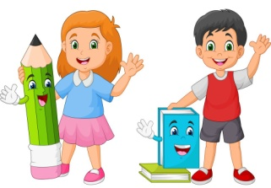
GREENWOOD PUBLIC SCHOOL, ADITYAPURAM
OUR MOTTO - DEVELOPMENT WITH DELIGHT
SYLLABUS FOR THE MONTH OF NOVEMBER (2020-21)
CLASS-NURSERY
SUBJECTS
English | Oral : Rhymes:- Mummy and Daddy ,Early to bed.  Written :Capital Letters (V,W,X,Y,Z) , write the first letter of the picture, missing letter, circle the odd letter.  Recognization:- V – Z  Workbook : 31 – 35
Hindi | Oral : कवितायेँ - मच्छरदानी ,पंखा  Written : स्वर - अ से अ: तक , जोड़ी मिलाओ , खाली स्थान भरें , चित्र देखकर पहला अक्षर लिखिए ,  Recognization:- अ से अ: तक ,  Workbook : Page no 36-40
Maths | Oral :Counting 31-40 , Revision of 1-20 , Spelling of three and four  Written : Counting 16-20 , Match the following, What comes before , count and write , fill the missing numbers (1-15)  Recognization:- Opposites(Long- short, Fat-Thin, Light-Dark,Good - bad, in - out, come - go)  Workbook : Page no 31-46
Drawing | Page No. (26-30)
G.K. | Five golden words(Please, Sorry, Excuse me,thank you, pardon), My family

