GREENWOOD PUBLIC SCHOOL,
ADITYAPURAM, GWALIOR

OUR MOTTO- DEVELOPMENT WITH DELIGHT
HOLIDAY ASSIGNMENT
CLASS-VI
SESSION :-2020-21

English
Write and Learn (Chapters 1$2)
Hindi
Write and Learn (Chapters 1$2)
Maths
Write and Learn Squares roots from 2-30 (Practice Chapters 1$2)
SCIENCE
Write and Learn (Chapters 1$2)

‘Sikkim or Himalayan wonderland is known for an astonishing variety of beautiful birds, animals and flowers.’ Make a collage using different types of flora and fauna of Sikkim mentioning their features in a few sentences on an A3 size sheet.
SOCIAL SCIENCE
Write and Learn (Chapters 1$2)
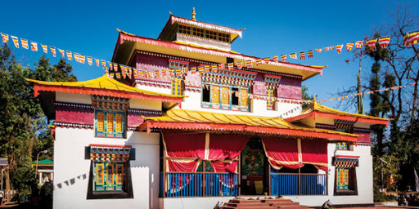
Sikkim is one of the prominent members of seven sisters in North East of India. The first monastery was established in 1701 by Chogyar Namgyal. Let us tour Sikkim by preparing a brochure (using 4 to 5, A4 size sheets) on following points :-
Monastery
Handicraft
Cuisine

General Knowledge
collect the information and prepare a report file with pictures:-
• An Octopus that resembles a Glowing Coconut
• The Elephant – Gifted with an amazing memory
• The mystery of the missing teeth in Cows!
• The beautifully Delicious photo cake
• The mixed Alphabets on the keyboard
• The Non-breathing underwater Alligator
• Flying Fish not bird
Computer
Write and Learn (Chapters 1$2)
Design a Travel Brochure using a PowerPoint Presentation illustrating the rich heritage of India.
OR
Make a formal welcome card for the new session 2021-22 in MS -WORD , using the following tabs on it-- insert , home , format, page layout etc.
Click a picture of it and send it or click a screenshot and send it
Sanskrit
- पाठ 1 और 2 याद करें|
- गीता के 10 श्लोक लिखें और याद करें|
Art & Craft
- Design a folder by drawing and colouring the given Sikkim Art borders on it.
- Make Rangoli with Leaves , Flowers Coloured Pebbles.
- Make creative designs using Thumb Printing , Hand Printing , Block Printing etc.
- Create a Bird House.
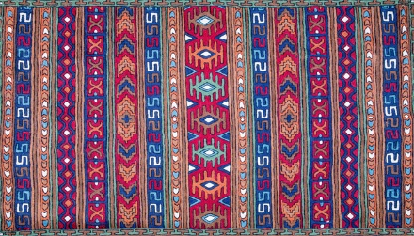

Physical Activities
- Perform yoga daily.
- Perform regular exercises.
- Listen to music, dance and meditate.
- Spend fun time with parents and other family
members.
Reduce Stress And Anxiety:
1. Listen to music, dance, exercise and meditate.
2. Share feelings and emotions with parents and other family members.
3. Spend fun time with parents and other family members.
4. Learn the devotional song Raghupati Raghav Raja Ram.
HAVE A GREAT VACATION

