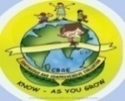
GREENWOOD PUBLIC SCHOOL, ADITYAPURAM
OUR MOTTO-DEVELOPMENT WITH DELIGHT

CLASS-IV SUBJECT- SCIENCE
Lesson - 1 (The Universe)
New words:
- Constellation
- Crust
- Mantle
- Core
- Rotation
- Revolution
- Axis
- Equator
- Hemisphere
- Satellite
Glossary:
- Orbit- The fixed path in which planets revolve around the sun.
- Equator- An imaginary line that divides the earth into two equal halves- the northern hemisphere and the southern hemisphere.
- Axis- An imaginary line running from the north pole to the south pole.
Short Answers:
Q.1 What is a satellite? Name earth’s satellite.
Answer: A satellite is an object in space which revolves around a planet. Moon is earth’s satellite.
Q.2 What is the difference between rotation and revolution?
Answer:
Rotation  1.Earth spins on it’s axis. This movement of the earth is called rotation.  2. Rotation of the earth causes days and nights. | Revolution  - Earth moves around the sun. This movement of the earth is called revolution.  - Revolution of the earth causes seasons.

Q.3 Name any two constellations?
Answer:
- Pisces- The fishes.
- Aries- The Ram.
Q.4 What is core?
Answer: Core is the hottest part of the earth. It consists of molten metals.
Long Answers:
Q.1 Name the Planets of the solar system in order?
Answer: The eight planets of the solar system are-
Mercury, Venus, Earth, Mars, Jupiter, Saturn, Uranus and Neptune.
Q.2 What is constellation?
Answer: Constellation is a group of stars visible within a particular region of the night sky.
Q.3 What causes formation of days and nights?
Answer: The earth rotates on it’s axis . The rotation of the earth causes days and nights.
Q.4 What causes change in seasons?
Answer: Change in seasons is because of the earth’s axis which is tilted at 23.5 degrees.
Diagrams
- Solar System:

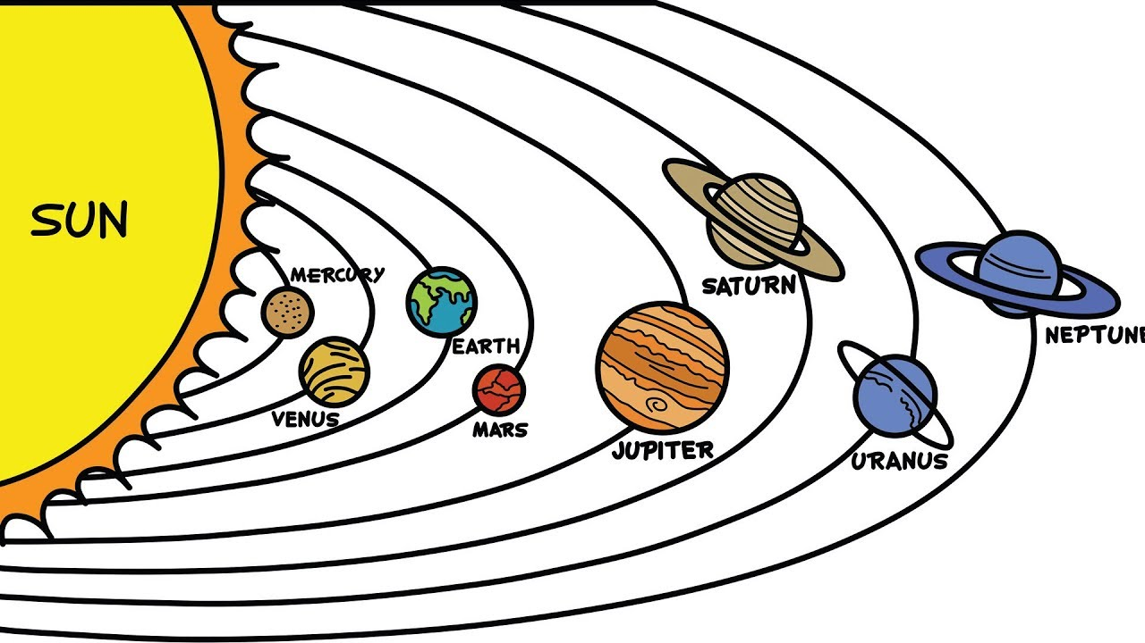
- The layers of the earth:
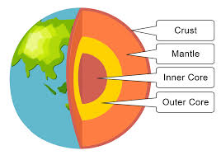
Lesson - 2 Life on the Earth
New words:
- Atmosphere
- Stomata
- Photosynthesis
- Ecological
- Chlorophyll
- Producers
- Consumers
- Herbivores
- Carnivores
- Ecosystem
Glossary:
- Atmosphere- The layers of gases surrounding the earth.
- Herbivores- Animals which feed on plants.
- Stomata- Tiny holes or pores found on the leaf surface.
Short Answers:
Q.1 Why do we need oxygen in breathing?
Answer: We need oxygen in breathing because oxygen burns the food to produce energy.
Q.2 What is the importance of sunlight?
Answer: Sunlight provides warmth to us. Green plants need sunlight to prepare their food.
Q.3 How are all living things dependent on one another?
Answer: The herbivores would not survive without the plants and carnivores would not survive without herbivores. Thus all living things are dependent on one another.
Q.4 Who are producers?
Answer: Green plants prepare food for all living things. So they are called producers.
Long Answers:
Q.1 Name the things which are necessary for life to exist on the earth?
Answer: The things which are necessary for life to exist on the earth are air, water, light, minerals and warmth.
Q.2 What things do plants need to make their food?
Answer: Plants need sunlight, water, carbon dioxide and chlorophyll to make their food.
Q.3 Name some important minerals?
Answer: Some important minerals needed by our body are iron, calcium, phosphorous and iodine.
Q.4 State three uses of water?
Answer: We use water for drinking, cooking, growth of the plants etc.

Diagram
- Photosynthesis:
