GREENWOOD PUBLIC SCHOOL, ADITYAPURAM
OUR MOTTO-DEVELOPMENT WITH DELIGHT

CLASS-III SUBJECT- E.V.S
Chapter- 1
The Family
New Words
- Adopted
- Homemakers
- Functions
- Members
- Nuclear family
- Photograph
- Picnics
- Relationship
- Cousins
- Together
GLOSSARY
- Family:- a group of people living together.
- Adopted:- taking someone/something as our own
- Generation:- people in the family who were born around the same time
- Tradition:- something that people in a certain place have done or believed for a long time
- Resemblance:- looking similar to somebody

QUESTION/ANSWER

Q1. What is family?
Ans. A family is a group of people who are related to each other.
Q2. How is a joint family different from a nuclear family?
Ans.
Joint Family | Nuclear Family
Joint families are larger than nuclear families | nuclear families consists of parents and their children only
It is an extended family | It is an elementary family
Q3.How can a family spend time together?
Ans. A family can spend time together by playing games, watching T.V. They also enjoy picnics and attend family functions together

ACTIVITY
- Draw a family tree.

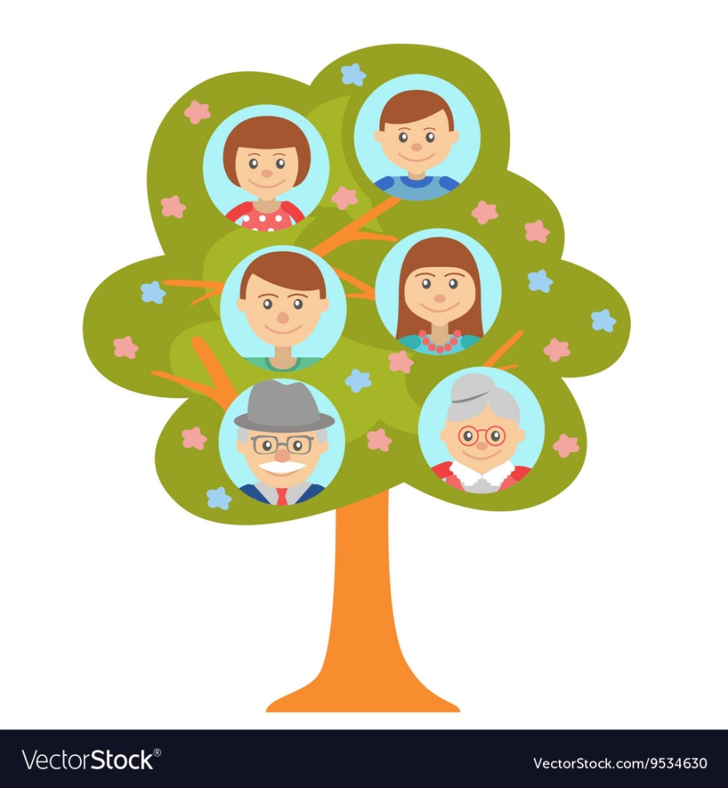

Chapter-2
PARTS OF OUR BODY

NEW WORDS
- External
- Limbs
- Hooves
- Paws
- Trunk
- Thirsty
- Abdomen
- Shapeless
- Muscles
- Leopard
GLOSSARY
- External parts: the parts of body which can be seen are called external body parts.
- Internal body parts: the parts of our body which cannot be seen are called internal body parts.
- Hooves: the feet of animals like cows and goats are called hooves.
- Paws: the feet of animals like cats and leopards

QUESTION/ANSWER

Q1. Name the external parts of the body.
Ans. The external parts of our body are:
Head,neck,arms,legs,chest and abdomen.

Q2. What are limbs?
Ans. Arms and legs together are called limbs.

Q3. How do our limbs help us?
Ans. Our limbs help us to do several things- we can do different actions, move from one place to another, hold things and move them etc.

Q4. How do fish swim?
Ans. Fish have fins and tails instead of arms and legs. They swim with the help of their fins and tails.

Q5. What is the difference between hooves and paws?
Ans.
hooves | paws
The feet of animals like cows and goats are called hooves. | The feet of animals like cats and leopards are called paws.
Hooves are hard | Paws are soft

ACTIVITY
Draw and label parts of arms and legs

