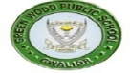
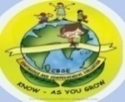
GREENWOOD PUBLIC SCHOOL, ADITYAPURAM
OUR MOTTO-DEVELOPMENT WITH DELIGHT

CLASS-III SUBJECT- E.V.S
TERM-1 SYLLABUS
Chapter-3
OUR SENSE ORGANS
New words
- Organs
- Spectacles
- Pleasant
- Listening
- Responds
- Tongue
- Brain
- Taste buds
- Message
- Controlled
Glossary
- Taste buds:- one of the small structure on the tongue that allows us to recognize the flavour of food and drink.
- Fragrance:- pleasant smell.
- Spectacles:- a thing that we use to see properly.

Question/Answers
- Name the five sense organs of our body?
Ans:- Five sense organs are: Eyes, ears, nose, tongue, skin.

- How does the brain help the sense organs?
Ans. All the sense organs send the message to the brain and then THE brain identifies what we are smelling ,testing etc.
- What we are looking
- Smell
- Taste etc.
- Functions of sense organs and brain.
Ans. Functions of sense organs:
Eyes | Help us to see the things
Tongue | Allows us to taste
Ears | Help us to hear every sound
Skin | Helps us to feel
Nose | Helps us to smell

Functions of brain:
- It controls our thoughts, memory, speed, and movements of arms and legs
- It allows us to think and feel
ACTIVITY
Draw eyes, nose, ear, tongue, and brain
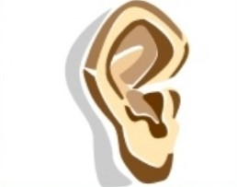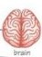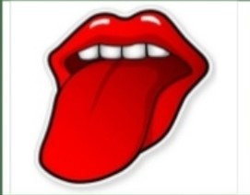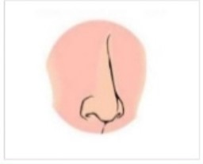
Chapter-4
Taking care of our body
New Words
- Germs
- Illness
- Healthy
- Bathing
- Regularly
- Fingernails
- cavities
- exercise
- plenty
- dangerous
Glossary
- germs:- germs are very small living things that cause diseases
- cavity:- a decayed part of tooth
- plaque:- a soft and sticky film that covers teeth and contains bacteria
- decay:- decompose through the action of bacteria
- junk food:-food that is not healthy as it has too much sugar and fat

Question/answers
Q1. What are germs?
Ans. Germs are very small living things that live and grow in dirt.
Q2. How can we keep our body clean?
Ans. We can keep our body clean in the following ways:
- By taking a bathe daily.
- We should wash our hands with soap and water before and after eating.
- Brush our teeth twice a day.
- Wear clean clothes.
- Drink plenty of clean water.
Q3. What happens when germs attack the teeth?
Ans. Tooth decay occurs when germs attack on the teeth.
Q4. Why should we wash our hands before we eat?
Ans. We should wash our hands before eating to remove germs and bacteria from our hands
Q5. How can you keep germs away?
Ans. Keeping our body clean helps us to stay away from germs and to stay healthy

Chapter-5
Bhupen’s best friend
New words
- movement
- guiding
- crowded
- wondering
- Braille
- Accident
- Injury
- Alphabet
- Fingertips
- Combination
Glossary
- Visually impaired: those who cannot see partially or at all
- Donate: give something to people who need it
- White cane: a device or stick used by blind people
Question/answers
Q1. What is Braille?
Ans. Braille is a system of reading and writing made for people who cannot see.
Q2. Who was Louis Braille?
Ans. Louis Braille was a French educator and inventor of a system of reading and writing ‘braille’for blind people
Q3. How was Bhupen different from other children?
Ans. Bhupen was different from others because he could not see. He was blind.
Chapter 6
Plants- our green friend
New words
- Botanical
- Fibre
- Bringing
- Medicines
- Construct
- Branches
- Climbers
- Creepers
- Chlorophyll
- Photosynthesis
Glossary
- Photosynthesis:- process by which plants make their food.
- Chlorophyll:- a pigment that gives green colour.
- Stomata:- small holes in the surface of leaves.
- Erect:- in an upright position.
- Sapling:- a young plant.
- Plough:- to dig and turn over soil.
Question/answers
Q1. How do plants make their food?
Ans. Plants make their food in the presence of sunlight, air, and water vapour through photosynthesis.
Q2. Mention four uses of leaves?
Ans. Leaves are used for:-
- Oxygen production
- Source of medicine
- Food production
- Provide fibre.
Q3. Name two common herbs used in India.
Ans. Common herbs used in India are :-
- Mint
- Coriander
Q4. Differentiate between shrubs and herbs.
Shrubs | Herbs
Shrubs are smaller trees | Herbs are smaller plants
They have hard, woody and thin stems | They have soft, green stems
Example: rose, cotton etc. | Mint, coriander etc.

ACTIVITY
Parts of a plant

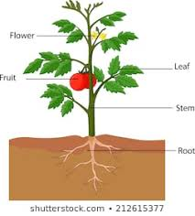

Chapter-7
The animal world
New words
- animals
- Domestic
- Grizzly
- Herbivores
- Carnivores
- Omnivores
- Sanctuaries
- Pets
- Insects
- National parks
Glossary
- Domesticate:- to tame an animal.
- Sanctuary:- protection or a safe place.
- Herbivores:- animals that eat only grass and plants.
- Carnivores:- animals that eat meat.
- Omnivores:- animals that eat both plants and meat.
Question/answers
Q1. Name two very big animals and two very small animals.
Ans. Whale and giraffe are very big animals.
Ant and ladybug are small animals.
Q2. What are domestic animals? Give two examples.
Ans. Animals like cows, buffaloes who are useful to mankind are known as domestic animals.
Q3. Differentiate between herbivores and carnivores.
Ans.
Herbivores | Carnivores
Animals that eat plants | Animals that eat meat
These animals usually have flat teeth so that they can crush and mash the plants. | These animals have sharp teeth and fangs to pull apart the meat
Example: cow, buffaloes etc. | Lion, tiger etc.

Q4. Why animals move around?
Ans. Animals move around in search of food and shelter.
ACTIVITY
Name the animals in the given category.
herbivores | carnivores | Omnivores
Cow | Lion | Bear
Buffaloes | Tiger | Pig
Goat | Snake | Mice
horse | leopard | rat

Chapter-8
Birds talk
New words
- Feather
- Twings
- Flight
- Beaks
- Hooked
- Woodpeckers
- Sparrow
- Vulture
- Pigeon
- Weaver
Glossary
- Feather:- one of the light, soft things that grows in the birds and cover its body.
- Beak:- the hard pointed part of a bird’s mouth.
- Hooked:- shaped like a hook.
Question/answers
Q1. Name a bird that eats dead animals.
Ans. Birds that eat dead animals are- eagle, vulture, crow etc.
Q2.name the tree types of feathers.
Ans. The three types of feathers are-
- Down feathers
- Flight feathers
- Body feathers
Q4. How do feathers help birds?
Ans. Feathers help to keep the birds body warm and cover their body.
Q5. Why do sparrows have short, strong and pointed beaks?
Ans. Sparrows have short, strong and pointed beaks to eat seeds and nuts. Their beaks help them to break and crush seeds.
ACTIVITY
Writ sounds of birds
birds | Sounds
owl | Hoot! Hoot!
pigeon | Gutar guun
Crow | Caw caw

Chapter-9
Work people do
New words
- Whispered
- Conductor
- Photographer
- Traffic
- Cobbler
- Hairdresser
- Electrician
- Mechanic
- Carpenter
- Neighbourhood
Glossary
- Skill:- a particular ability.
- Manual labour:- physical work.
- Occupation:- the work a person does in order to earn money.
Question/answers
Q1. Name at least five different kinds of work people do which are mentioned in the lesson.
Ans. The five different kinds of work are:
- Policeman
- Photographer
- Fireman
- Cleaners
- Hairdresser
Q2. Where do these people work?
- Doctor (b) baker (c) teacher (d) pilot
Ans:
- doctor- hospital
- baker- bakery
- teacher- school
- pilot- airport
ACTIVITY
List the different jobs that people do-
- doctor- a doctor treats people who are ill.
- Plumber- fixes leaking pipes and taps.
- Tailor- stitches clothes.
- Carpenter- makes furniture.

