GREENWOOD PUBLIC SCHOOL, ADITYAPURAM
OUR MOTTO-DEVELOPMENT WITH DELIGHT
CLASS-I SUBJECT- ENGLISH
TERM-1 SYLLABUS
LESSON-3
MAKING NEW FRIENDS
DIFFICULT WORDS
- Friends 11. Plants
- Slide 12. Grandmother
- Swing 13. Grandfather
- Worms 14. Grains
- Scare 15. Gentle
- Pretty
- Flowers
- Honey
- Pluck
- Bus
WORD MEANINGS
- Pretty- Attractive
- Scare- Afraid, frightened
- Pluck- To remove
- Feed- To give food
- Gentle- Kind , calm
FRAME SENTENCES
- Pluck- We should not pluck flowers.
- Flower- Rose is a beautiful flower.
- Friend- Sumit is my best friend.
OPPOSITES
- New - Old
- With - Without
- Above – Under
- Give - Take
- Pretty – Ugly
QUESTION/ ANSWER
Q1. Where were Arush and Kina?
ANS. Arush and Kina were in the playground.
Q2. Who feed grains to the birds?
ANS. Grandfather feeds grains to the birds.
Q3. Who wants to pluck a flower?
ANS. Kina wants to pluck a flower.
Q4. Who helps Arush to climb up the ladder?
ANS. Grandfather helps him to climb up the ladder.
Q5. Who pushes the swing?
ANS. Grandmother pushes the swing.

ACTIVITY
Q1. Which is your favourite game?
ANS. My favourite game is______________
Q2. Who is your favourite player?
ANS. My favourite player is_____________
Q3. Write the names of indoor game.
ANS. Carrom, chess, ludo, scrabble and playing cards.
Q4. Write the names of outdoor games.
ANS. Cricket, hockey, badminton, football and tennis.

LESSON-4
LET US HAVE LUNCH

DIFFICULT WORDS

- Lunch 11. Fruits
- Wash 12. Rings
- Spread 13. Yummy
- Napkins 14. School
- Butter 15. Noodles
- Sandwich
- Muffins
- Lemon
- Desk
- Playground
WORD MEANINGS
- Lunch- Mid day meal
- Shut- To close
- Fold- To bend
- Spread- Lay
- Muffins- A type of small cake

FRAME SENTENCES
- Playground- We play in the playground.
- Again- The bell rings again.
- Shut- The teacher shut the door.
- Open- He opened the door.
- Wash- We should wash our hands before eating.

OPPOSITES
- Before - After
- Shut - Open
- In - Out
- Go - Come
- Fold - Unfold

QUESTION/ANSWER
Q1. What should we do before eating the lunch?
ANS. We should wash our hands before eating the lunch.
Q2. Who has lemon rice?
ANS. Deepti has lemon rice.
Q3. What do you usually bring to school for lunch?
ANS. We bring different types of snacks, vegetables in our lunch.
Q4. Write the names of five fruits that you usually bring in your lunch box?
ANS. Apple, Banana, Grapes, Orange and Papaya.
ACTIVITY

List a few healthy food items and paste their pictures.
Milk
Fruits
Pulses
Vegetables
Eggs

LESSON-5
THE RABBIT AND THE TURTLE
DIFFICULT WORDS
- Rabbit 11. Towards
- Turtle 12. Lifts
- Burrow 13. Around
- Floppy 14. Touch
- Sturdy 15. Tucks
- Beach
- Shell
- Wakes
- Magic
- Stone
WORD MEANINGS
- Burrow- A hole in the ground.
- Sturdy- Strong
- Tuck- To put
- Hop- A short jump.
- Beach- An area of sand
FRAME SENTENCES
- Beach – The children were playing on the beach.
- Turtle- Turtle lives in water.
- Hop- Rabbit hops up and down.
- River- Ganga is a holy river.

OPPOSITES
- Near - Far
- Like - Unlike
- Sturdy - Weak
- Sit – Stand
- Good – Bad
QUESTION/ANSWER
Q1. What was the name of the Rabbit?
ANS. The name of the Rabbit was Floppy.
Q2. Who was Sturdy?
ANS. Sturdy was a little turtle.
Q3. Who became friends at the end?
ANS. Floppy and Sturdy became friends at the end.
ACTIVITY
Animals and their houses.
- Fish Pond
- Crow Tree
- Horse Stable
- Lion Den
- Rabbit Burrow
- Spider Web
PARAGRAPH
MY MOTHER

- My mother’s name is Mrs._____________
- She takes care of my family.
- She is a house wife/ teacher.
- She is smart and intelligent.
- She cooks delicious food for us.
- She helps me with my studies.
- I love my mother a lot.
PARAGRAPH
MY SCHOOL

- The name of my school is GREENWOOD PUBLIC SCHOOL.
- It is situated at Adityapuram in Gwalior.
- It has a big playground and a library.
- It has many big and airy class rooms.
- I learn so many good things here.
- I like my school a lot.

DEFINITION OF PRONOUN

It is a word which is used in place of a noun.
Eg: I, he, her, she, it, you, we, his, her they etc.

UNDERLINE THE PRONOUN
- They are playing.
- You have a bat.
- You are a good boy.
- We like to play.
- She reads a book.

SINGULAR PLURAL
- Frog Frogs
- Star Stars
- Cat Cats
- Bush Bushes
- Box Boxes
- Well Wells
- Watch Watches
- Bench Benches
- Stick Sticks
- Fan Fans

GENDER

Masculine Feminine

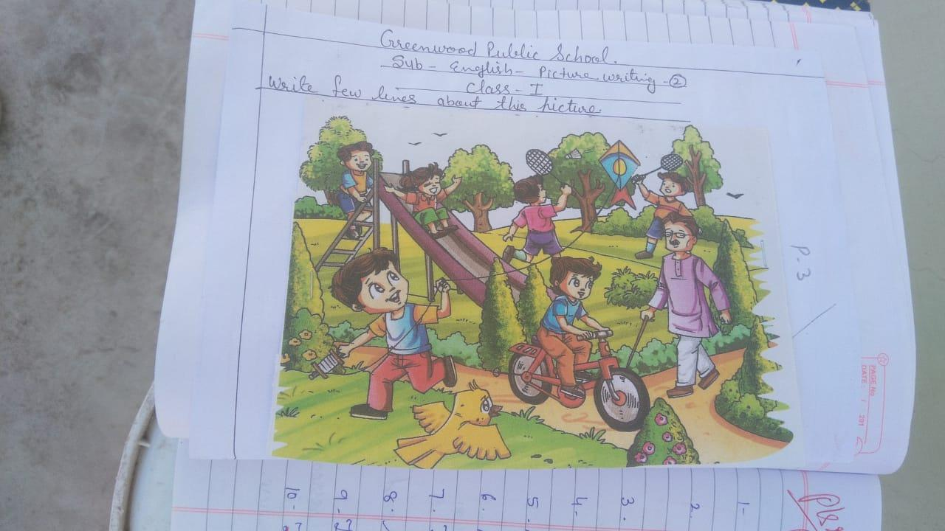
- Son Daughter
- Boy Girl
- King Queen
- Cock Hen
- Bull Cow
- Man Woman
- Uncle Aunt
- Horse Mare
- He goat She goat
- Lion Loiness

SPEAKING SKILLS
STORY: THE WISE CROW

Once upon a time. It was a hot summer day. A crow was very thirsty. He flew from one
place to another, but he could not get any water. At last he saw a big pot. There was very
little water in it. He thought of a plan. He picked up some stones and dropped them in to
the pot one by one. The water in the pot came up. He drank the water and flew away happily.
Moral: We should always use our common sense.
___________________________________________________________________
PICTURE WRITING
Write a few lines about this picture

- This is the picture of a park.
- An old man is walking in the park.
- Two boys are playing badminton.
- Two boys are sliding.
- Children are enjoying.
- There are many trees.
PICTURE WRITING
Write a few lines about this picture.

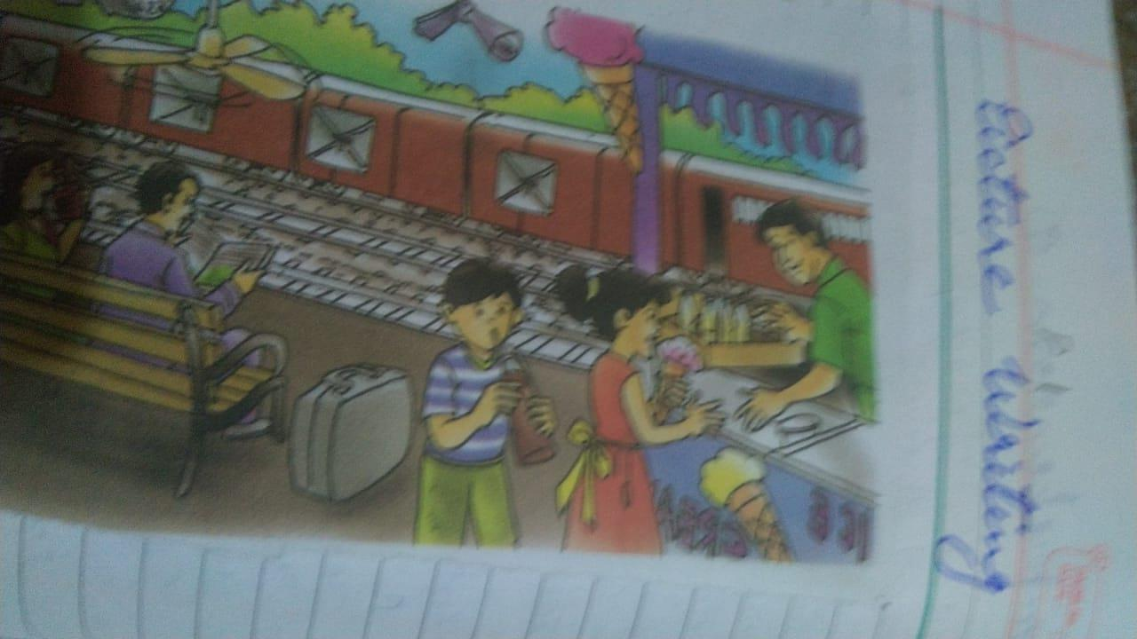

- This is a picture of railway station.
- Two people are sitting on the bench.
- The boy is enjoying coke.
- The girl is buying softy.
- People are waiting for their train.
- A train is standing on other track.

