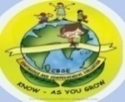
GREENWOOD PUBLIC SCHOOL, ADITYAPURAM
OUR MOTTO-DEVELOPMENT WITH DELIGHT

CLASS-I SUBJECT- E.V.S
TERM-1 SYLLABUS
CHAPTER-4
MY BODY NEEDS CARE
DIFFICULT WORDS:-
1. Clean
2. Brush
3. Drink
4. Morning
5. Untidy
6. Dirty
7. Nails
8. Hankerchief
9. Towel
10. Soap
QUESTION/ANSWERS:-
Q1. How are our body parts useful to us?
Ans. Body parts help us in a lot of ways. Skin protects us from sun, muscles help us to move, talk and breathe , skeleton gives body a shape.
Q2. How can we keep our skin clean?
Ans. We must take a bath everyday to clean our skin.
Q3. What is the use of doing exercise everyday?
Ans. Exercise keeps us fit and healthy.
H.O.T.S
Q. Why do we need to keep our body clean?
Ans. We need to keep our body clean to remain healthy.
ACTIVITY
Q Write the use of the given objects.

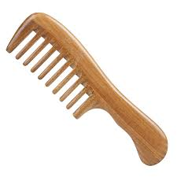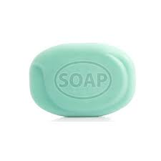
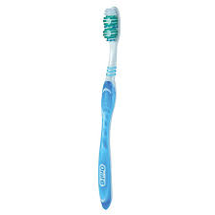
1. I use a comb to comb my hair.
2. I use a toothbrush to clean my teeth.
3. I use a soap to clean my body.

CHAPTER-5
THE FOOD WE EAT
DIFFICULT WORDS:-
1. Meals
2. Breakfast
3. Plenty
4. Energy
5. Strong
6. Fight
7. Diseases
8. Healthy
9. Pulses
10. Grow
QUESTION/ANSWERS:-
Q1. Name the three main meals that we have in a day?
Ans. The three main meals are:-
1. Breakfast
2. Lunch
3. Dinner
Q2. Write three types of food that we eat.
Ans. 1. Energy giving foods.
2. Body building foods.
3. Protective foods.
Q3. Write two good eating habits that we should learn.
Ans. 1.We should wash our hands before and after every meal.
2. We should chew our food properly.
NAME THE FOLLOWING:-
1. Two food items that help us to grow.
Ans. Milk , Pulses.
2. Two food items that give us energy.
Ans. Chapati, Sugar.
3. Two food items that keep us healthy.
Ans. Fruits , Vegetables.
H.O.T.S
Q1. What would happen if we do not take breakfast?
Ans If we don’t take breakfast, we will feel weak.
ACTIVITY
Q Draw three fruits and vegetables you like to eat and write their
names.
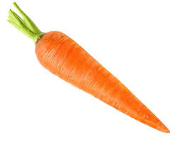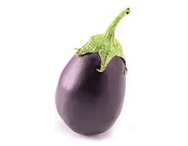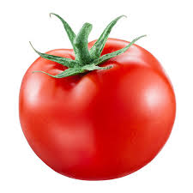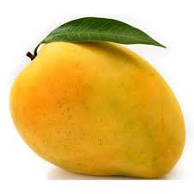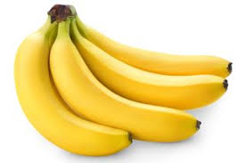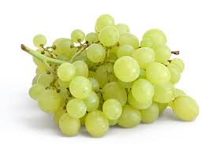
GRAPES
BANANA
MANGO
TOMATO
BRINJAL
CARROT

Chapter-6
The Clothes We Wear
Difficult Words:-
1. Wear
2. Protect
3. Warm
4. Umbrellas
5. Carry
6. Sweater
7. Thunder
8. Through
9. Woollen
10. Cotton
Question/Answers:-
Q1. Why do we wear clothes?
Ans. We wear clothes to cover our body.
Q2. What type of clothes do we wear in summer?
Ans. We wear cotton clothes in summer to keep our
body cool.
Q3. Why do we wear woollen clothes in winter?
Ans. We wear woollen clothes in winter to keep our
Body warm.
H.O.T.S
Q. From which insect do we get silk?
Ans. We get silk from silkworms.
ACTIVITY
Q. Paste different types of clothes.
COTTON
WOOL

SILK

Chapter-7
My Family
Difficult Words:-
1. Family
2. Joint
3. Nuclear
4. Care
5. Cousin
6. Bring
7. Parents
8. Shows
9. Different
10. Kinds
Question/Answers
Q1. What is a nuclear family?
Ans. A nuclear family is a small family with only parents and children.
Q2. What is a joint family?
Ans. A joint family is a big family.
Q3. Two things that your family does for you.
Ans. 1. My family provides food and clothes.
2. My family makes me feel safe and secure.
H.O.T.S
Q. Name two types of families.
Ans. 1. Nuclear family
2. Joint family
Subject Enrichment
Activity
Q. Draw a family tree
