GREENWOOD PUBLIC SCHOOL, ADITYAPURAM
OUR MOTTO-DEVELOPMENT WITH DELIGHT

CLASS-VIII SUBJECT- SCIENCE
TERM-1 SYLLABUS CHEMISTRY

CHAPTER-2

Materials : Metals and Non-metals

1. Metals:
Those materials which possess the characteristic of being hard, shiny, malleable, fusible, ductile, etc. are termed as metal. Few examples of metals are iron, gold, silver, Aluminium, copper, etc.
Physical Properties of Metals:
(a) Malleability: It is that property of metals which allows them to be beaten into the thin sheets. Due to presence of this property, the shape of iron nail and aluminium wire can be changed on beating. The silver foils used for decorating sweets and the aluminium foil used for wrapping food are possible because of malleability property of metals.
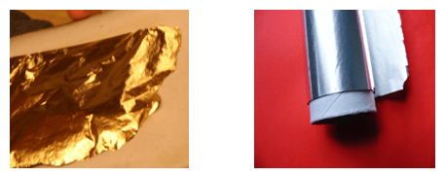
(b) Conductivity:
It is that property of metals which allows the current and heat to pass through them easily.
Example- Metals like iron rod, nail, copper wire, etc. are good conductors of electricity.
(c) Ductility It is that property of metals which allows them to be drawn into the wires:.
Example: Metals like aluminium and copper wires are used in electric connection.
(d) Sonorous:
It is that property of metals which produces ringing sounds on hitting. Example: Temple bells are made up of metals to produce vibrating or ringing sound.
Ringing property of Metal

(e) Lustrous:
It is that property of metals which makes them shine and their structures are capable of reflecting incident light.
Lustrous Property of Metal

Note: Metals like sodium and potassium are soft and can be cut with a knife. Mercury is the only metal which is found in liquid state at room temperature. These are exceptions
2. Non -Metals:
Those materials which do not possess the characteristics of metals are termed as non-metal. Materials like coal and sulphur are soft and dull in appearance. They break down into powdery mass on tapping with hammer. They are non-sonorous and are poor conductors of heat and electricity. Few examples of non metals are sulphur, carbon, oxygen etc.
Chemical Properties of Metals & Non-Metals:
1. Reaction with Oxygen
(a) For Metals:
Generally, when metals are reacted with oxygen they will form metallic oxides. And these metallic oxides are basic in nature.
Example-1: Rusting of Iron. Following is the reaction to express it.
Iron (Fe) + Oxygen (O₂) + Water (H₂O) → Iron Oxide (Fe₂O₃)
Example-2: If a copper vessel is left open in presence of the moist air, then, a dull green coating will be observed on it. The green material is a mixture of copper hydroxide (Cu(OH)₂) and copper carbonate (CuCO₃). Following is the reaction to express it:
2Cu + H₂O + CO₂ + O₂→Cu (OH)₂ + CuCO₃
ACTIVITY – 1 Testing of nature of Rusting:
(i) Collect a spoonful of rust and dissolve it in a very little amount of water.
(ii) The rust remains suspended in water. Shake the suspension well.
(iii) Test the solution with red and blue litmus papers. The red litmus turns blue.
So, generally metallic oxides are basic in nature.
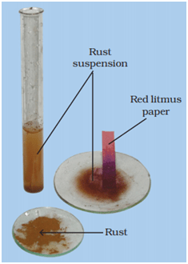Testing Nature of Rust

(b) For Non-metals:
Generally, non-metals also produce oxides when reacted with oxygen. But, in contrast to metals, these oxides are acidic in nature.
ACTIVITY – 2 Testing the nature of non metal:
(i) Take a small amount of powdered sulphur in a deflagrating spoon and then heat it.
(ii) As soon as sulphur starts burning, introduce the spoon into a gas jar/ glass tumbler.
(iii) Cover the tumbler with a lid to ensure that the gas produced does not escape.
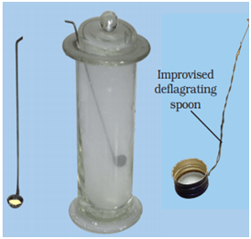
(iv) After some time remove the spoon. Add a small quantity of water into the tumbler and quickly replace the lid. Shake the tumbler well. Check the solution with red and blue litmus papers.
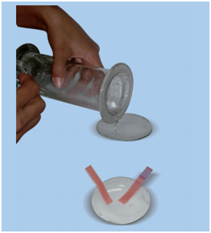

(v) The name of the product formed in the reaction of sulphur and oxygen is sulphur dioxide gas. When sulphur dioxide is dissolved in water sulphurous acid is formed. Following is the reaction to express it:
Sulphur dioxide (SO₂) + Water (H₂O) → Sulphurous acid (H₂SO₃)
(vi) The sulphurous acid turns blue litmus paper red.
Generally, oxides of non-metals are acidic in nature.
2. Reaction with Water:
(a) For Metals:
Some metals react vigorously with water like in case of sodium. It is stored in kerosene.. While, some metals reacts very slowly with water like in case of iron.
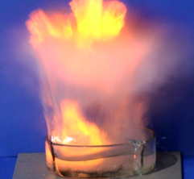
Reaction of Sodium with Water

(b) For Non-metals:
Generally, most non-metals do not react with water but there are some non-metals which are quite reactive in air like phosphorous, which is very reactive and is kept in water to prevent explosion.
3. Reaction with Acids:
(a) For Metals:
Generally, a metal reacts with acids and releases hydrogen gas with a ‘pop’ sound.
The presence of hydrogen gas is confirmed by bringing a burning matchstick or candle near the gas. And when the burning matchstick or candle produces pop sound then it means that hydrogen gas has evoloved.
It is found that, copper does not reacts with hydrochloric acid while it reacts with a sulphuric acid.
(b) For Non-metals:
Generally, non-metals do not react with acids.
4. Reaction with Bases:
(a) For Metals:
Generally, reactions of metals with bases releases hydrogen gas, like in case of many metals they react with sodium hydroxide to produce hydrogen gas.
(b) For Non-metals:
Generally, reactions of non-metals with bases are complex.
5. Displacement Reaction:
During reaction if a metal replaces another metal from its compound then such reactions are called displacement reaction.
Metals can actually be arranged as per their reactivity order, thus, a more reactive metal will always displace a less reactive metal from its compound but a less reactive one cannot replace a more reactive metal.
Example : When zinc is reacted with copper sulphate solution, then copper will be displaced by zinc as zinc is more reactive than copper. The blue colour of copper sulphate disappears and a powdery red mass of copper is deposited at the bottom of the beaker. The reaction-
Copper Sulphate (CuSO₄) + Zinc (Zn) → Zinc Sulphate (ZnSO₄) + Copper (Cu)
Applications of Metals:
(i) Metals are generally used in making of machines, automobiles, airplanes, cars, satellites, etc.
(ii) Some metals are used in making wires like copper, etc.
(iii) Some metals are used for making ornaments like gold, silver, etc.
Applications of Non - Metals:
(i) The oxygen necessary for all living beings to survive is a non-metal.
(ii) Some non-metals are used as fertilizers to enhance the growth of plants.
(iii) Some non-metals are used for water-purification.
(iv) Some non-metals are used as antiseptic.
(v) Non-metals used in crackers.

CH APTER– 3 (COAL AND PETROLEUM)
Natural Resources:
The resources which are obtained from nature, are called as natural resources.
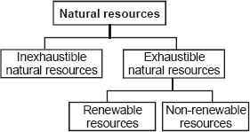
Types of Natural Resources:
(i) Inexhaustible Natural Resources
(ii) Exhaustible Natural Resources
1. Inexhaustible natural resources:
The resources which are available in large quantities in nature and will not be depleted even after continuous usage are known as Inexhaustible natural resources.
Examples are sunlight, water, wind, etc
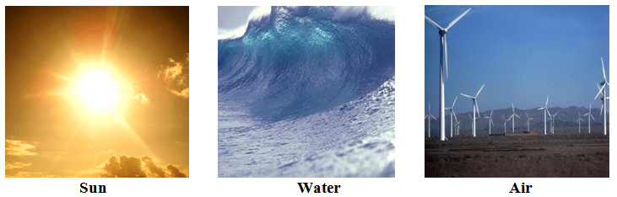
2. Exhaustible Natural Resources:
The resources which are available in limited quantities in nature and will get depleted after continuous usage, are known as Exhaustible natural resources.
Examples are forests, coal, natural gas, etc.
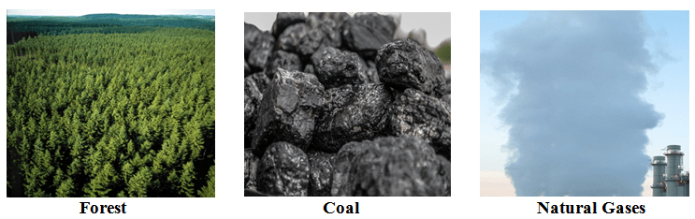
Fossil Fuels:
Some of the exhaustible natural resources like coal, petroleum, etc. are formed from dead remains of the living organisms. These kinds of resources are known as fossil fuels.
1. Coal: Coal is a complex mixture of carbon, hydrogen and oxygen compounds. me nitrogen, sulphur and phosphorus compounds are also present in it. It is found in coal mines deep under the surface of earth. Story of formation : It is believed that millions of years ago, the ground below the forests was split open by natural forces such as earthquakes and volcanoes. The forests got buried under the surface of earth. Thus, the plants had no contact with oxygen. Successive layers of sediments sealed the buried plants. Over millions of year, these deposits were subjected to tremendous pressure and heat finally transformed them into coal. 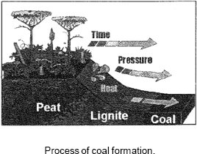
The different varieties of coal are as follows (1) Peat (2) Lignite (3) Bituminous coal (4) Anthracite coal
Peat: It is the youngest variety of coal which is light brown in colour. It contains minimum carbon content and produces less heat and more smoke on burning. Its calorific value is 10 to 15 kJ/g.
Lignite: It is known as soft coal. It is also brown in colour and contains more carbon than peat. Its calorific value is 15 to 20 kJ/g.
Bituminous coal: It is the common household coal. It is the most abundant f and Is compact, black, contains more carbon and produces more heat than peat and lignite. Its calorific value is 30 to 35 kJ/g.
Anthracite coal: It is the hardest coal containing maximum carbon. T+ burns with difficulty due to presence of very low volatile matter. Therefore it is not used for household purposes, it is mainly used for industrial purposes. Its calorific value is 28 to 30 kJ/g.

Carbonisation: The chemical process involved in the transformation of punt matter into coal is called the carbonisation of plant matter.
(i) It is a hard like stone substance and black in color.
(ii) It has many uses since old times like it was used as heat source to cook food, to produce steam to run train and other engines, in thermal power plants to produce electricity etc.
Coal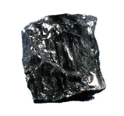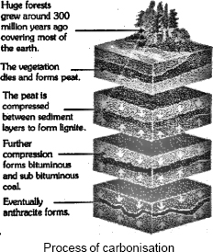

Destructive distillation of coal
The process of heating coal in the absence of air is called the destructive distillation of coal. Coal contains a number of elements such as carbon, hydrogen, oxygen, nitrogen and sulphur. When coal is heated in the absence of air, a number of products are obtained.
The main products obtained by the destructive distillation of coal are as follows:
(1) Coke (2) Coal tar (3) Coal gas

A) Coke: contains 98 % carbon. It is porous, tough, black and the purest form of coal. Like charcoal, it Is a good fuel and burns without smoke. It is largely employed as a reducing agent in the extraction of metals from their ores. It is also used in making fuel gases like water gas and producer gas.

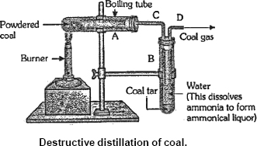
Coke
Applications: In manufacturing of steel, extraction of metals, etc.
(b) Coal Tar:
It is thick black colored liquid having foul smell. It is mixture of about 200 substances.
Coal Tar
Applications: The by-products obtained from coal tar are used in manufacturing of synthetic dyes, drugs, explosives, perfumes, etc. Interestingly, naphthalene balls used to repel moths and other insects are also obtained from coal tar.
(c) Coal Gas:
(i) It is obtained when coal is processed to obtain the coke.
(ii) Coal gas was used for street lighting for the first time in London in 1810 and in New York around 1820. Now a days, it is used as a source of heat rather than light.
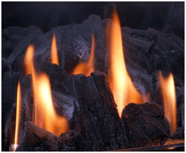

Coal Gas
Applications: It is mainly used as fuel in many industries
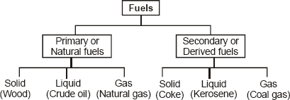
Petroleum
It is dark brownish to green coloured viscous liquid fossil fuel. It has strong foul smell due to the presence of sulphur containing compounds in it. It is commonly called as crude oil. The economy of a nation depends to a great extent on petroleum wealth, that's why petroleum is called the black gold.
Its name is derived from Latin words Petra (meaning rock) and O1eum (meaning oil). Thus, petroleum literally means "rock oil".
Origin of petroleum: Petroleum is a complex mixture of solid, liquid and seous hydrocarbons, mixed with salt water and earthy particles. It is always found trapped between two impervious rocks.
It is believed that petroleum is formed by the anaerobic decomposition of extremely small sea animals and plants which got buried in the sea bed millions of years ago.

Occurrence of petroleum: Petroleum occurs at a moderate depth (500 m to 200 m) between the 2 layers of impervious rocks. The petroleum is lighter than It water & hence, floats over it. Natural gas is found above petroleum, trapped between the rock cap & petroleum layer.
Drilling of oil wells: The hole is drilled in the Earth's crust & when it reached the rock cap, the natural gas comes out first with a great pressure. When the pressure of gas subsides, petroleum starts flowing out due to the pressure of natural gas.
Refining of petroleum: Petroleum is a mixture of several hydrocarbons. It also contains water, salt and rocky materials. It cannot be used in this made form either as a fuel or a basic material to produce other useful components. Before being put to use, it has to be purified or refined. The process of separating the various components of petroleum from one another is known as the refining of petroleum. This is done by a process called fractional distillation which is based on the fact that the different components of petroleum have distinctly different boiling points.
In fractional distillation, crude petroleum is heated to a temperature of 450°C or slightly above in a furnace.
Uses of petroleum
(1) Petroleum products are used as fuels.
(2) Lubricating oils, and vaseline are used as lubricants.
(3) Paraffin wax, products of petroleum, is used for manufacturing candles, polishes, waxed paper, water proofing, etc.
(4) Some of the by-products of petroleum after purification are used in the preparation of medicines, ointments, face creams and cosmetics

Process of refining petroleum:
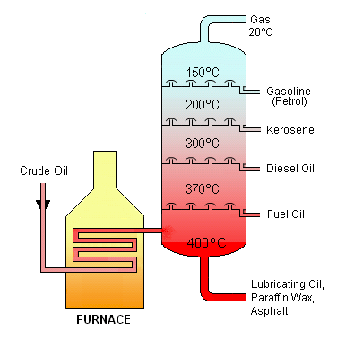
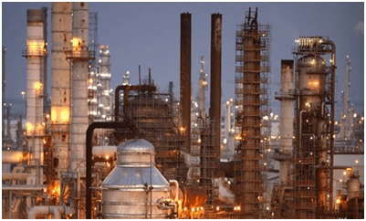 A petroleum refinery

Different constituents of petrol and their uses:
No. | Constituents of petroleum | Uses
1 | Liquefied Petroleum Gas (LPG) | As fuel for home and industry
2 | Petrol | As fuel for automobiles and as solvent for dry cleaning
3 | Kerosene | As fuel for stoves, lamps, etc.
4 | Diesel | As fuel for heavy motor vehicles, generators, etc.
5 | Lubricating Oil | For lubrication
6 | Paraffin Wax | In ointments, candles, vaselines, etc.
7 | Bitumen | For making paints, surfacing roads, etc.
3. Natural Gas: Natural gas
Natural gas was formed millions of years ago along with petroleum when microscopic sea plants & animals died & got buried under the sand & mud. These plants & animals under anaerobic conditions changed to gas.
Composition
It consist mainly of methane (about 85%), ethane (about 10%) propane (about 3%) and butane when natural gas is compressed at high pressure then it is called CNG (compressed natural gas). CNG is used for power generation.
It is now being used as a fuel for transport vehicles because it is less polluting. The great advantage of CNG is that it can be used directly for burning in homes and factories where it can be supplied through pipes. Such network of pjpeline exists in Vadodara (Gujarat) and some parts of Delhi.
Occurrence
It is generally found trapped between impervious rocks, sometimes along with petroleum & sometimes without petroleum.
In our country, natural gas has been found in Tripura, Rajasthan, Maharashtra and in the Krishna Godavari Delta.
Uses of natural gas
(1) As a fuel - It has a very high calorific value of 55 ktJ/g
(2) As a source of hydrogen & carbon
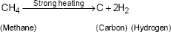

Q1. Why petroleum is also known as black gold?
Explanation
Many useful substances are obtained from petroleum which can be used for the manufacture of detergents, fibers (polyester, nylon, acrylic etc.) polyethene and many other plastics.
Due to its great commercial importance, petroleum is also called Black Gold.
Compressed Natural Gas (CNG):
When natural gas is stored under high pressure it is termed as CNG.
Advantage: It causes less pollution. Moreover, it can be used directly at homes and factories for burning and other purposes as it can be easily be transported through pipes.
Applications:
(i) It is used as fuel in automobiles.
(ii) It is used as a starting material for manufacturing of many chemicals and fertilizers.
(iii) Currently, there is a huge network of pipelines in Vadodara and some in some areas of Delhi used for supplying CNG.
(iv) It is used as a starting material for manufacturing chemicals and fertilizers.
Limitations of Natural Resources:
Fossil fuels like coal, petroleum, etc. needs millions of years to get transformed from dead bodies to fuels. But, currently their demands are so high that after few hundred years there will be scarcity of these resources.
In addition, too much of air pollution is caused when these fuels are burnt. And these fuels are also responsible for the problems associated with the global warming. Hence, it is very much important to use these fuels wisely.

Conservation of fossil fuels
It is believed that it took millions of years for the dead organisms to change into coal, petroleum or natural gas. Furthermore, their known reserves are limited.
Another problem with fossil fuels is that they are steadily increasing air . pollution, their use is linked to global warming. So, it is important that we use fuels only when it is absolutely necessary. tri this way, we can save these fuels for the Manufacture of many substances which are dependent on petrochemicals.
For energy purpose, we must look for alternative sources, such as solar energy, tidal energy, wind energy, etc. Furthermore, fossil fuels will be available to future generations for more useful products.
Some preventive measures to save fuels by Petroleum Conservation Research Association (PCRA)
(i) Drive vehicles at average and constant speed.
(ii) When not necessary shut down the vehicle’s engines.
(iii) Make sure pressure in tyres is correct.
(iv) Always keep vehicles under good condition.

