GREENWOOD PUBLIC SCHOOL, ADITYAPURAM
OUR MOTTO-DEVELOPMENT WITH DELIGHT
CLASS-I SUBJECT- ENGLISH
TERM-2 SYLLABUS
PARAGRAPH
DIWALI
- Diwali is a festival of lights.
- It is celebrated in the month of October/November.
- People worship Goddess Lakshmi and Ganesha on this day.
- They light candles and diyas.
- People wear new clothes and exchange gifts and sweets.

VERB
It is a word which shows an action.
Eg: Rohan is singing.
Divya is dancing.

LESSON – 6
PICNIC IN THE WOODS
DIFFICULT WORDS
- Picnic 11. Behind
- Holiday 12. Trunk
- Squirrel 13. Nibbles
- Throw 14. Enjoy
- Catch 15. Safe
- Biscuit
- Softly
- Sorry
- Aloud
- Little
WORDMEANINGS
- Catch – capture.
- Throw – to deliver.
- Spot – see.
- Nibble – take small bites.
- Scurry – to run quickly with short steps.
- Behind – towards the back.

FRAMESENTENCES

- Picnic – Today I am going for a picnic with my friends.
- Furry – Squirrel has a furry tail.
- Basket- The basket is full of mangoes.
- Enjoy – I enjoy with my friends.
- Children – Children are playing in the park.
OPPOSITES
- Catch – throw
- Hide – appear
- Behind – front
- Hold – unhold
- Safe – unsafe

QUESTION/ANSWERS

Q1. Where were the four friends going ?
Ans. The four friends were going for a picnic.

Q2. Who packed food for them ?
Ans. Sheela’s mother packed food for them.

Q3. Who are twins ?
Ans. Sameer and Riaan are twins.

Q4. Who nibbles biscuit from Sameer ’s hand ?
Ans. A squrriel nibbles biscuit from Sameer ’s hand.

LESSON – 7
THE NEW WATCHMAN
DIFFICULTWORDS
- Watchmam 11. Face
- Happily 12. Shape
- Licking 13. Kitchen
- Wonderful 14. Glass
- Fridge 15. Laugh
- Window
- Parents
- Kennel
- Voice
- Hugs
WORD MEANINGS
- Kennel – A small hut for a dog.
- Peeps – Secret look.
- Wag – To shake.
- Shout – Loud voice.
- Creep – To move slowly.
FRAME SENTENCES
- Hugs – Mother hugs her son tightly.
- House – The big house is near the river.
- Happily – Children were playing happily on the beach.
- Garden – I have a small garden.
OPPOSITES
- Black – White
- Night – Day
- Late – Early
- Light – Dark , Heavy
- Soft – Hard

QUESTION/ANSWERS
Q1. Where does Scooby live ?
Ans. Scooby lives in a kennel in the garden.
Q2. When does Scooby hear the sound ?
Ans. Scooby hears the sound late in the night.
Q3. Why does Raj go to the kitchen ?
Ans. Raj goes to the kitchen to drink a glass of water.
Q4. Whom does mother call a watchman ?
Ans. Mother calls Scooby a watchman.

ACTIVITY
Q1. Write three lines on your favourite pet ?
Ans.
1. Dog is a faithful animal.
2. It barks on strangers.
3. I love my pet a lot.

SPEAKING SKILLS
NATIONAL SYMBOLS
1.Our National flag is Tricolour.

2.Our National Symbol is Ashoka’s Emblem.

3.Our National language is hindi.

4.Our National sweet is Jalebi.
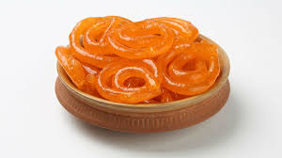

5.Our National bird is peacock.
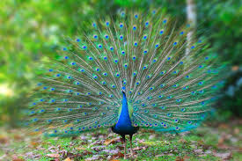
6.Our National animal is Tiger.
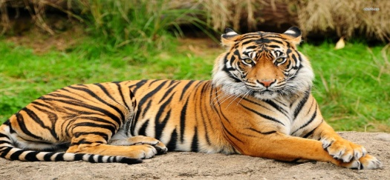

7.Our National flower is Lotus.

8.Our National game is Hockey.

9.Our National fruit is Mango.
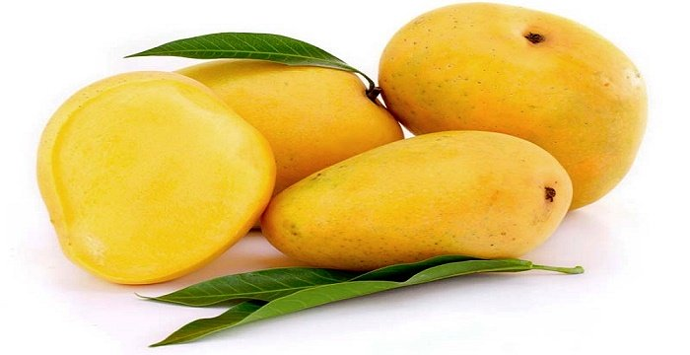

10.Our National tree is Banayan Tree.
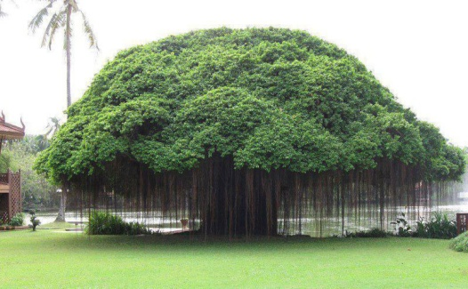
LESSON – 8
THANK YOU !
DIFFICULT WORDS
- Pretty 11. Basket
- Evening 12. Bottle
- Behind 13. Front
- Marigolds 14. Carry
- Ripe 15. House
- Pours
- Along
- Path
- Plucks
- Unripe
WORD MEANINGS
- Ripe – ready to be eaten.
- Unripe – not fully developed
- Basket – hamper
- Pluck – to pick
- Pretty – attractive
FRAME SENTENCES
- House – She lives near my house.
- Evening – He comes to play with me in the evening.
- Pluck – We should not pluck the flowers.
- Climb –Ram and Riya climb the tree.
OPPOSITES
- Ripe – Unripe
- Evening – Morning
- Pretty – Ugly
- Cool – Warm
- Give - Take

QUESTIONS / ANSWERS
Q1. Who carries the baskets into the house ?
Ans . The two children carry the baskets into the house.
Q2. Who climbs the tree ?
Ans. Jatin and Julie climb the tree.
Q3. Where is the pretty garden ?
Ans. The pretty garden is in front of Julie’s house.
Q4. Who makes jam ?
Ans. Julie’s mother makes jam.
Q5. What does she make with unripe apples ?
Ans. She makes chutney with unripe apples.

LESSON – 9
BRAVE DEBBY
DIFFICULT WORDS
- Towards 11. Scared
- Looking 12. Animals
- Counting 13. Behind
- Saving 14. Rock
- Forest 15. Close
- Friend
- Wolf
- Under
- Sharp
- Happy
WORD MEANINGS
- Sad – unhappy , sorrow.
- Near – close.
- Scared – frightened.
- Shout – loud voice.
FRAME SENTENCES
- Friend – Reena is my friend.
- Shout – I heard someone shout outside the windows.
- Together – We will play together.
OPPOSITES
- Look – Ignore
- Shout – Whisper
- Open – Close
- Start – Finish
- Sharp – Blunt

QUESTON / ANSWERS
Q1. Where did Debby live ?
Ans. Debby lived in a forest.
Q2. Who was near the lake ?
Ans. Becky the bear and Harry the hare were near the lake.
Q3. Who is hiding behind a rock ?
Ans. A wolf is hiding behind a rock.
Q4. Who is so scared ?
Ans. The wolf is so scared that he runs away.
Q5. At the end how many friends Debby has ?
Ans. At the end Debby has five friends.

LESSON – 10
COME , LET US PLAY
DIFFICULT WORDS
- Quickly 11. Sunny day
- String 12. Reach
- Holiday 13. Kite
- Idea 14. Bright
- Inside 15. Unwell
- Fly
- Carrom
- House
- Pick
- Football
WORD MEANINGS
- Idea – plan
- Inside – inner part
- Missing – not found
- Unwell – sick/ill
- Pick – to choose
FRAME SENTENCES
- Pick – Siya picked the best dress from the shop.
- Idea – The teacher gave us a good idea.
- Unwell – Mira was feeling unwell yesterday.
- Stairs – The children ran up / down the stairs.
OPPOSITES
- Wake – Sleep
- Sunny – Shady
- Inside – Outside
- Best – Worst
- All – Little

QUESTION / ANSWERS
Q1. Why is Shiv happy ?
Ans. Shiv is happy because it is a holiday and he can play all day.
Q2. Why does Shiv wear a cap!
Ans. Shiv wears a cap because it is hot outside.
Q3. Why is Mira not ready yet ?
Ans. Mira is not ready because she is unwell.
Q4. Who has an idea ?
Ans. Shiv and Sam have an idea.
Q5. What do you like to do when it is hot and sunny ?
Ans. I like to eat Ice - cream when it is hot and sunny.
ACTIVITY
Name 5 Indoor games and 5 Outdoor games.
Ans. Indoor Games Outdoor Games
(a) Chess Cricket
(b) Table Tennis Tennis
(c) Ludo Basket ball
(d) Carrom Football
(e) Cards Hockey

PARAGRAPH
HOLI
- Holi is a festival of colours.
- It is celebrated all over the country with joy.
- It falls in the spring season.
- Everyone plays with colours on this day.
- People enjoy by singing loudly on drum beats.
- It spreads joy and happiness everywhere.

FORMAT OF APPLICATION
Senders Address
Date
Receiver’s Address
Subject
Salutation

Content

Subscription

The Principal
Greenwood Public School
Gwalior
23rd July 2020
Sub – Two days leave
Respected Mam
As I have been suffering from fever since last night, I shall be unable to attend the class for two days.
Kindly grant me leave for the same.
Thanking you
Yours obediently
ABC
Class I A
SPEAKING SKILLS
SAVE WATER
- Water is the most precious gift of Nature.
- It is found every where in tanks, pond, wells, river, etc.
- Three fourth of the earth is water.
- Without water nobody can live.
- We need it to cook, to drink, to wash, to grow crops and plants etc.
- We should save it for future generation.
ADVERB
It is a word that adds something to the meaning of a verb.
Eg
- He walked slowly.
- The dog barks loudly.
- The driver drives carelessly
Adjective
It is a word which describes a noun or a pronoun.
Eg-
- She wears a beautiful dress.
- He is a good student.
- I have a pretty doll.
- She has long hair.

GENDER
Masculine Feminine
- Mr Mrs
- Tiger Tigress
- Husband Wife
- Drake Duck
- Peacock Peahen
- Prince Princess
- Fox Vixen
- Deer Doe
- Actor Actress
- Monk Nun

SINGULAR PLURAL
- Day Days
- City Cities
- Baby Babies
- Lady Ladies
- Wife Wives
- Knife Knives
- Child Children
- Tooth Teeth
- Goose Geese
- Man Men

