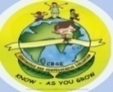
GREENWOOD PUBLIC SCHOOL, ADITYAPURAM
OUR MOTTO-DEVELOPMENT WITH DELIGHT
CLASS- VII SUBJECT- SCIENCE
TERM-2 SYLLABUS
Respiration in Organisms (Chapter-9)
Difficult words:-
- Respiration
- Organisms
- Cellular
- Breathing
- Biochemical
- Trachea
- Expiration
- Alveoli
- Capillaries
- Aerobic
- Fermentation
- Lenticels
Glossary:-
Breathing: take air into and expelling it from the lungs
Respiration : the process involving the production of energy and release of carbon dioxide from the oxidation of complex organic substances
Stomata : minute pores in the epidermis of a leaf Gill :the respiratory organ in fish and other aquatic animals
Lungs : organs of gaseous exchange in humans and higher organisms
Aerobic Respiration : respiration in presence of oxygen
Anaerobic Respiration : respiration in absence of oxygen
Diaphragm : a muscular partition that separates thorax from the abdomen
Tidal Volume : the amount of air inhaled and exhaled in a single stroke
Notes:-
Breathing:- it is a physical process involving exchange of Oxygen and Carbon dioxide.
Respiration:- it is a biochemical process in which glucose is oxidised.
Types of respiration:-
External Respiration:- Process in which oxygen is taken inside the body and carbon dioxide is given out. It is also called breathing.
Internal Réspiration:- Process in which food is broken down in body cells through various chemical reactions.
Respiration in Plants:-Leaves have pores called stomata for gaseous exchange by diffusion.
Stems have openings called lenticels for gaseous exchange by diffusion.
Roots have root hairs for gaseous exchange of oxygen dissolved in soil water.
Respiration in Animals:-
Earthworm:-Gaseous exchange occurs through its skin.
Thin, moist skin is supplied with a network of capillaries which absorb oxygen and remove carbon dioxide from the body.
Fish :-Fish absorbs dissolved oxygen from the water by means of gills.
Oxygen gets diffused into the blood and carbon dioxide diffuses into the water.
Insects:-Gaseous exchange takes place through the entire body surface by diffusion.
They have elaborate system of branching tubes called tracheae.
Frogs:-Exchange of gases in frog takes place through its thin, moist and smooth skin, when in water. Frogs also have lungs for respiration on land.
Respiration in Humans:-Inhaled air passes through nostrils into nasal cavity and then into lungs through windpipe.
In the lungs, the windpipe branches out into bronchi and even smaller bronchioles, which end in air sacs called alveoli.
Here, oxygen from the air diffuses into blood capillaries and carbon dioxide diffuses out into the alveoli.
Types of Réspiration in Humans:-
Aerobic Respiration:-Food molecules combine with oxygen and get oxidised inside the cell into carbon dioxide, water and energy.
Glucose + Oxygen ➡ Carbon dioxide + Water + Energy
Anaerobic Respiration:-Food molecules are broken down without using oxygen to release little energy.
Glucose➡ Ethyl alcohol + Carbon dioxide + Energy
Glucose ➡Lactic acid + Energy
Difference between:-
Aerobic respiration | Anaerobic respiration
It occurs in all living organisms  Oxygen is required.  Complete oxidation of food occurs during the process.  Oxidation of glucose produces carbon dioxide, water and energy.  It produces energy. considerable amount of | It occurs only in some bacteria, fungi, germinating seeds and certain animal tissues like skeletal muscles.  Oxygen is not required.  Oxidation of food remains incomplete in this process.  Oxidation of glucose produces ethyl alcohol and carbon dioxide (as in yeast), or Lactic acid (as in muscles). It also produces some amount of energy.  Much less energy is produced.

Breathing | Respiration
It is a physical process involving exchange of oxygen and carbon dioxide.  There is no release of energy.  Enzymes are not involved.  Modes of breathing are different in different organisms.  It takes place between cells/organisms and environment. | It is a biochemical process in which glucose is oxidised.  Energy is released in this process.  Enzymes are involved.  Details of respiration are similar in every living cell whether of plants or animals.  It takes place within the cells.

Activity:-
Aim:-Studying the mechanism of breathing
Take two bell jars. Take two Y-shaped glass tubes and fix two deflated balloons on each,
Insert the Y-shaped glass tube with the balloons in the jar and put the cork on the mouth of the bell jar.
Tie a thin rubber sheet around the bottom of the bell jar. This set-up is a replica of the human respiratory system.
The bell jar is the chest cavity, the balloons are the lungs and the rubber sheet is the diaphragm. o Pull the rubber sheet down.
The space inside the jar increases and the balloons get inflated. When the rubber sheet is released, the balloons get deflated.
The same thing happens to our lungs when we breathe in and out.

Diagrams:-
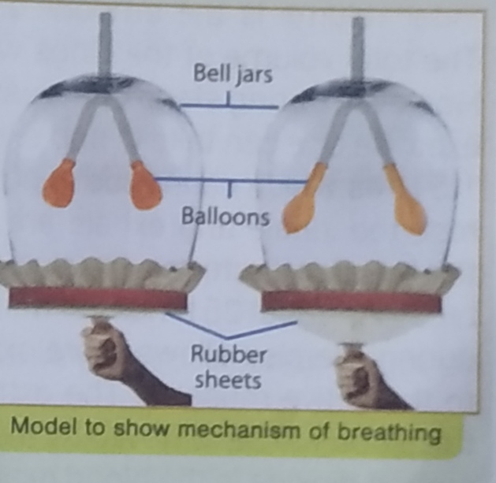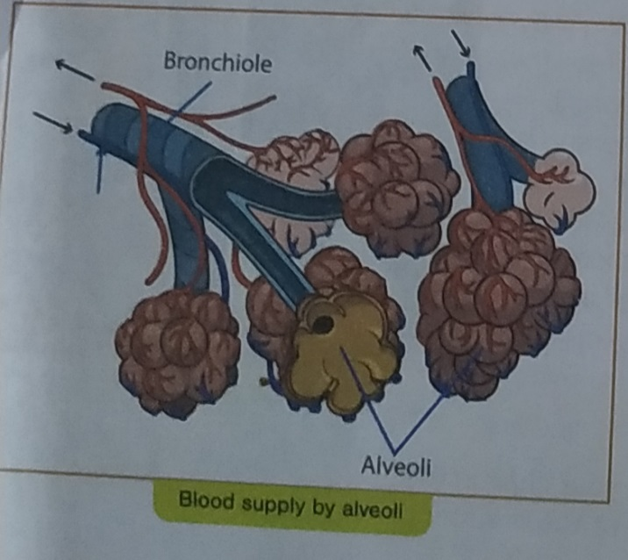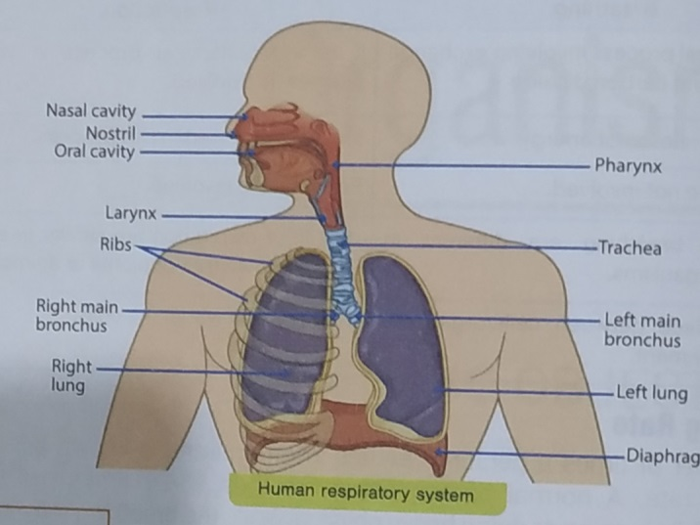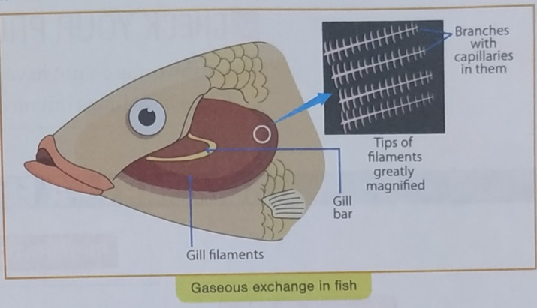

Chapter-10
Transportation in Animals and Plants
Difficult words:-
- Transportation
- Substances
- Urethra
- Ureters
- Transpiration
- Arteries
- Veins
- Capillaries
- Atria
- Ventricles
- Xylem
- Phloem
Glossary:-
Haemoglobin : a pigment in RBC, which carries oxygen and gives blood its red colour
Excretion .removal of wastes produced by the body
Xylem :woody tissue that conducts water in plants Phloem . the tissue conducting food material in plants
Systole : the contraction of the heart when blood is pumped into the arteries
Diastole : the period between two contractions of the heart when the heart muscle relaxes and allows the chamber to fill with blood
Dialysis : the clinical purification of blood by a machine as a substitute for the normal function of the kidney
Vein : blood vessels carrying deoxygenated blood to the heart from body parts
Artery : blood vessels carrying oxygenated blood from the heart to body parts
Notes:-
Transportation of Substances:-
- In Plants:-
Transportation of water and Minerals:-
Plants absorb water and minerals by roots through root hair.
Water and nutrients in the plant are transported by xylem.
Xylem forms a continuous network of channels that connects roots to the leaves through the stem and branches.
Food is transported to all parts ofthe plant by phloem.
Excretion of Waste:-
Water is lost by plants in the form of vapour through stomata by transpiration.
Some wastes are stored in leaves and barks of trees which are periodically shed.
Gaseous wastes are released into the air by stomata.
- In Animals:-
- Circulatory System:-
- Blood:-It transports substances like digested food from the small intestine to the other parts of the body. It carries oxygen from the lungs to the cells of the body.It also transports waste for removal from the body.
components of Blood:-
Plasma: Fluid part ofthe blood.
Red Blood Cells (RBC): Contains a red pigment called haemoglobin, which binds with oxygen and transports it to all the cells.
White Blood Cells (WBC): Fight against germs thatmayenter body.
Platelets: Help in blood clotting,
- Blood vessels:-There are three types of blood vessels:
Arteries: Carry oxygen rich blood from the heart to all parts of the body; have thick elastic walls.
Veins: Carry carbon dioxide rich blood from all parts ofthe body back to the heart; have thin walls.
Capillaries: Passes the food and oxygen present in the blood into the body cells; very thin walls.
- Heart:-Beats continuously and acts asa pump for transport of blood.
It has four chambers: two upper chambers are called the atria and two lower chambers are called the ventricles.
It has a partition between the chambers to avoid mixing up of oxygenated and deoxygenated blood.
Heartbeat:-Rhythmic contraction followed by relaxation of heart chambers constitutes a heartbeat.
Each heartbeat generates one pulse in the arteries.
- Excretory System:-
Blood reaches the two kidneys, where waste dissolved in water are removed as urine.
Urine goes into the urinary bladder through tube-like ureters.
It is stored in the bladder and is passed out through the urinary opening at the end of a muscular tube called urethra.
Activity:-
Aim:-To show the movement of water and minerals in plants.
Method:- Pour water to fill one-third of the tumbler. Add few drops of red ink.
Cut the base of the stem of the herb and place it in a glass.
Allow the apparatus to stand for a day.What do you observe?
You will observe that part of the herb appears red, which shows that water and minerals move up the stem through xylem.
Diagrams:-
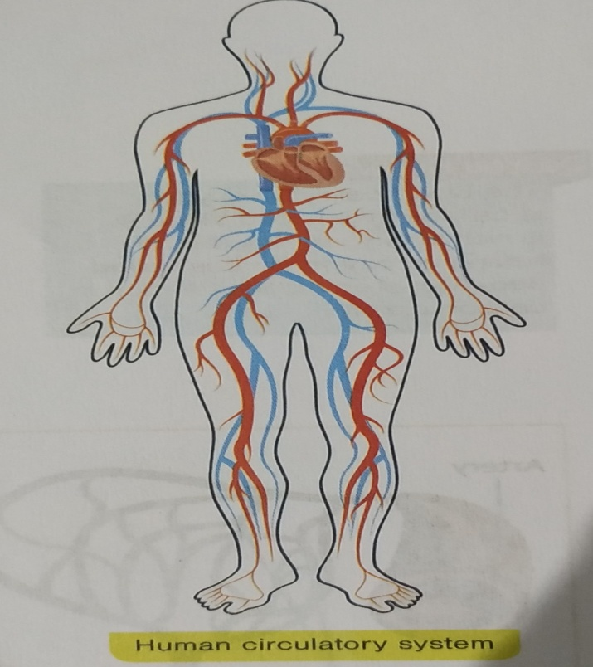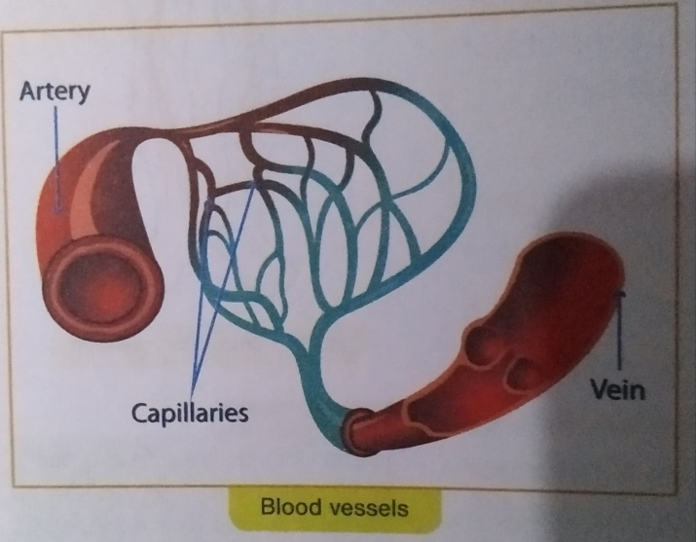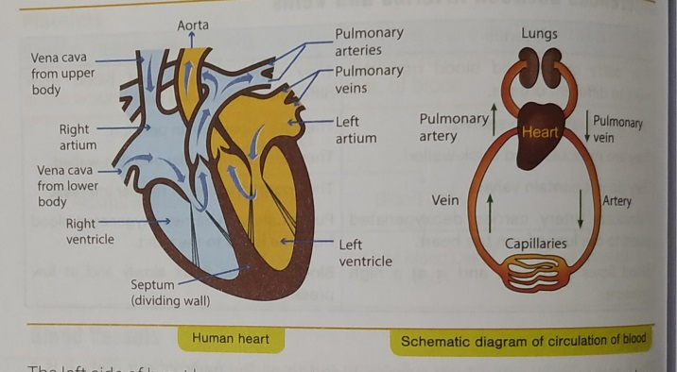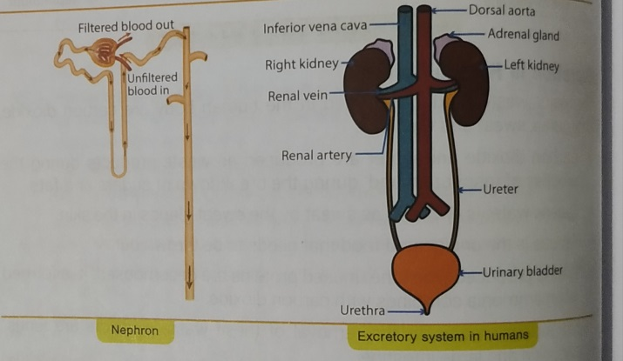

Chapter-11
Reproduction in Plants
Difficult words:-
- Reproduction
- Budding
- Fragmentation
- Spore formation
- Vegetative
- Propagation
- Grafting
- Fission
- Pollination
- Zygote
- Fertilization
- Germination
Glossary:-
Reproduction : the process by which living beings produce new organisms.
Sexual Reproduction : reproduction involving two parents and the fusion of male and female gametes
Asexual Reproduction : reproduction involving only one parent
Binary Fission division of a single cell organism into two equal halves
Budding : asexual reproduction involving formation of a small growth called bud.
Pollination : transfer of pollen grains from the anther to the stigma of the same (self-pollination) or different (cross-pollination) flower
Vegetative Reproduction : reproduction from the body parts like stem, root, leaves
Dispersal : scattering of seeds, away from the parent plant
Unisexual Flowers : flowers with either male or female reproductive organs
Bisexual Flowers : flowers with both male and female reproductive organs
Embryo : a rudimentary plant in a seed
Spore : a specialised reproductive cell of many plants and microorganisms
Hermaphrodite : a plant having stamens and pistils in the same flower
Ovary : hollow base of carpel of a flower containing one or more ovules
Fertilisation : the fusion of male and female gametes during sexual reproduction.
Notes:-
Reproduction:-The process by which living beings produce new organisms
Modes of Reproduction:-
Asexual Reproduction:-It is a process in which plants give rise to new plants without seeds of spores.
Budding:-Seen in yeast cells.Small bulb-like projection (bud) comes out.
Bud gradually grows and detaches from parent.
New cell grows, matures and reproduces.
Spore formation:-Seen in fungi and bacteria. Parents produce spores covered with hard coat which germinate under favourable conditions to develop into new individuals.
Fragmentation:-Seen in Spirogyra (an alga).Algae break into two or more fragments which grow into new individuals.
Binary Fission:-Seen in Amoeba.It is splitting ofa mature cell into two cells of the same type.
Vegetative Propagation:- New plants are produced from roots, leaves, stems and buds.
Artificial Methods of vegetative propagation:-
Layering
Grafting
Cutting
Example: potato tuber (by stem), Bryophy/lum (by leaves), sweet potato (by root).
Advantages of Vegetative Propagation:-
Some of the plants such as bananas which do not produce seeds at all multiply only by vegetative reproduction.
Vegetative reproduction takes less time for plants to grow and bear flowers and fruits as it does not involve germination of seeds.
In some cases where the seeds produced are not viable or fit and cannot form new plants, vegetative reproduction is used.
The new plants formed through vegetative reproduction are exactly like the parent plants. If the plants with similar qualities as that of the parent are required, vegetative propagation is the best method.
Sexual Reproduction:- New plants are obtained from seeds.
Flowers are the reproductive parts of a plant.there are two types of flowers
Reproductive part:-
Male:-Stamens are male reproductive parts.
Stamen consists of anther and filament.
Anther contains pollen grains (male gametes).
Female:-Pistil or carpel is the female reproductive part. Pistil consists of stigma, style and ovary.
Ovary contains one or more ovules in which egg (female gamete) is formed.
Pollination:-Transfer of pollen from the anther to the stigma of a flower.
Self-pollination:-Transfer of pollen from the anther to the stigma ofthe same flower.
Cross-pollination:-Transfer of pollen from the anther to the stigma of another flower of the same plant or ofa different plant ofthe same kind.
Agents of pollination:-
By wind
By water
By animals
By explosion
Fertilisation:-Fusion of male and female gametes to form a zygote. The zygote develops into an embryo.
Formation of Seed and Fruit:-Fruits and seeds are formed after fertilisation.
Ovary grows into a fruit and other parts fall off.
Seeds develop from ovules.
Dispersal of Seeds:-It prevents competition between plant and its own seedlings for sunlight, water and minerals. It enables plants to invade new habitats.
Activity:-
Aim:-To study the growth of bread moulds .
Take a piece of moist bread. Keep it in a warm and dark place. Sprinkle water on it at regular intervals to keep it moist.
After a few days, if we observe this bread piece under a magnifying glass, we will notice greenish-coloured structures growing on thin stems along with tiny thread-like projections (called hyphae).
These are bread moulds and the blob-like structure are sporangia that contains spores.
Now take one blob on a slide and cover it with a cover slip.
Observe this slide under a microscope and we would see a large number Of spores. It was one of these spores which was present in the air that lead to growth of moulds on the bread.
Diagrams:-
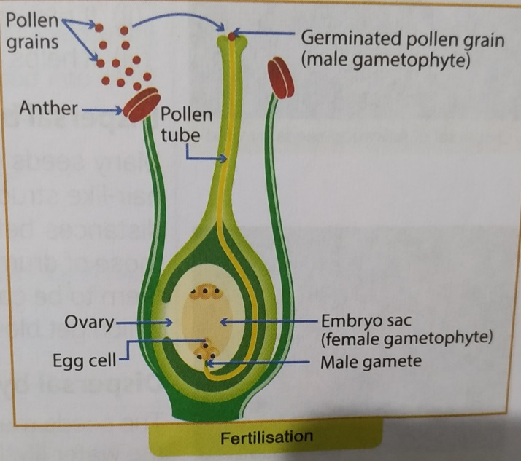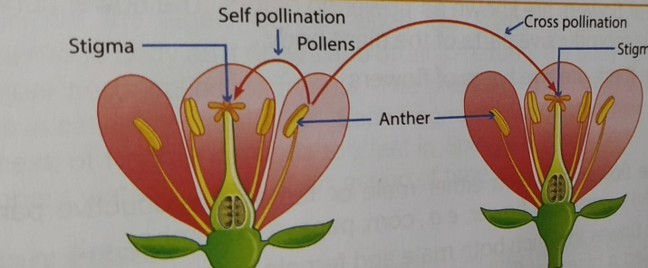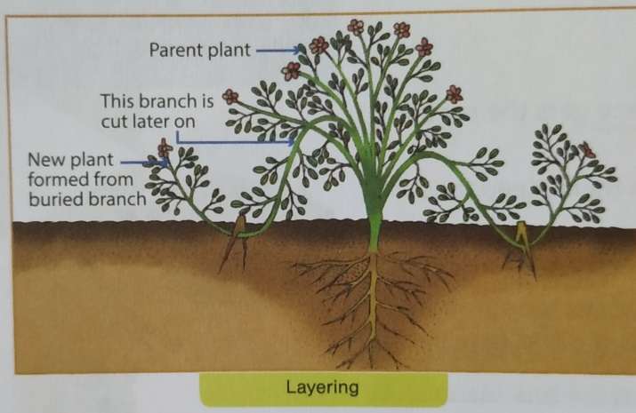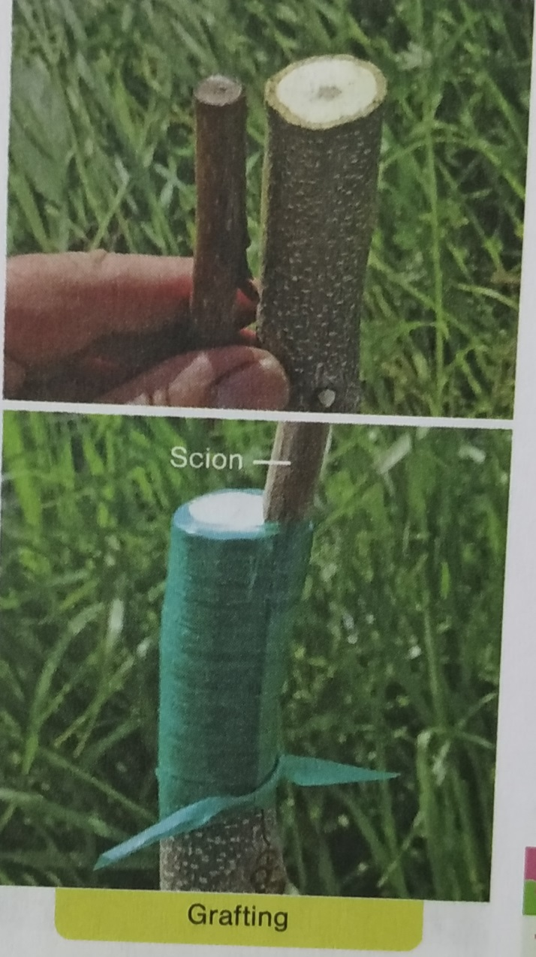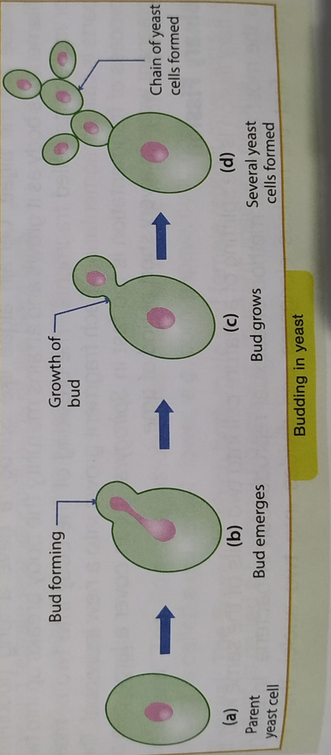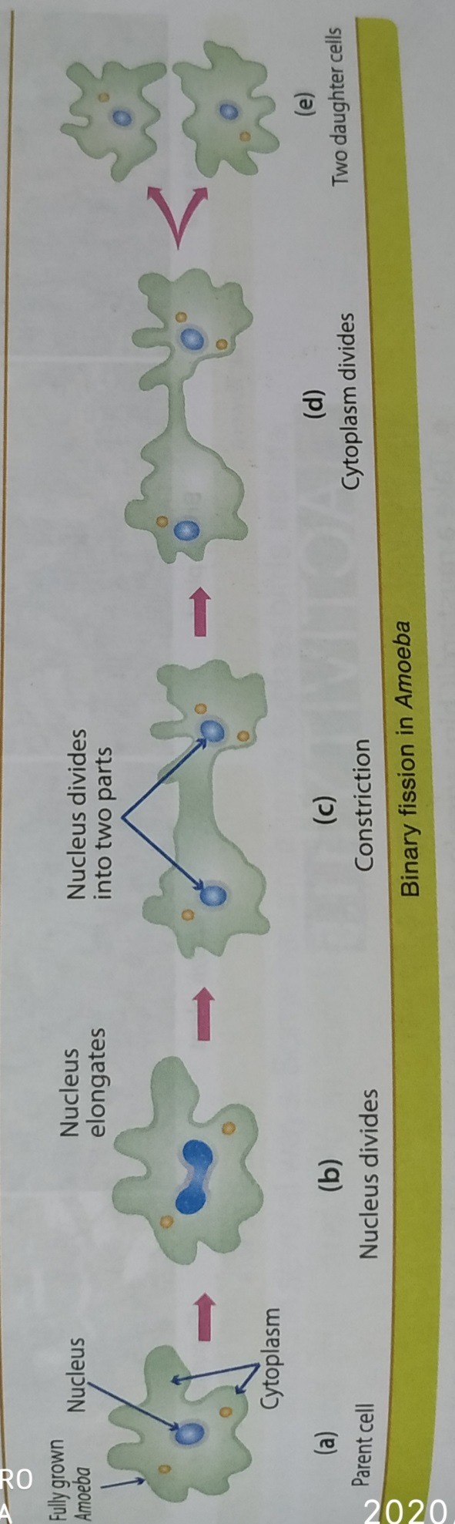

Chapter-12
Motion and Time
Difficult words:-
- Measurements
- Ancient
- Roman
- Sundial
- Occurrences
- Instruments
- Angular
- Contemporary
- Hourglass
- Motion
- Uniform
- Plotting
Glossary:-
Sundial : an instrument showing the time by the shadow of a pointer cast by the sun on to a graduated plate
Speed : distances covered in unit time
Uniform Motion • when a body covers equal distances in equal intervals of time
Non-uniform Motion : when a body covers unequal distance in equal intervals of time
Pendulum : a string which has a weight on one end while the other end is tied to a support
Speedometer : an instrument on a motor vehicle indicating its speed
Graph : a diagram showing the relation between two (usually) variable quantities, each measured along one of the pair of axes
Motion : change in position with respect to the surroundings
Rest : no change in position of a body with respect to stationary objects in the surroundings
Notes:-
Motion:- Change in position with respect to the surroundings.
Types of motion:-
- Uniform Motion:-An object moving along a straight line with constant speed is said to be in uniform motion.
The average speed is the same as the actual speed.
- Non-uniform Motion:-• If the speed of an object moving along a straight line keeps changing, its motion is said to be non-uniform.
Speed:-It is the distance covered by an object in a unit time.
Speed=Total distance covered Speed /Total time taken
Unit of speed is m/s.
Measurement of speed:-
Speedometer:- in vehicles gives the speed in kilometres per hour.
Odometer:- records the total distance covered by a vehicle.
Measurement of Time:-Time between one sunrise and the next is a day.
Time between one new moon and other is a month.
The time taken by the earth to complete one revolution of the sun is a year.
Clocks or watches are perhaps the most common time measuring devices.
Periodic motion of a pendulum has been used to make clocks and watches.
Simple Pendulum:-The to and fro motion ofa simple pendulum is an example of a periodic or an oscillatory motion.
The metallic ball of the pendulum is called the bob.
The time taken by the pendulum to complete one oscillation is called its time period.
Distance -time graph:-Motion of objects can be presented in a pictorial form by their distance-time graphs.
The distance-time graph for an object moving with a constant speed is a straight line.
Activity:-
Aim:-To measure the time period of a simple pendulum
Suspend a metallic ball (bob) by a long thread from a rigid support. Our simple pendulum is ready.
Set the simple pendulum in motion.
Note the time in our watch when bob is at an extreme position (say A).
When the bob again comes to the position A, count 1 (one). Each time the bob reaches this position (A), increase the count by 1 (one).
Check the time after 25 such oscillations. Find the time taken in 25 oscillations.
Calculation:
Time taken for 25 oscillations = t
Time taken for 1 oscillation = T = t/25
Numericals:-
Q1 A snail covers 1 metre in 10 seconds. What is the speed of the snail in km/h?
Q2 A superfast train moves with a speed of 120 kilometres per hour. What is the distance travelled by the train in one minute?
Q3 What is the average speed of
I. a car which travels 400 m in 20 s?
II an athlete who runs 1500 m in 4 minutes?
Q4An object travels 15 m in 4 s and then another 15 m in 2 s. What is the average speed of the object?
Q5 A boy jogs 10 metres in 5 seconds.
I. What is his speed?
II. How far would he travel in 100 seconds?
Q6.A car moves with a speed of 40 km/h for 15 minutes and then with a speed of 60 km/h for the next 15 minutes. Calculate the total distance covered by the car.
Diagrams:-
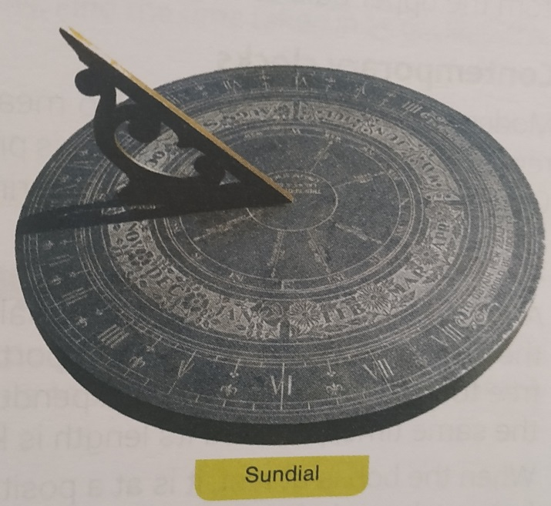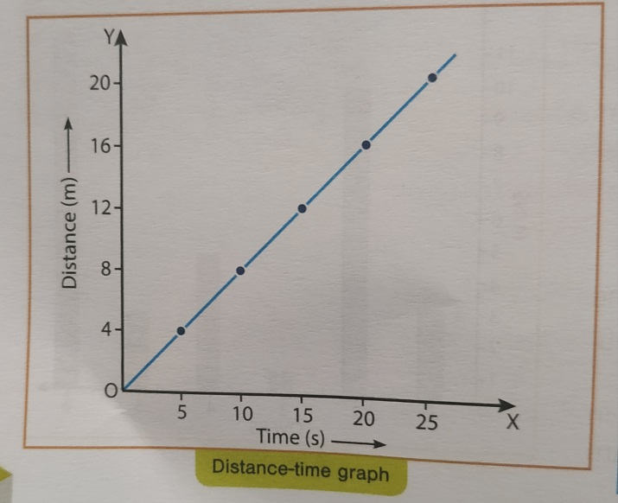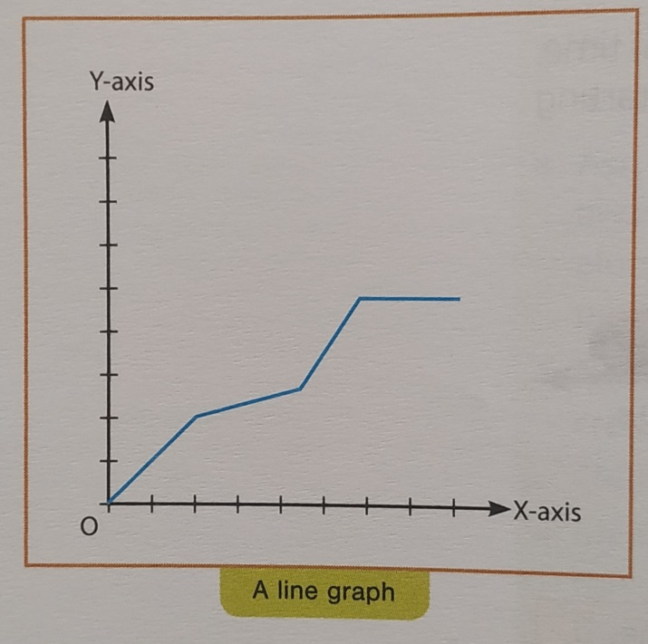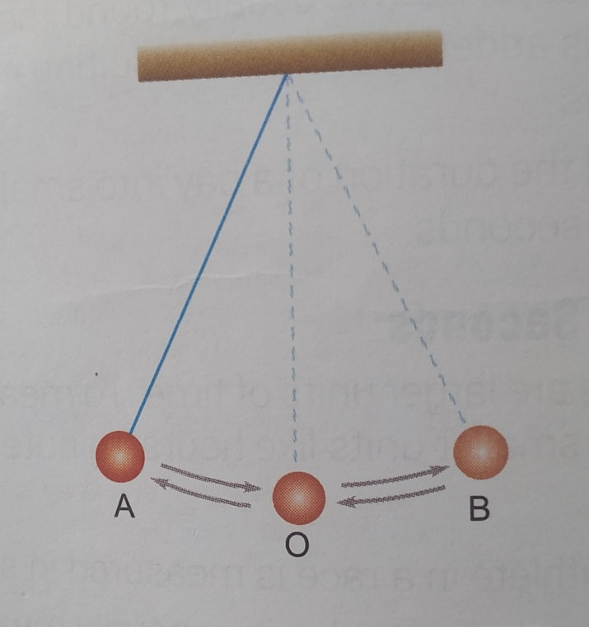

Chapter- 13
Electric current and it's Effects
Difficult words:-
- Filament
- Electric
- Electromagnet
- Instruments
- Directions
- Damage
- Pathway
- Miniature
- overloading
- Aluminium
- Resistance
Glossary:-
Battery: two or more cells joined together
filament : very thin wire in a light bulb
Electric circuit: a complete pathway for the flow of electric current
Electromagnet : an electric wire coiled around a metal core
Compass:- an instrument showing the direction of magnetic north
Fuse : a safety device in the form of a small wire placed in a circuit to prevent damage due to excess current
Notes:-
Electric current:- it is a flow of electrons through a conductor.
- Electric circuit:- a complete pathway for the flow of electric current.
Components of electric circuit:-
Cell: Provides energy for the current to flow.
Bulb: Lights up when an electric current flows through it.
Switch: Keeps the circuit off or on.
Connecting wires: Help to conduct the electric current and complete the circuit.
- Effects of electric current:-
- Heating Effect:-The wire gets hot when an electric current passes through it. This is the heating effect ofthe electric current.
Electric heater contains a coil of wire called element which becomes red hot when current passes through it.
The amount of heat produced in a wire depends on its material, length and thickness.
- Application:-
a. Fuse:-It is a safety device which prevents damage to electric circuit.
It is made by inserting a short wire into porcelain or insulating material.
b. MCB:-Stands for Miniature Circuit Breakers. These are switches which automatically turn off when current in a circuit exceeds the safe limit.
- Magnetic Effect:-When electric current passes through a wire, it behaves like a magnet. This is the magnetic effect of the electric current.
First observed by Hans Christian Oersted.
- Electromagnet:-An electromagnet is a coil of wire wound on a soft iron core.
Used to separate magnetic material from the junk.
Doctors use tiny electromagnets to take out small pieces of magnetic material that have accidentally fallen in the eye. Many toys also have electromagnets inside them.
- Electric Bell:-One of the applications of electromagnet is the door bell or an electric bell. Its components are: an electromagnet, an armature (a soft iron bar mounted on a spring), a contact screw, a gong and a hammer.
Working of Electric Bell:-The bell works in following manner.
When the bell is pressed the contact screw touches the iron strip then the circuit is completed.
The current starts flowing through the coil.
The electromagnet becomes magnetised and the soft iron armmature is attracted towards the electromagnet. The movement of the iron causes the hammer to hit the gong.
This movement breaks the circuit at point P, so that the current stops flowing and switches off the electromagnet.
The spring pulls the armature back to its original position, the circuit is remade and the process starts over again. This is how the bell ring.
Activity:-
Aim:-Making an electromagnet
Materials required: A large iron nail, thin coated copper wire, a low voltage dry cell, some paper clips, switch, electrical tape.
Wind the wire tightly around the nail so that we have at least 25 turns, Keep the turns close together and always wind in the same direction. Try not overlap the wires.
Remove the insulation from the ends of the wire and attach one end of the wire to one end of the battery and the other end of the wire to the other end of the battery through a switch.
Close the circuit by closing the switch.
Now our electromagnet is ready. Put some light weight iron objects like paper clips near the point of nail. Observe what happens.
Observation:- We will observe that the nail will attract iron objects placed near it.

Diagrams:-
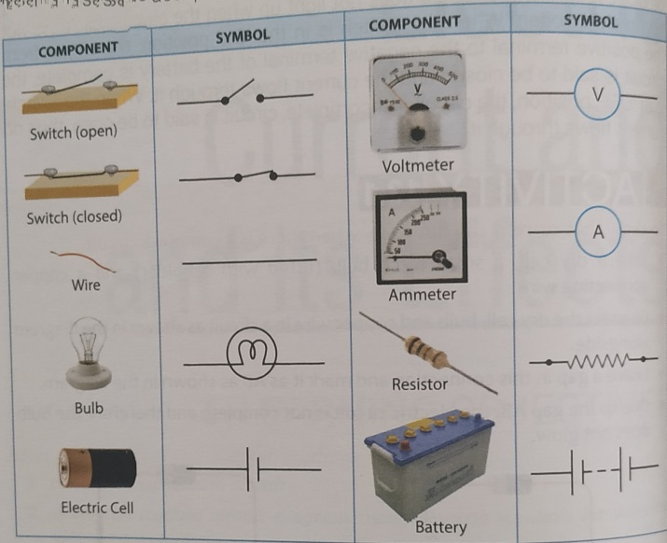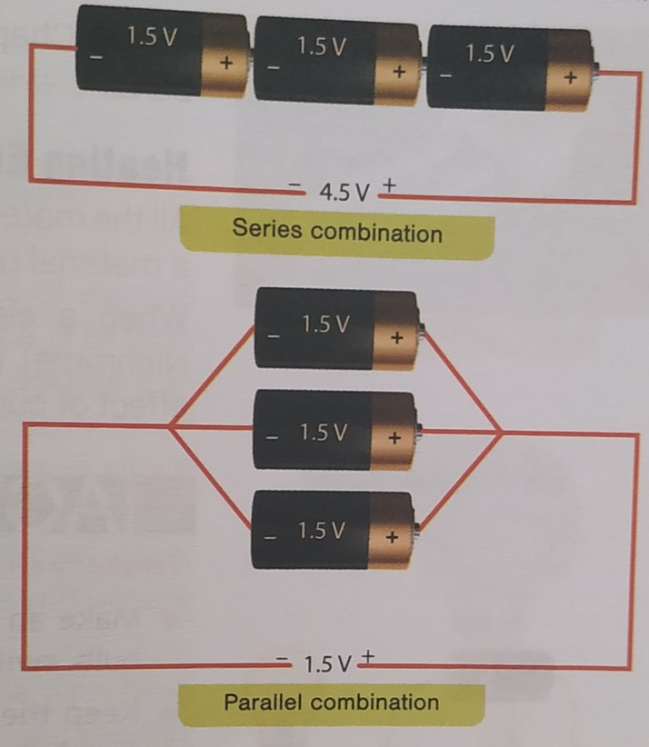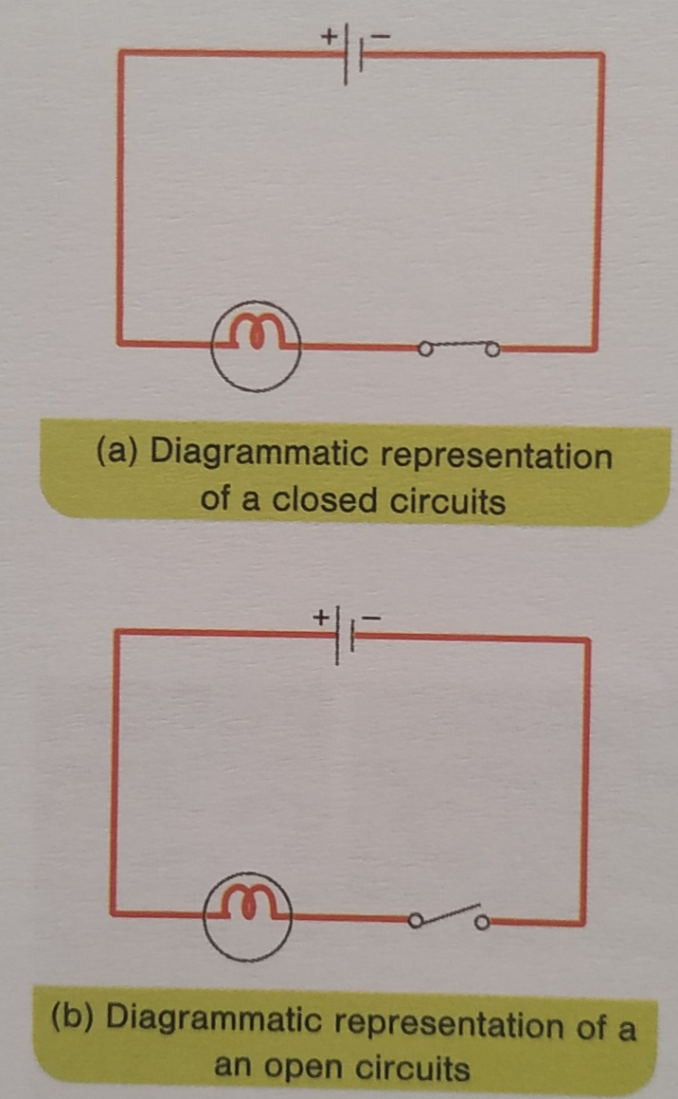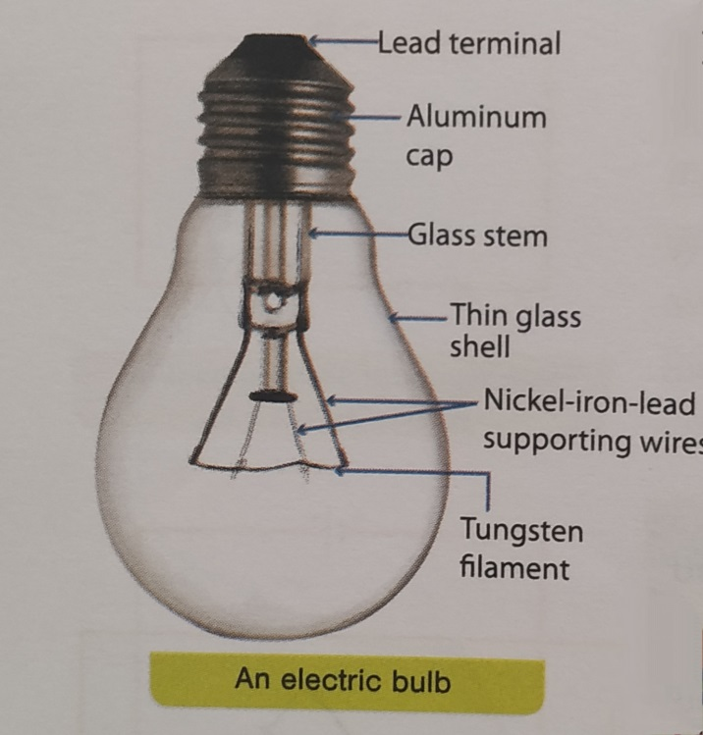

Chapter-15
Light
Difficult words:-
- Reflection
- Virtual
- Rectilinear
- Propagation
- convex
- concave
- lateral
- Inversion
- Dispersion
- Composition
- Magnifying
- Antennas
- Satellites
Glossary:-
Reflection : the bouncing back of light after striking the surface of an object
Mirror is a smooth polished surface from which reflection takes place
Lens : a piece of transparent material which has one or two special surfaces
Concave Lens : a lens which is thicker at the edges and tapering in the middle
Convex Lens : a lens which is thicker in the middle and tapering at the edges
Concave Mirror a reflecting surface which curves inward
Convex Mirror : a reflecting surface which curves outward
Dispersion : the phenomenon due to which white light splits into seven colours
Real Image : an image formed by the actual convergence of rays of light which are reflected by a mirror or which pass through a lens
Virtual Image : an image in which the rays reflected by a mirror or on passing through a lens diverge, but to the eye they appear to converge at the same point.
Notes:-
Light:- it is the natural agent that stimulates sight and makes things visible.
Properties of light:-
- Rectilinear propagation of light:-It is the property of light to travel in a straight line in any direction.
- Reflection of light:-It is the bouncing back of light after striking the surface of an object.
Shiny smooth surfaces reflect almost all the light.
- Reflecting Surfaces:-
- Plane Mirror:-
Lateral Inversion:-It is the phenomenon due to which the image is laterally inverted. This is because the image of object in a plane mirror is formed as far behind the mirror as the object is in front of it.
- Curved mirror:-
Concave Mirror | Convex Mirror
It is the mirror that curves in the reflecting surface is concave.  If object is close to mirror, image formed is virtual, upright and magnified, otherwise the image formed is real. | It is the mirror that curves out; the reflecting surface is convex.  Image formed is virtual, upright and diminished.

- Lenses:- Lens has two opposite surfaces either both curved or one curved and one plane.
Convex Lens | Concave Lens
It is a converging lens.  If the object is close to the lens, image is virtual, upright and magnified.  If the object is distant, image is real, inverted. | It is a diverging lens.  Image formed is virtual, erect and diminished.

- Images:-
Real | Virtual
The image that is formed on a screen.  It is formed by light rays that actually pass through the screen. | The image that cannot be obtained on a screen.  It is formed by light rays that seem to pass through the screen.

- Dispersion:-It is the phenomenon of splitting of white light into its seven colours.
White light is mixture of. Violet, Indigo, Blue, Green, Yellow, Orange and Red (VIBGYOR) colours.
Activity:-
Aim:-To show that sunlight is a mixture of different colours.
Method:-Take a glass prism.
Allow a thin beam of sunlight to fall on a prism in dark room.
After passing through the prism, it falls on a white sheet of paper or on a white wall.
Do we see colours similar to those in a rainbow?
we will observe that beam splits into seven colours.

Diagrams:-
