GREENWOOD PUBLIC SCHOOL, ADITYAPURAM
OUR MOTTO-DEVELOPMENT WITH DELIGHT
CLASS- VIII SUBJECT- CHEMISTRY
TERM-2 SYLLABUS
Chapter – 18
POLLUTION OF AIR AND WATER
Pollution: Pollution is the introduction of harmful or poisonous substances into environment that may cause adverse effects. Pollution can be natural or man-made. Natural pollution occurs from volcanic eruption, emission of natural gas, soil erosion, dust stroms, forest fires, etc. Man made pollution occurs from burning of fossil fuels, deforestation, mining, sewage waste, synthetic fertilisers and pesticides.
Pollutants:- The unwanted and harmful agents that contaminate the environment are termed as pollutants.
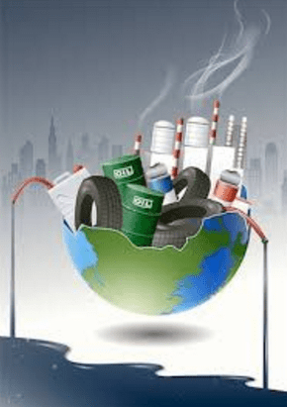
Types of pollution:
1. Air Pollution: It is the contamination of air, which takes place due to unwanted substances which causes harmful effects on both biotic and abiotic components.
1. Smoke from factories 2. Smoke from volcanic erruption
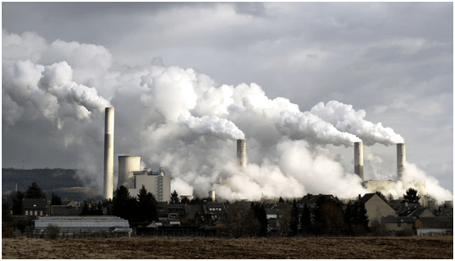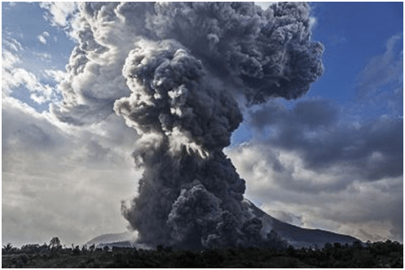

The things which are responsible for contamination of air are called air pollutants. These pollutants may result from natural causes like smoke or dust from forest fires or volcanic eruptions and from man-made causes like burning of fuels, smoke from factories etc.
Effects of Air Pollution:
1. Many problems related to respiratory system might be caused due to air pollution.
2. Oxygen carrying capacity of blood reduces because of improper burning of vehicle fuels; As the vehicles emit high levels of pollutants like carbon monoxide, carbon dioxide, nitrogen oxides and smoke into atmosphere. 3. Smog: It comprises of smoke and fog. It contains oxides of nitrogen and causes problems in breathing, cough, etc. Also, there are visibility problems in affected areas. 4. Smog: It comprises of smoke and fog. It contains oxides of nitrogen and causes problems in breathing, cough, etc. Also, there are visibility problems in affected areas. 5. Sulphur dioxide resulting from burning of fuels such as coals might result in respiratory problems.
6. Electronic devices like refrigerators, air conditioners, etc. emit chlorofluorocarbons (CFCs). CFCs damage the ozone layer present in the atmosphere. And the ozone layer is responsible for protecting us from harmful ultraviolet rays of the sun.

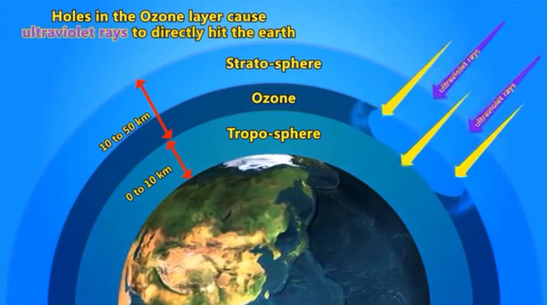
Depletion of Ozone layer due to CFCs

Acid Rain:-
Gases like Sulphur and nitrogen react with the water vapour present in the environment to form sulphuric acid and nitric acid. The acids drop down with rain water, making the rain acidic. This is called acid rain. Acid rain can be harmful for living beings and also for non-living things. Acid rain corrodes the outer surface of buildings. This has caused the Taj Mahal becoming pale.
The Acid rain has corroded the marble of this monument. And this phenomenon is called “Marble cancer”.

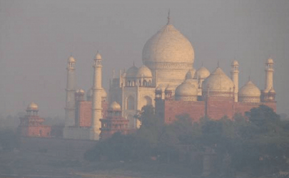
Acid Rain Effect on Taj Mahal
Greenhouse Effect:
It is the trapping of radiations inside the earth’s atmosphere. Along with other gases, CO₂ also gets trapped in the atmosphere which is responsible for Greenhouse Effect.
Because of human activities the amount of CO₂ level has increased in the atmosphere which traps heat and does not allow heat to escape into space. As a result, the average temperature of the earth’s atmosphere is gradually increasing. This is called global warming.
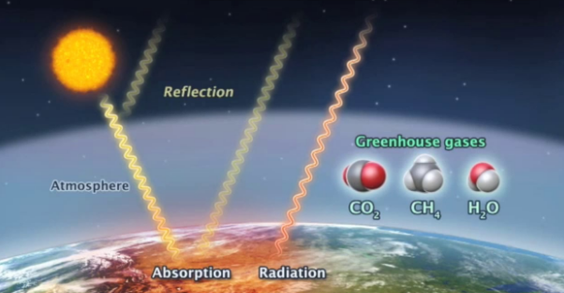
Green House Effect
Effect of Global Warming:
1. Global warming can cause sea levels to rise dramatically. Coastal areas have already been flooded.
2. Global warming could result in wide ranging effects on rainfall patterns, agriculture, forests, plants and animals.
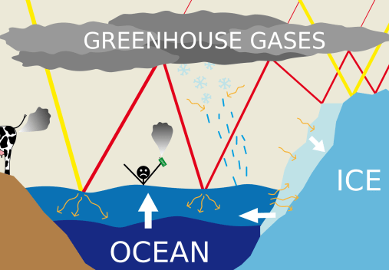
Green House Effect on water level

Key points to Prevent Air Pollution:
1. Trees take up carbon dioxide and release oxygen. So, planting more number of trees will reduce the amount of carbon dioxide responsible for Greenhouse Effect. 2. We should use CNG; instead of petrol and diesel in automobiles. 3. Avoid unnecessary usage of vehicles. Try using public transport more. 4. Location of factories and industries must be in remote areas to avoid problems resulting from air pollution.
5. Natural resources like solar energy, tidal energy, etc. should be used.
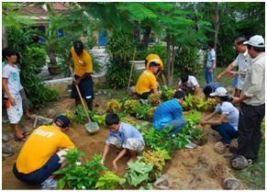
Planting

2. Water Pollution:-
The addition of undesirable and unwanted material in water which makes water harmful for biotic and abiotic components is called water pollution.
The things which pollute the water are known as water pollutants. Example includes washing of clothes, industrial waste from factories, etc.
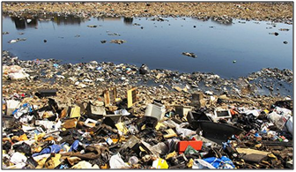
Polluted Water Due to Wastes

Potable Water: The water which is convenient for consumption is known as potable water.
Effects of Water Pollution:
1. River Ganga is one of the ten most endangered rivers in the world. Large quantities of garbage, untreated sewage, dead bodies, and many other harmful things are discharged into the river. All these have resulted into adverse conditions for the aquatic animals residing in the Ganga.
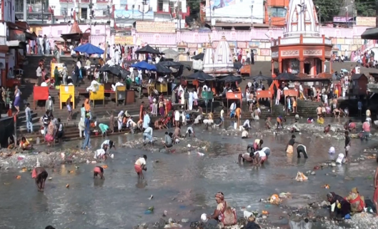
Effect of Pollution on Ganga

2. The harmful chemicals like arsenic, lead, etc. discharged by various industries have lead to many bad effects like impure water, acidity changes in water, etc.
3. The usage of pesticides and weedicides in the field gets mixed with water bodies during rainfall. Indeed, this water seeps into ground and has polluted ground water too.
4. Various diseases like cholera, diarrhea, jaundice, etc. results from water pollution.
5. Bacteria present in the faeces of mammals indicate the quality of water. If such fecal contaminated water is consumed then it can cause many infections.
Key points to Prevent Water Pollution:
1. Some plans can be implemented for polluted rivers like Ganga Action Plan was launched in 1985 with the aim of reducing pollution levels in river. 2. Industries must treat the waste before discharging them into waters. 3. At household level, candle type filter can be used. Moreover, water must be boiled for drinking as it kills the germs inside the water.
4. Chemical process like chlorination can be used for treating water. 5. Laws for industrial units should be strictly implemented to stop the throwing of wastes in water.
6. Proper sewage treatment plan must be implemented. 7. The idea of reduce, reuse and recycle should be incorporated for prevention of water pollution.
3 R's for Prevention of Water pollution:
Each year, human beings generate millions of tons of wastes in form of garbage, refuse, or trash. It is the wastage that we produce in our homes and communities. These wastages are thrown out the water bodies, rivers and make the water contaminated. Each of us can make a difference by reducing, reusing, and recycling materials at home and throughout our communities and encouraging our neighbours to do the same.
1. Reduce: Waste prevention reduces the generation of waste in the first place. So we should not create wastage by reducing the uses of goods.
(i) While brushing our teeth, leaving the tap running may waste several litres of water. A tap that drips once every second wastes a few thousand litres of water every year. So we should reduce the water uses for brushing teeth.
(ii) Purchasing durable, long-lasting goods.
(iii) Reduce the use of non biodegradable materials like things made of plastic, disposals, polythene etc.
2. Reuse: We can reuse the things in our daily routine work so that it will reduce the amount of wastage.
(i) Reusing water used for washing and for other household tasks. For example,water used for washing vegetables may be used to water plants in the garden.
(ii) Refill bottles, Reuse boxes.
(iii) Reuse the cotton or jute bag instead of polythene carry bag.
(iv) Use empty jars into containers for leftover food.
3. Recycle: Recycling prevents the generation of many greenhouse gases and water pollutants, and saves energy.
(i) Materials made of plastic, paper, glass and metal should be recycled to make new items.
(ii) Using recycle material generates less solid wastage.
We should realise our responsibility and start using environment-friendly processes for survival of our planet is in danger.
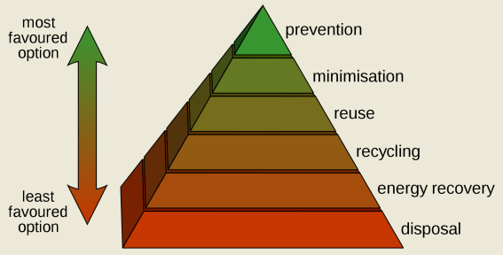

CHAPTER - 5
COMBUSTION AND FLAME
We use different kinds of fuels for various purposes at home, in industry and for running automobiles. These fuels are cowdung, wood, coal, charcoal, petrol, diesel, compressed natural gas (CNG), etc.
Combustion: It is a chemical reaction in which heat is released by a material when it reacts with oxygen. 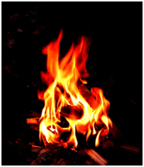
Fuel or Combustible Substance : Any material that undergoes combustion is called a combustible substance. It is also called as fuel. Some examples of fuels are petrol, diesel, etc. The fuel may be in solid, liquid or gas state. Sometimes, light is also given off during combustion, either as a flame or as a glow.
Ignition Temperature:
(i) It is the minimum temperature at which any material catches fire.
(ii) If the temperature of combustible substance is lower than the ignition temperature then the substance will not burn.
Example: (i) Cooking oil catches fire when a frying pan is kept for long on a burning stove.
(ii) Kerosene oil and wood do not catch fire on their own at room temperature. But, if kerosene oil is heated a little, it will catch fire. But if wood is heated a little, it would still not catch fire.
Inflammable Substances:
Those materials which have low ignition temperature and catch fire easily are termed as inflammable substances. Example includes petrol, LPG, etc.
Necessary Condition Required For Combustion
(i) Fuel or Combustible substance.
(ii) Air (With presence of Oxygen in it).
(iii) Temperature above the Ignition temperature.
Measures to control fire:
1. Fire Brigade Stations:
In case of fire, fire brigades extinguish the fire by sprinkling the water on the affected areas. The water brings down the temperature below its ignition temperature. As a result, fire stops spreading. Water vapours also surrounds the combustible material, helping in cutting off the supply of air. So, the fire is extinguished.

2. Fire Extinguisher:
Water is the most common fire extinguisher. But, it works only on things like wood, paper, etc. However, in case fire is caught on electrical things then, water being good conductor of electricity will destroy those equipment. Even water is not good in case of fires due to oil, petrol, etc.
For such cases, Carbon dioxide (CO₂) is best extinguisher. This extinguisher cut off the air supply and thus brings down the temperature below the ignition temperature as a result fire gets extinguished. Moreover, it usually does not damage electrical equipment.
3. Use of Blankets:
If a person catches the fire, then blankets can be used to extinguish the fire.
Different Types of Combustion:
1. Rapid Combustion
In this type of combustion, the substances burns rapidly and yield light and heat. Example :- Bring a burning matchstick or a gas lighter near a gas stove in the kitchen. Turn on the knob of the gas stove. We find that the gas burns rapidly and produces heat and light.
2. Spontaneous Combustion:
In this type of combustion, substances burst out into flames suddenly without any known reason. Examples :- Many disastrous fires in coal mines result due to this kind of combustion. The heat rays coming from the sun or a lightning strike might be responsible for this kind of combustion.
3. Explosion:
In this type of combustion, all of a sudden reaction results into heat, light and sound. Moreover, large quantity of gas also gets released. Example :- When a fire cracker is ignited, a sudden reaction takes place with the evolution of heat, light and sound with the large amount of gas.
Flame:
When something is burnt, a hot luminous gas emerges out of the substance. This gas is called as flame. Flames are the result of the substances which vaporize on burning. Example includes kerosene oil, wax, etc. which form flames on burning.
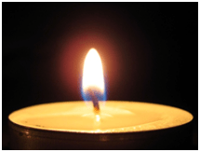
Flame structure:
When flames are observed carefully, one can notice different layers of flame as shown in figure below:
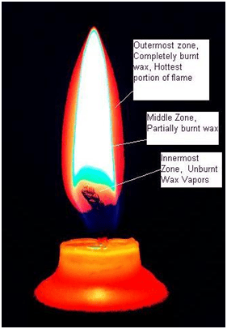
Outermost zone: It is blue in colour and is the hottest amongst all the zones. In this portion, complete combustion takes place.
Middle zone: It is yellow in colour and is somewhat hot. In this portion, partial combustion takes place.
Innermost zone: It is black in colour and is coolest amongst all the zones, and shows no combustion
Fuel:
The substance that undergoes combustion is called as fuel. Examples of fuels are wood, charcoal, petrol, kerosene, etc.
Characteristics of good fuel:
(i) It should easily be available.
(ii) It should be cheap.
(iii) It should generate large amount of heat.
(iv) It should not leave any unwanted matter after combustion.
Ideal Fuel
(i) The fuel which satisfies all the characteristics of good fuel is termed as an ideal fuel.
(ii) Probably, there is as such no ideal fuel present, but LPG is considered as an ideal fuel
Fuel Efficiency OR Calorific Value
(i) The quantity of heat generated on combustion of 1 kg of a fuel is called its calorific value.
(ii) Its unit is kilojoule per kg (kj/kg).
Harmful Effects of Burning Fuels:
The increasing fuel consumption has harmful effects on the environment.
1. Various air pollutants like unburnt carbon particles are released due to partial burning of carbon fuels causes many respiratory diseases.
2. The partial burning of some fuels release carbon monoxide, which is a poisonous gas. And this gas can kill a person if left in a room filled with this gas.
3. Global Warming: Combustion of most fuels increases the amount of carbon dioxide in the atmosphere that has lead to increase in the average temperature on the earth
.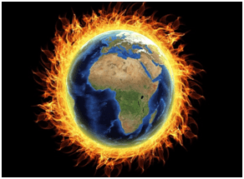
4. Acid Rain: Due to burning of coal and diesel, Chemicals like sulphur dioxide and nitrogen dioxide are released into the air. The pollutants reacts with the water vapour present in the air and forms sulphuric and nitric acid. When it rains, these acids are also present. Such kind of rain is called Acid Rain. It is very harmful for crops, buildings and soil.
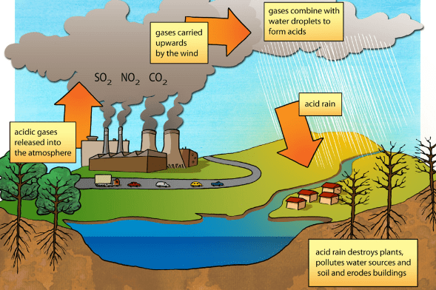

Acids Rain

Prevention from Acid rain: The use of diesel and petrol as fuels in automobiles is being replaced by CNG (Compressed Natural Gas), because CNG produces the harmful products in very small amounts. CNG is a cleaner fuel.
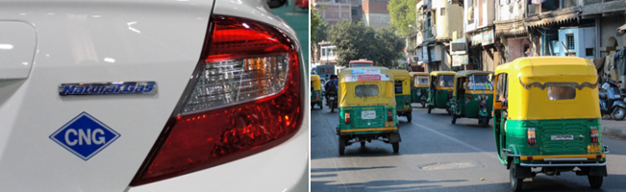
CNG Auto Mobiles

CHAPTER -14
CHEMICAL EFFECTS OF ELECTRIC CURRENT
Electric Current:
The flow of electrons in any material is termed as an electric current.
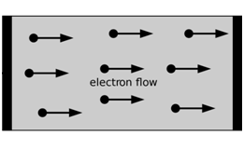
Flow of Electrons in the Matter

Good Conductors of Electricity:
The materials which allow the current to pass through them are known as good conductors. Examples are copper, aluminium, etc.
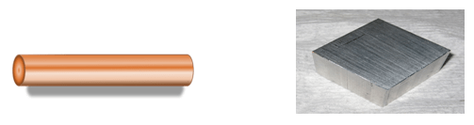
Poor Conductors of Electricity:
The materials which do not allow the current to pass through them, are known as poor conductors. They are also called as insulators. Examples are glass, plastic, etc.
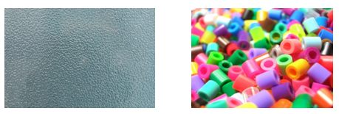

Tester:
It is a device to test if a particular material allows electric current to pass through it or not.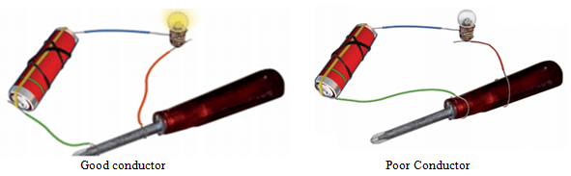
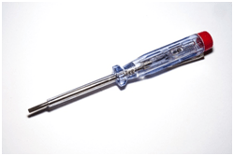
Tester
Conductivity in Liquids:
(i) A tester can be used to check if a liquid is conducting or non-conducting.
(ii) To check if the liquid is conducting or not, connect the liquid between the two ends of tester by completing the connection of the circuit properly. If bulb in the tester glows, it means the liquid is conducting. But, if does not glow then it means liquid is non-conducting. (iii) Most liquids that conduct electricity are solutions of acids, bases and salts.

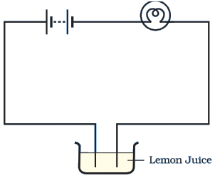
Testing conduction of electricity in liquid

Heating effect of current:
The heating effect of current is responsible for the glowing of the bulb.
To test whether substance is conducting or not using heating effect:
When current passes through the bulb, the filament gets heated to a high temperature and as a result bulb starts glowing. But, if current is very small then the filament will not get heated to a high temperature and so will not glow.
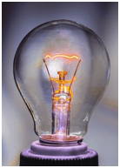
Heating Effect of Electric Current for Glowing Bulb

LED (Light Emitting Diodes):
LED’s can be used to detect weak currents, since; their filament does not require much temperature to glow.
They have two terminals called anode and cathode. The length of anode lead is slightly longer than the cathod lead and is always connected to the positive terminal of the battery. On the hand, cathode lead is shorter and is connected to the negative terminal of the battery.
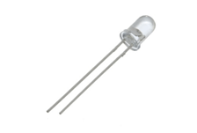
LED

Magnetic effect of current:
The magnetic effect of current is responsible for the deflection in magnetic compass when current passes nearby it. It can detect weak currents.
To test whether substance is conducting or not using magnetic effect:
For a closed circuit, when current passes nearby a magnetic needle and if the deflection is observed in the needle then it means the substance is conducting; otherwise it is non-conducting.
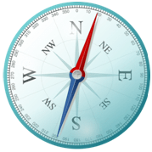
Magnetic Compass

Tester By using Magnetic Compass:
(i) Take the tray from inside a blank matchbox.
(ii) Wrap an electric wire a few times around the tray.
(iii) Insert a small compass needle inside it.
(iv) Now connect one free end of the wire to the terminal of a battery. Leave the other end free.
(v) Take another piece of wire and connect it to the other terminal of the battery
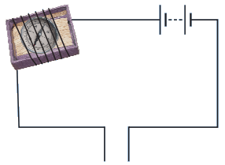
Tester by using the magnetic compass

Join the free ends of two wires momentarily. The compass needle should show deflection. our tester with two free ends of the wire is ready.
Touch both the ends of tester to any substance to check whether the substance is conducting the electricity or not. If the deflection is observed in the needle then it means the substance is conducting; otherwise it is non-conducting.
Tap Water:
The water obtained from various sources like rivers, wells, taps, etc. is not in its purest form. It contains many impurities in it. These impurities include different salts too. As a result of these salts, the tap water becomes a good conductor of electricity.
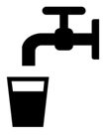
Distilled Water:
It is the purest form of water and does not contain any kind of impurities in it. Hence, it is a poor conductor of electricity.
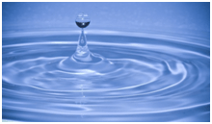
Distilled Water
We can check the conductivity of tap water or distilled water via the magnetic tester.
Chemical Effects of Electric Current:
Electrodes:
These are conducting materials through which current enters or leaves a substance.
Types of Electrodes:
(i) Positive Electrode: It is the electrode which is connected to the positive terminal of the battery. It is also known as Anode.
(ii) Negative Electrode: It is the electrode which is connected to the negative terminal of the battery. It is also known as Cathode.
There can be various chemical effects observed on passing electric current depending on the type of solution and electrodes:
1. Formation of Gas Bubbles:
If current is passed through water, then, bubbles of oxygen and hydrogen are produced. The oxygen bubbles are present on positive electrode and hydrogen bubbles on the negative electrode. The passage of an electric current through a conducting solution causes chemical reactions. As a result, bubbles of a gas may be formed on the electrodes
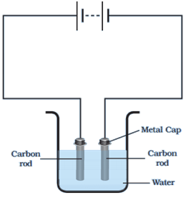
Passing current through water

2. Deposits of metal may be visible on the electrodes.
3. The colour of solution might change.
Electroplating:
The process of depositing a thin layer of some metal (less reactive) on another material by using electricity is known as electroplating.
Experiment: We need to take copper sulphate and two copper plates of same size. Take 250 mL of distilled water in a clean and dry beaker. Dissolve two teaspoonfuls of copper sulphate in it. Add a few drops of dilute sulphuric acid to copper sulphate solution to make it more conducting. Connect the copper plates to the terminals of a battery and immerse them in copper sulphate solution.
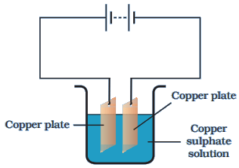
Connect the circuit as shown in the figure.
When current is allowed to pass through the copper sulphate solution, then the solution will separate into the copper and sulphate. The separated free copper of the solution will get deposited on the negative electrode. And the same amount of copper will get dissolved in the solution from the positive electrode. Hence, we can say that copper from positive electrode got transferred to the negative electrode. This kind of transfer is known as electroplating.
Applications of Electroplating:
(i) It is used in industries for coating different metals on other metal objects. For example, chromium which is a lustrous, corrosion free, scratch resistant, etc, is deposited on materials like car parts, taps, burners, etc. to lower the manufacturing cost.
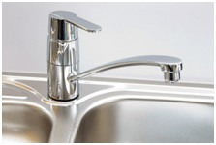
(ii) Iron cans are electroplated with tin used for storing food, as iron gets easily rusted and so protects the food from spoiling.
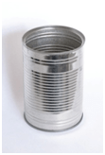
(iii) Zinc is deposited on iron used for the construction of bridges, vehicles, etc. to protect it from rust and corrosion.
