GREENWOOD PUBLIC SCHOOL, ADITYAPURAM
OUR MOTTO-DEVELOPMENT WITH DELIGHT
CLASS- VIII SUBJECT- BIOLOGY
TERM-2 SYLLABUS
CH – 4 CELL STRUCTURE AND FUNCTION
Question 1.
What is the basic, functional and structural unit of life?
Answer:
Cell
Question 2.
Which cell does not have nucleus?
Answer:
Red blood cell
Question 3.
What is the name of the organism which can be seen only with the help of microscope?
Answer:
Microorganisms
Question 4.
What are the organisms which are composed of many cells packed together called?
Answer:
Multicellular organisms
Question 5.
What is the name of the power house of the cell?
Answer:
Mitochondria
Question 6.
Name one example of prokaryotic cell.
Answer:
Blue-green algae
Question 7.
Amoeba and Paramecium belong to which category of organisms?
Answer:
Unicellular
Question 8.
Which instrument is used to observe cells?
Answer:
Microscope
Question 9.
Why we do not sense any pain when we cut nails and hair?
Answer:
Nails and hair are made up of dead cells.
Question 10.
What is the name of living substance present in cell?
Answer:
Protoplasm
Question 11.
What is the other name of cell membrane?
Answer:
Plasma membrane
Question 12.
What is the name of thread-like structure present in nucleoplasm?
Answer:
Chromatin
Question 13.
What is the name of cell which has a well-defined nucleus?
Answer:
Eukaryotic cell
Question 14.
Name the two types of cell.
Answer:
Prokaryotic cells and eukaryotic cells.

Cell Structure and Functions Class 8 Extra Questions Short Answer Questions
Question 1.
What is the function of cell wall?
Answer:
Cell wall is a tough, rigid layer that surrounds some types of cells (plants and some bacterial cells). The major function of the cell wall is to provide rigidity, tensile strength, structural support, protection against mechanical stress and infection.
Question 2.
Name the parts of the nucleus and state its function.
Answer:
Nucleus consists of three main parts—nuclear membrane, nucleoplasm and nucleolus. Nucleus plays an important role during cell division. It also controls the activities of the cell.
Question 3.
What is an organ?
Answer:
The structure that contains more than one type of tissues and is visible to the naked eyes are called organs.
Question 4.
What do you mean by unicellular and multicellular organisms?
Answer:
Organisms which consists of only one cell are called unicellular organisms while the organisms made up of more than one cell are called multicellular organisms.
Question 5.
Give a brief description of nucleus.
Answer:
Nucleus is a dense round body found in the centre of an animal cell and mostly on the periphery of the plant cell. The nucleus controls all the activities in a cell.
Question 6.
Name the following:
- Controls the function of a cell.
- Selectively allows things to get in and out of the cell.
- Transfer characters from parents to offsprings.

Answer:
- Nucleus
- Cell membrane
- Genes
Question 7.
What is nucleolus?
Answer:
A spherical body present at the centre of the nucleus is called the nucleolus.
Question 8.
What is endoplasmic reticulum?
Answer:
It is the system of complex folded network of membranous tubes which connects nuclear membrane with the plasma membrane. They allow movement of substances within the cell.
Question 9.
What are cell organelles?
Answer:
The tiny components present in the cytoplasm are called cell organelles.
Question 10.
What is cell membrane?
Answer:
The thin and delicate membrane surrounding the cell cytoplasm is called cell membrane.

Cell Structure and Functions Class 8 Extra Questions Long Answer Questions
Question 1.
Differentiate between
(a) Cell wall and cell membrane
(b) Leucoplast and chloroplast
(c) Vacuole in a plant cell and an animal cell
(d) A tissue and an organ
Answer:

(a)
Cell wall | Cell membrane
(i) It is present in only plant cells. | (i) It is present in both plant and animal cells.
(ii) It is rigid, thick structure. | (ii) It is delicate, thin structure.
(iii) It is completely permeable to ordinary molecules. | (iii) It is selectively permeable to molecules.
(iv) It is metabolically inactive and nonliving. | (iv) It is metabolically active and living.
(b)
Leucoplast | Chloroplast
(i) It is colourless plastid. | (i) It is green plastid.
(ii) It is found in underground parts of plants like, roots, and underground modified stems. | (ii) It is found in green parts of plants like leaves, stem and sepals.
(iii) It help in storage of food. | (iii) It helps in photosynthesis.

(c)
Vacuoles in plants | Vacuoles in animals
(i) Plant cell vacuoles are large in size. | (i) Animal cell vacuoles are smaller in size.
(ii) Usually a large central vacuole is found. | (ii) Many vacuoles are found.
(iii) It is usually permanent structure. | (iii) It is mostly temporary structure.
(d)
Tissue | Organ
It is made of similar cells.  Example: Muscle tissue, connective tissue, nerve tissue, etc. | It is made of similar tissues. Example: Heart, lung, stomach, etc.

Question 2.
What are the main functional regions of a cell? Explain.
Answer:
Main functional regions of a cell are:
- Plasma membrane: This is the membrane which makes the outer boundary of the cells. It is very thin, delicate and selectively permeable.
- Cytoplasm: Cytoplasm is viscous, transparent jelly-like substance of the cell. It contains cell organelles.
- Nucleus: Nucleus controls the working of the cell. It is a dense oval body lying in the protoplasm of the cell.
Question 3.
Define cell membrane and state its functions.
Answer:
Cell membrane or plasma membrane is a thin, delicate membrane surrounding the cytoplasm. Following are the functions of cell membrane:
- It separates the cells from one another and also separates the cells from the surrounding medium.
- It gives a definite shape to the cell.
- Being porous, it allows the movement of substances from both inside and outside the cells.
- Its porous structure helps in regulating the movement of materials through the cells.
Question 4.
Define nucleus and state its major parts.
Answer:
Nucleus is a dense round body found in the centre of an animal cell and mostly on the periphery of the plant cell. The nucleus controls all the activities in the cell like digesting movement of substances within cell. Nucleus also controls the process of cell division. This is the reason nucleus is also known as the ‘brain of the cell’.
Nucleus consists of four major parts. They are:
- Nuclear membrane
- Nucleoplasm
- Nucleolus
- Chromatin

Cell Structure and Functions Class 8 Extra Questions Higher Order Thinking Skills
Question 1.
Which organism is more efficient in its functioning—unicellular or multicellular? Why?
Answer:
Multicellular organisms are more efficient in its functioning because labour is divided among the cells and have great capacity to survive than unicellular organisms.
Question 2.
What would happen if animals have cell wall?
Answer:
All parts of the animal would become rigid which will make their movement of limbs and body parts difficult.
Question 3.
Cells consist of many organelles, yet we do not call any of these organelles as structural and functional unit of living organisms. Explain.
Answer:
Organelles cannot function outside the cell as an independent unit. They can perform their functions only when they are within the living cells.
Question 4.
Why plant cells need cell walls?
Answer:
As plants cannot move, they need protection against variations in temperature, high wind speed, atmospheric moisture, etc.

BIOLOGY CH-5

Reproduction in Animals
Reproduction:
Reproduction is the process by which living organisms produce more living organisms of its own kind.
Mode of Reproduction:
There are two main types of reproduction in living organisms.
1. Asexual Reduction: The process of reproduction in which new individuals are produced from a single parent. E.g. microorganisms.
Asexual reproduction is found in the single-celled organism such as the archabacteria, eubacteria etc. Many plants and fungi reproduce asexually as well.
2. Sexual Reproduction: The process of reproduction in which two individuals are involved to produce a new individual. E.g. Human, tiger
Sexual Reproduction:
In animals, males and females have different reproductive parts or organs. The reproductive parts in animals produce gametes that fuse to form a zygote. It is the zygote which develops into a new individual. This type of reproduction beginning from the fusion of male and female gametes is called sexual reproduction.
Reproductive Organs in Humans:
1. Male Reproductive Organs:
A pair of testes (singular, testis), two sperm ducts and a penis, these are the male reproductive organs. The testes produce the male gametes called sperms. Millions of male gametes (sperms) are produced by the testes. Though sperms are very small in size, each has a head, a middle piece and a tail. Sperm is a single cell with all the usual cell components.
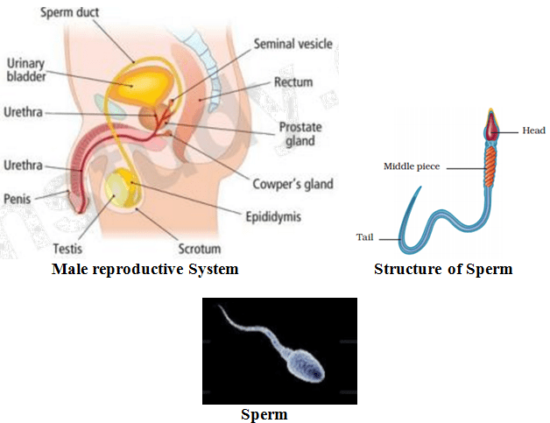
Female Reproductive Organs:
A pair of ovaries, oviducts (Fallopian tubes) and the uterus, these are the female reproductive organs. Ovary produces female gametes called ova (eggs). In human beings, a single matured egg is released by one of the ovaries, into the oviduct every month. Uterus is the part where development of the baby takes place. An egg is also a single cell.
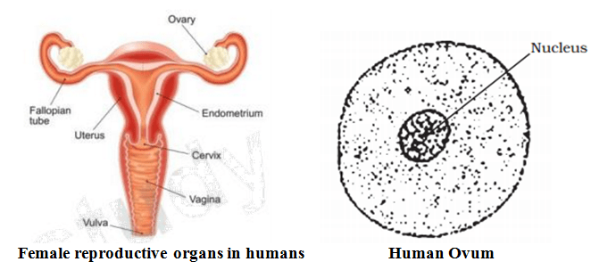

Fertilization:
The process of fertilization is fusion of a male gamete (Sperm) with a female gamete (Ovum) . Zygote is formed after fertilization.
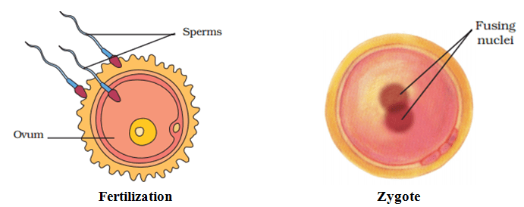
Types of Fertilization:There are two types of fertilization in animals, external fertilization and internal fertilization.
1. Internal Fertilisation: When fertilization takes place inside the animal’s body, it is called internal fertilization. Internal fertilization occurs in many animals including humans, cows, dogs and hens.
2. External Fertilisation: In this type of fertilization, the fusion of a male and a female gamete takes place outside the body . It is very common in aquatic animals such as fish, starfish, etc.
Example: During spring or rainy season, frogs and toads move to ponds and river. When the male and female comes together in water, the female lays the eggs, the male deposits sperms over them. Each sperm swims randomly in water with the help of its long tail. The sperms then come in contact with the eggs.
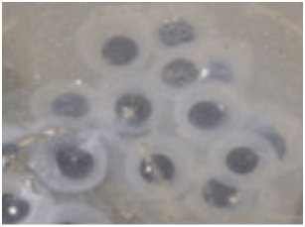Eggs of frog

Development of Embryo:Development of embryo takes place in the female reproductive system through following steps:
1. Every month, a single egg comes out of the ovary and reaches the fallopian tube of female reproductive system.
2. During copulation, sperms reach the Fallopian tube where a sperm fertilizes the egg. This results in formation of zygote.
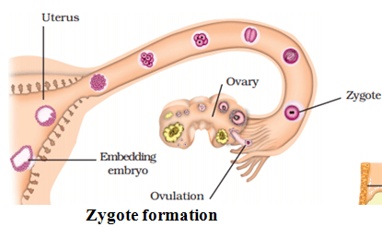
3.The zygote divides repeatedly to give rise to a ball of cells. The cells then begin to form groups that develop into different tissues and organs of the body. This developing structure is termed an embryo.
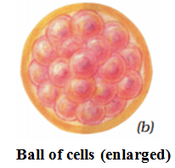
4. The embryo gets implanted in the wall of the uterus for further gradually developed body parts such as hands, legs, head, eyes, ears, etc.
5. The stage of the embryo in which all the body parts can be identified is called a foetus. When the development of the foetus is complete, the mother gives birth to the baby.
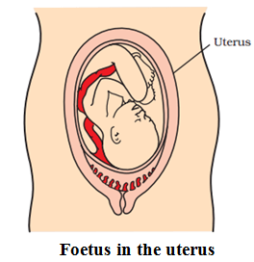
Formation of Egg Shell in Hens:
Internal fertilization takes place in hens. After fertilization, the zygote divides continuously and moves to the oviduct. As it travels down, many protective layers are formed around it. The hard shell in a hen’s egg is one such protective layer. After the hard shell is formed, the hen finally lays the egg. The embryo takes about 3 weeks to develop into a chick. The hen sits on the eggs to provide sufficient warmth. After the chick is completely developed it bursts open the egg shell.

Viviparous and Oviparous Animals:
1. The animals which give birth to young ones are called viviparous animals. Examples- Human being, dog, cows.
2. Those animals which lay eggs are called oviparous animals. Examples – hen, frog etc.

IVF (In Vitro Fertilisation):
1. A biological process carried out in laboratory is called in-vitro. Thus, fertilization carried out in laboratory is called in-vitro fertilization.
2. Some women are unable to bear babies because oviducts get blocked as a result sperms cannot reach the egg for fertilization. Doctors collect freshly released egg and sperms and keep them together for a few hours for IVF or in vitro fertilization (fertilization outside the body).
3. If fertilization occurs, the zygote is allowed to develop for about a week and then it is transferred in the mother’s uterus. Whole development takes place in the uterus and the baby is born like any other baby. Babies born through this technique are called test-tube babies.

Young Ones to Adults:
1. Direct Development: When the young ones of an animal resemble the adult, then direct development takes place, e.g. hen, man, monkey, etc.
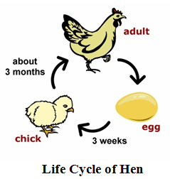
2. Indirect Development: When the young ones of an animal do not resemble the adult, then indirect development takes place, e.g. frog, butterfly, silk moth, etc.
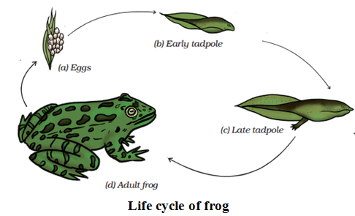3. Metamorphosis: In case of indirect development, transformation of young ones into adult through drastic changes is called metamorphosis. Larva of butterfly undergoes metamorphosis to become a butterfly. A tadpole undergoes metamorphosis to become a frog.
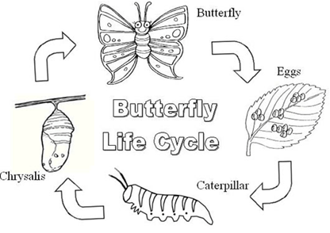
Asexual Reproduction Methods: The process of reproduction in which new individuals are produced from single parent. Example - Microorganisms.
1. Budding: This reproduction method is seen in those multi cellular animals which are highly simple in structure. A small bud or bulge develops on the body. After developing the bud, it gets detached from the parent’s body to begin life as a new individual. Since new individuals develop from the buds, this type of asexual reproduction is called budding Examples: Hydra and sponges.
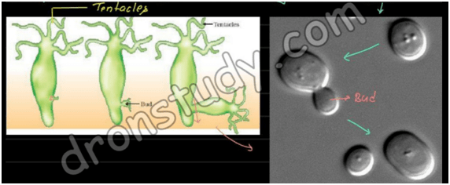
2. Binary Fission:This method of reproduction is seen in unicellular animals, example- amoeba. In this method, an organism divides and forms two daughter cells. First the nucleus divides and forms two daughter nuclei. Then the cytoplasm in the mother cell divides into two daughter cells. This leads to the formation of the two daughter cells each having a nucleus and its own cell organelles which then develop into a fully formed adult. Example- paramaecium, leishmania etc.
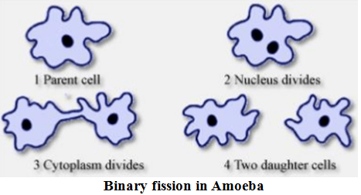
Cloning:
1. Cloning is process of production of an exact copy of a cell, any other living part, or a complete organism. Cloning process of an animal was successfully performed for the first time by Ian Wilmut and his colleagues at the Roslin Institute in Edinburgh, Scotland. They cloned successfully a sheep named Dolly.
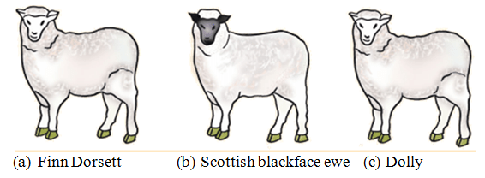2. During the process of cloning sheep named Dolly, a cell was collected from the mammary gland of a female Finn Dorsett sheep. Simultaneously, an egg was collected from a Scottish blackface ewe. The nucleus was removed from the egg. After that, the nucleus of the mammary gland cell from the Finn Dorsett sheep was inserted into the egg of the Scottish blackface ewe whose nucleus had been removed. Then this egg was implanted into the Scottish blackface ewe. Development of this egg followed normally and then finally Dolly was born. It was found to be absolutely identical to the Finn Dorsett sheep from which the nucleus was taken.

CH- 6 REACHING THE AGE OF ADOLESCENCE
Adolescence: Adolescence is that period of life when many changes start taking place in the body; which results in reproductive maturity. It usually begins at around the age of 10 years and is seen till 18 or 19 years of age.
Adolescents are also called as teenagers as teen age period is also covered up in adolescence.
Teenage: The number of years during adolescence span is counted as ‘teen’, .e.g. thirteen, fourteen and fifteen. Hence, this duration is also termed as teenage.
Puberty: The process of transformations taking place during adolescence period is known as puberty. The onset of puberty points out the starting of adolescence. And the end of adolescence or puberty informs about the completion of reproductive maturity.
The Various Changes taking place during puberty
1. Increase in Height:
(i) It is the most visible change noticed during the puberty.
(ii) In the beginning, it is observed that the girls grow faster than boys, but, on reaching 18 years of age, both gain their maximum height. Also, the rate of growth in height differs individually.
(iii) During these years, it is really significant to eat nutritious food for better development of bones, muscles and other parts of the body.
2. Change in Body Shape:
(i) During puberty, boys will start having broad shoulders and wider chests while in case of girls the region below the waist becomes broader.
(ii) Moreover, the muscles of boys will grow more prominently than in the girls.
3. Change in Voice
(i) During puberty, it is being noticed that voice of boys starts cracking and their voice box or larynx starts to grow.
(ii) Adam’s apple: The increase in the size of voice box in boys is seen as a prominent protrusion in the neck. This protrusion is called Adam’s apple.
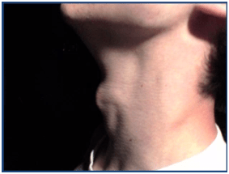
Adam’s apple
4. Increased Activity of Sweat and Sebaceous Glands:
The Sweat glands present starts operating and produces more sweat. And the Sebaceous glands or oil glands increases function results in pimples or acne.

5. Development of Sex Organs:
(i) Growth of sex organs takes place and are found to be more active. In males, the testes start to produce male gametes, called sperms. And in females, the ovaries start developing and releases one mature ovum once in 28 days.
(ii) In males, the size of the penis increases with respect to ages. On the other hand, development of breasts is observed in females.
6. Reaching Mental, Intellectual and Emotional Maturity:
(i) Brain becomes more active and so more learning takes place.
(ii) Mental and intellectual maturity is seen.

Secondary Sexual Characters: These are the characters that distinguish a male from a female.
1. In males, growth of hair is seen on face and body. And hair growth is seen in the under the arms and in the region above the thighs or pubic region in females.
2. Shoulders get broad and chest gets widened in males. The waist gets wide and hips get narrow in females.
3. The development of breasts takes place in females.
4. Mood swings are seen in males as well as females. Mental and emotional maturity is attained by both sexes. Brain gets more active and has capability of learning more.
Hormones:
Hormones are the chemical substances secreted by endocrine glands for proper functioning taking place during adolescence in the human body
In males, at the beginning of puberty, the hormone or testosterone begins to get released by the testes. And this results in some changes in boys like the growth of facial hair, deep voice and hair on chest.
In females, ovaries start to produce the female hormone or estrogen which results in breasts development on reaching puberty. Also, milk secreting glands or mammary glands development takes place inside the breasts.
The production of these hormones is under the control of another hormone secreted from an endocrine gland called pituitary gland. The testes and ovaries secrete sex hormones. These sex hormones are controlled by the hormones secreted from the pituitary gland. The pituitary secretes many hormones, one of which makes ova mature in the ovaries and sperms form in the testes.
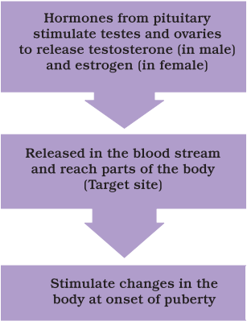
The onset of puberty is controlled by hormones

Humans Reproductive Phase:
The reproductive stage starts with the beginning of puberty and it is observed in boys and girls at near about same age. But, reproductive phase in males remain much longer in comparison with females. In women, the reproductive phase starts at puberty (10 to 12 years of age) and lasts till 50 years of age. While in males, the reproductive phase lasts even above 60 years of age.
Menstruation:
In females, each month one egg is set free by either of the ovaries. The uterus forms a thickening to support a foetus to keep it ready in case of pregnancy. If fertilization of egg does not take place, then egg and thickening in uterus are removed in small parts. As a result, bleeding in the vagina takes place for some days. This bleeding through vagina at the end of menstrual cycle, is known as menstruation.
The sequence of events starting from the release of an egg and till egg gets removed it is called menstrual cycle. A menstrual cycle normally comprises of 28 to 30 days.
Menarche: It is the first menstrual bleeding in a girl’s life. And it indicates the beginning of puberty in a girl.
Menopause: It is the ending of menstrual cycle. And it is observed at around 45 – 50 years of age. Menopause indicates the end of reproductive phase.
Hormones Other Than Sex Hormones: Sex hormones are not the only hormones responsible for changes during adolescence. There are few other hormones that act in the background.
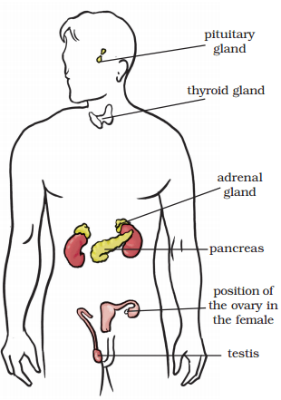
Position of Endocrine Glands in the Human body

1. Thyroxine: It is released by the thyroid glands and is present in the front part of the neck. In case of improper secretion of thyroxine, it leads to swelling of the throat, a disease called goitre.
Goitre Disease

2. Insulin: It is hormone, which is responsible for controlling the sugar level in our body. And this hormone is secreted by the pancreas. If insulin is not secreted properly, then blood sugar level might increase and can result into a condition called diabetes.
3. Adrenaline: It is released from a pair of adrenal glands at the top of kidneys. Adrenaline is called as "fight-flight hormone". It is the hormone of emergency. It also helps in balancing the salt level in the blood.

Sex Determination
Will it be a Boy or Girl?
Gender of a child is dependent on the combination of chromosomes taking place in the zygote. In human beings, normally a cell has 46 chromosomes, i.e. 23 pairs of chromosomes. Out of these 46 chromosomes, 22 pairs are identical. But chromosomes in the 23rd pair may be same or different.
There are two kinds of chromosomes in 23rd pair. They are known as X and Y chromosomes. The last pair (i.e. 23rd) in a male has XY combination, while in case of female it has XX combination.
1. Birth of girl will take place when a sperm with X chromosome fertilizes the egg.
2. Birth of boy will take place when a sperm with Y chromosome fertilizes the egg.
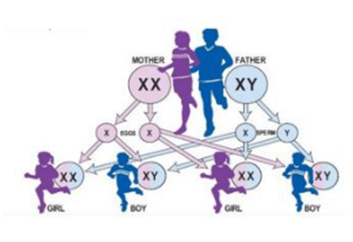Sex Determination

Role of Hormones in Completing the Life History of Insects and Frogs:
The life span of insects can be categorized into four stages: Egg, Larva, Pupa and Adult.
Metamorphosis: It is the change of insect from larva to an adult.
Hormones in insects control the metamorphosis under the action of thyroxine hormone produced by thyroid.

Reproductive Health:
1. Balanced Diet: During adolescence there is need of proper balanced diet. Proper amount of carbohydrates, proteins, fats, vitamins and minerals must be included in food.
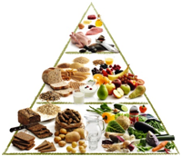
Balanced Diet
2. Personal Hygiene: Many physical and psychological changes are observed during adolescence. If good hygiene is not undertaken, it may result into skin diseases. And Girls need special attention during menstrual period.
3. Physical Exercise: Physical exercise not only helps in making a strong body but also helps in proper energy utilization.
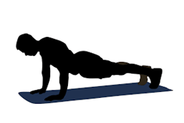
Physical Exercise

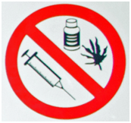
5. HIV (Human Immunodeficiency Virus): AIDS (Acquired Immunodeficiency Disease) is caused due to this virus. It on incurable disease as yet no medicine can cure it. It might spread due to sexual contact, because of infected needles and from an infected mother to her unborn child. . Hence, prevention is the only way to keep away from this dangerous disease.

