GREENWOOD PUBLIC SCHOOL, ADITYAPURAM
OUR MOTTO-DEVELOPMENT WITH DELIGHT

CLASS-VIII SUBJECT- SOCIAL SCIENCE
TERM-2 SYLLABUS
GEOGRAPHY
CHAPTER-6
AGRICULTURE AND CROPS
DIFFICULT WORDS:
- Tertiary
- Horticulture
- Commercial
- Nomadic
- Coarse
- Nutrients
- Mechanization
- Intensive
- Pesticides
- adequate
KEY TERMS:
- Agriculture-The science and art of cultivation on the soil, raising crops and rearing livestock. It is also called farming.
- Sericulture-Commercial rearing of silk worms. It may supplement the income of the farmer.
- Pisciculture- Breeding of fish in specially constructed tanks and ponds.
- Viticulture-Cultivation of grapes.
- Horticulture-Growing vegetables, flowers and fruits for commercial use.
Very Short Answer Questions
Q.1 In which season Wheat is grown in India?
Ans. Wheat is grown in winter season in India.
Q.2 Which crop is also known as the Golden Fibre.?
Ans.Jute is known as golden fibre.
Q.3 What is meant by Sericulture?
Ans. Sericulture means commercial rearing of silk worms.
Short Answer Questions
Q.1 Define agriculture. What factors influence agriculture?
Ans. Agriculture is a primary activity that includes growing crops, vegetables, fruits, flowers and rearing livestock. It is connected with the extraction and production of natural resources.The factors that influence agriculture include soil, climate, topography, population etc.
Q.2 Differentiate between intensive and extensive agriculture.
Ans. Difference between extensive and intensive farming :
Extensive Farming | Intensive farming
1. A type of farming in which the crops grown are consumed by the farmer and his family  2. The main motive of the farmer is to satisfy the needs of his family.  3. It is practiced in different parts of the world, like Russia | 1.A type of agriculture where crops are grown on small land holdings  2. The main motive of the farmer is to use minimum land for maximum use by crop rotation.  3. It is practiced in thickly populated areas of the monsoon regions of south and south east Asia.

Q.3 What do uou understand by mixed type of farming?
Ans. Mixed farming is a type of farming which involves both the growing of crops and the raising of livestock. ... The cultivation of crops alongside the rearing of animals for meat or milk defines mixed farming. For example, a mixed farm may grow cereal crops such as wheat or rye and also keep cattle, sheep, pigs or poultry.
Long Answer Questions
Q.1 What is shifting agriculture? Why has it been banned?
Ans. Shifting cultivation is also known as Slash-and-burn cultivation. It is a type of farming activity which involves clearing of a land plot by cutting down trees and burning them. The ashes are then mixed with the soil and crops are grown. After the land has lost its fertility, it is abandoned. The farmers then move to a new place.
They felt that land which was used for cultivation every few years could not grow trees for railway timber. When a forest was burnt, there was the added danger of the flames spreading and burning valuable timber. Shifting cultivation also made it harder for the government to calculate taxes. Therefore, the government decided to ban shifting cultivation.
Q.2 How is dairy farming different from pastoral farming?
Ans. Dairy farming is farming of milch cows in confined spaces for production of milk. It is highly mechanized with animals confined in tight cells. It is also called factory farming for milk production.The calves are separated from their mothers and grown for other purposes or disposed off. Grains like maize, soyabean or ready made feeds are fed to cows. In some places they also give them green fodder
Pastoral farming aims at producing livestock rather than growing crops. It includes dairy farming , raising beef cattle and raising sheep for wool.

Map work
Q.1 On an outline map of India Political shade and label the regions where the following crops are grown.
Ans. Rice , Wheat, Maize
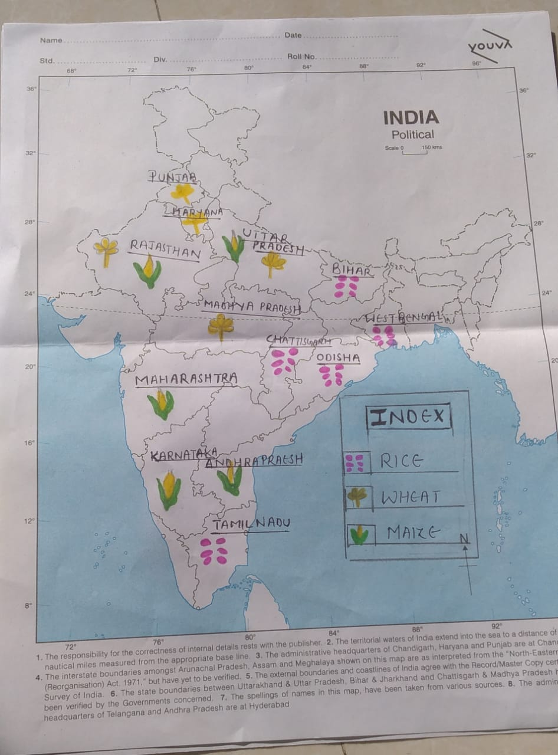

Q.2 On an outline map of India Political shade and label the regions where the following fiber crops are grown.
Ans. Jute , Cotton

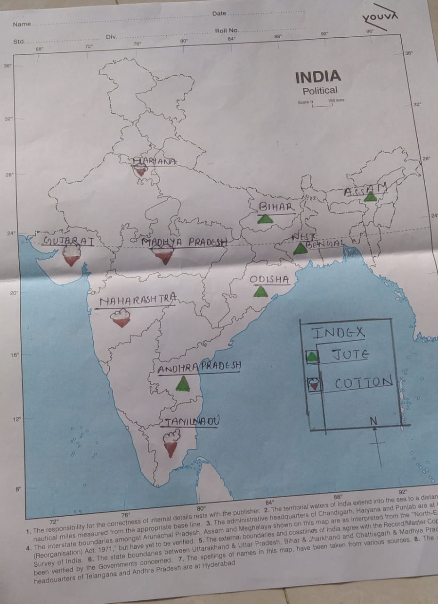
Q.3 On an outline map of India Political shade and label the regions where the following commercial crops are grown.
Ans. Sugarcane , Rubber
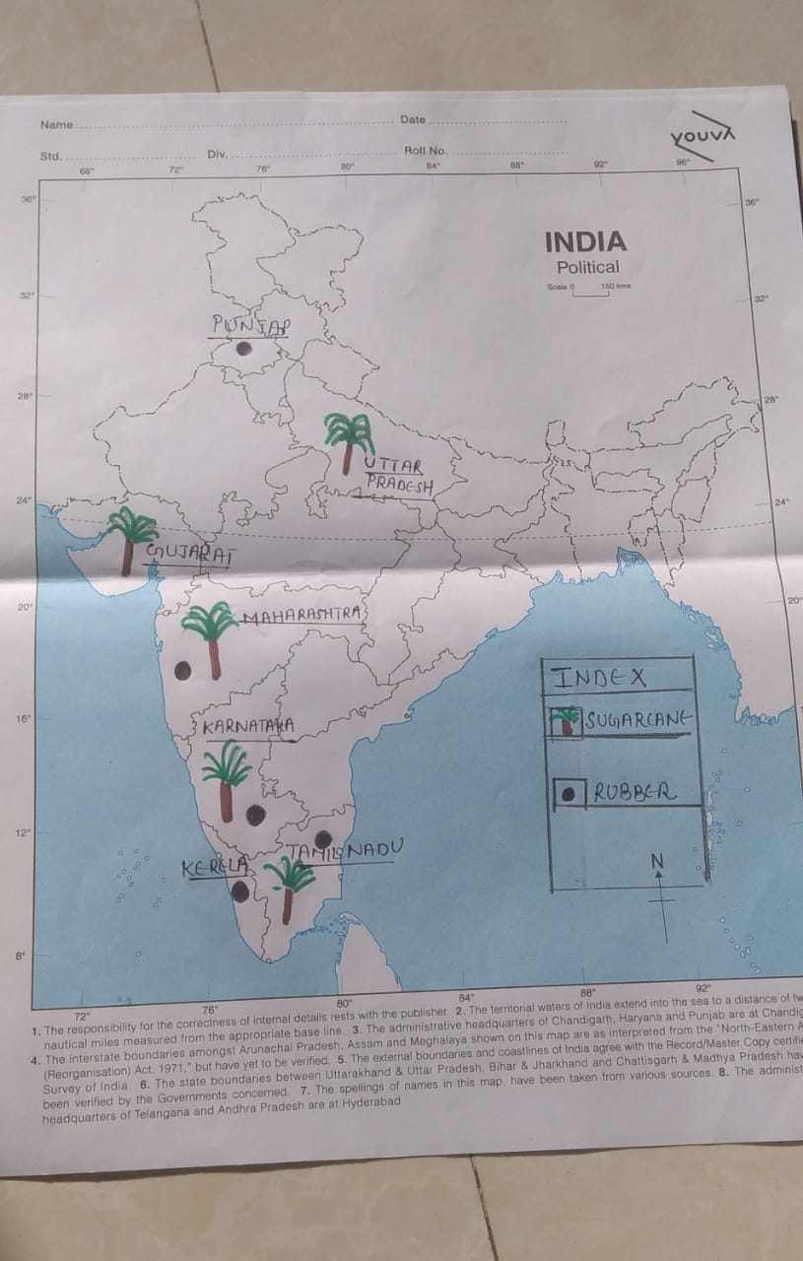

ACTIVITY
Q.1 Table showing the climatic requirements of different crops in India.
Ans.
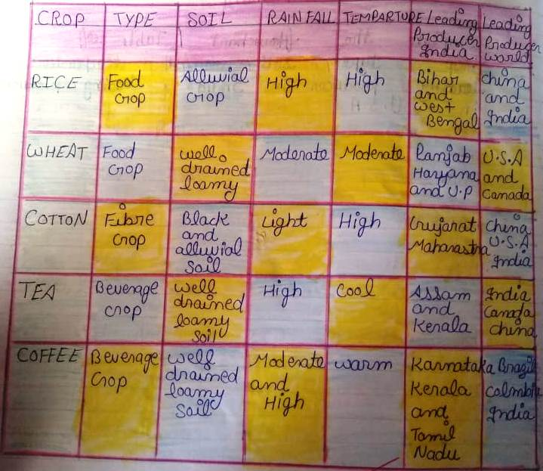

CHAPTER-7
INDUSTRIES
DIFFICULT WORDS:
- Extraction
- Authority
- Subsidized
- Industrialization
- Infrastructure
- Transport
- Concentrated
- Aeronautics
KEY TERMS:
- Secondary activities-Activities that change raw materials into products of more value to people
- Smelting- It is the process in which metals are extracted from their ores by heating beyond the melting point
- Marine based industries- They use products from the sea and oceans as raw materials. Industries processing sea food or manufacturing fish oil are some examples.
- Forest based Industries- They utilize forest produce as raw materials. The industries associated with forests are pulp and paper, pharmaceuticals, furniture and buildings.
- Agro based industries- They use plant and animal based products as their raw materials. Food processing, vegetable oil, cotton textile, dairy products and leather industries are examples of agro-based industries.
Very Short Answer Questions
Q.1 Which river provides sufficient water to Osaka’s textile industry?
Ans. Yodo River
Q.2 From where did the Silicon Valley get its name?
Ans. It got its name from the silicon that was used to make chips for computers.
Q.3 Which city is known as Manchester of India?
Ans. Ahmedabad
Short Answer Questions
Q.1 What was the impact of the Industrial revolution Which started in Great Britain in the 18th century?
Ans. The Industrial Revolution also led to an unprecedented rise in the rate of population growth. Textiles were the dominant industry of the Industrial Revolution in terms of employment, value of output and capital invested. The textile industry was also the first to use modern production methods.
Q.2 Name the four major industrial regions of the world.
Ans. Major industrial regions of the world are eastern North America, western and central Europe, Eastern Europe and eastern Asia.
Q.3 Name any four major industrial regions of India.
Ans. These are four major industrial regions in India.
- Mumbai-Pune Industrial Region
- The Hugli Industrial Region
- Bengaluru-Tamil Nadu Industrial Region
- Gujarat Industrial Region

Long Answer Questions
Q.1 Differentiate between the following and give one example for each type of industries.
i. Marine-based and Forest-based industries.
Marine-Based | Forest-Based
1.Industries which depend on seas and oceans for raw materials.  Eg. Sea Food | 1.Industries which depend on forests for their raw materials  Eg. Paper , Furniture etc

Ii. Private sector and public sector.
Ans. Public sector:
1. It is controlled and managed by the government.
2. The main aim of the sector is public welfare.
3. The sector provides basic facilities like education, health, food and security to the people. For Example: Railways, Post office, BSNL.
Private sector:
1. It is controlled and managed by an individual or a group.
2. The main aim of the sector is to earn profits.
3.Private sector does not provide any service at a reasonable rate. For example: Tatas, Birla’s, Reliance.

Q.2 What factors led to the development of TATA Steel Company in Jamshedpur?
Ans. Geographically, Jamshedpur is the most conveniently situated iron and steel centre in the country. The first iron and steel plant of India, namely, TISCO (Tata Iron and Steel Company Limited) was started here in 1907.
2) This place was chosen due to many reasons – It was only 32 km away from Kalimati railway station and was close to the iron ore, coal and manganese deposits and as well as to Kolkata which provided a large market
3) Moreover, Kharkai and Subarnarekha rivers ensured sufficient water supply and the Government initiatives provided adequate capital for its later development.

CHAPTER-8
HUMAN RESOURCES AND DISASTER MANAGEMENT
DIFFICULT WORDS:
- Human resource
- Density
- Climate
- Minerals
- Life expectancy
- Emigrants
- Cyclone
- Earthquake
- Management
- Pyramid

KEY TERMS:
- Drought: is a natural phenomenon, which happens when an area receives lesser rainfall.
- Floods: They are caused when water rises above and beyond its normal place or course.
- Mitigation : Actions that reduce the damage caused by disasters to people
- and property such as cyclone resistant houses in cyclone prone areas.
- Migration: It is the movement of people in and out of an area
- Natural growth rate: The difference between the birth rate and the death rate of a country.
Very Answer Questions
Q.1 In which country is the city of Osaka located?
Ans. Japan.

Q.2 Compare the population density of the world with that of India.
Ans. The population density of the world is around 45 persons per sq km, whereas that of India is over 320 persons per sq km.
Q.3 What is life expectancy
Ans.Life expectancy is the number of years an average person can expect to live, based on data
Q.4What is an age-sex pyramid?
Ans. An age-sex pyramid is a graph showing the number of males and females under certain defined age groups.
Q.5 Define flood.
Ans. A flood is an overflow of water that submerges land that is usually dry
Short Answer Questions
Q.1 Why are people considered a valuable resource?
Ans People are the greatest resource of the nation. All other resources of nature become significant only when people extract its usefulness. It is people with their demands and abilities that turn them into resources. Hence, human resource is the ultimate resource.
Q.2 Define the terms-sex ratio, birth rate and death rate.
Ans.
- Birth rate-the number of live births per 1,000 people.
- Sex ratio-Sex ratio is defined as the number of females per 1000 males.
- Death rate-the number of deaths per 1,000 people.
Q.3 What is a population pyramid?
Ans. The graphical representation used to study the composition of a country’s population is called the population pyramid. It shows the total population divided into various age groups, percentage of the total population subdivided into males and females and the number of dependents in a country.
Q.4 What is a Disaster?
Ans. A disaster is a serious disruption occurring over a short or long period of time that causes widespread human, material, economic or environmental loss which exceeds the ability of the affected community or society to cope using its own resources
Ans. Q.5 What is the difference between Natural disasters and human-made disasters?
Ans. Natural disasters are those disasters that are caused due to some natural happenings such as earthquakes, floods, etc.
Human-made disasters are those disasters that are caused by the human activities such as Bhopal gas tragedy, magmata disease in Japan,etc.
Long Answer Questions
Q.1 What are the causes for uneven distribution of population on the earth?
Ans. Population distribution in the world is uneven because of the two factors Geographical and Social factors.
Geographical factors include.
- Topography: People prefer living on plains rather than mountains and plateaus because these areas are suitable for farming, manufacturing and service activities. The Ganga plains are the most densely populated areas of the world, while mountains like Andes, Alps and Himalayas are sparsely populated.
- Water: People prefer living in areas where fresh water is easily available. The river valleys of the world are the densely populated regions, while deserts have spare population.
Social Factors include:
- Social: Areas of better housing, education and health facilities are more densely populated. (For example: Pune)
- Economic: Industrial areas provide employment opportunities. Large number of people are attracted to these areas. Osaka in Japan and Mumbai in India are two densely populated areas.
Q.2 Explain the disaster cycle with the help of a diagram.
Ans. Disaster (Emergency) management is a comprehensive approach dealing with all four phases of disasters:
- response
- recovery
- mitigation/prevention
- preparedness
Response-Response is defined as the actions taken to decrease mortality and morbidity, and to prevent further property damage when the hazard occurs. Response is putting preparedness plans into action.
Recovery-Recovery is defined as the actions taken to return to normal following an event.
- Repairing buildings
Mitigation-Prevention/Mitigation is defined as “sustained actions that decrease the risk of a hazard (probability of occurrence) or to reduce the potential negative consequences suffered by people and/or property.”
Preparedness-Preparedness takes the form of plans or procedures designed to minimize physical and property damage when an event occurs.These activities ensure that when a disaster strikes, disaster (emergency) managers will be able to provide the best response possible.

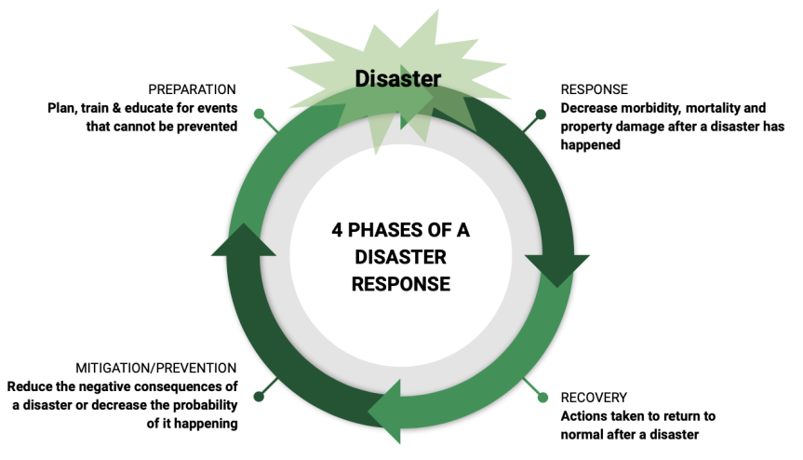

Q.3 How can be disaster management be done in case of Cyclones?
Ans.
