GREENWOOD PUBLIC SCHOOL, ADITYAPURAM
OUR MOTTO - DEVELOPMENT WITH DELIGHT
SYLLABUS FOR THE MONTH OF JULY (2018-19)
CLASS-NURSERY
SUBJECTS |  | ACTIVITY+USE OF ICT | PARENTS INVOLVEMENT
English | Oral : Rhymes –Johny –Johny, Early to bed…….. Alphabets –A-D.  Written :Standing lines, sleeping lines , slanting lines , Zig-Zag lines , Curves , Circles , Letters A,B  Workbook: Page No. 2-8  Sentence structure : Sit , Stand , Join Hands  Vocabulary Building: School , Teacher , Classroom, Charts , Almirah. | 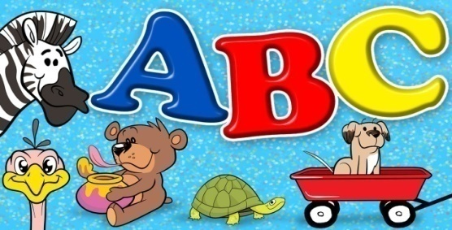 | Help your child in learning rhymes and written work
Hindi | Oral : dfork,¡ & vke ] eksVwjke ] कोयल , अक्षर अ- ई  Written : रेखा अभ्यास ] xksykdj ,oa v/nxksykdkj lajpuk,sa अक्षर अ- आ  Workbook: Page no 3-13  Sentence structure: यह मेरी कक्षा है! | 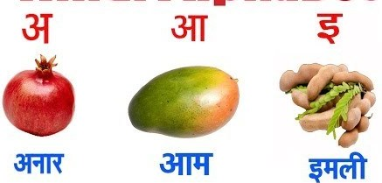 | dfork,sa ;kn djok,Wa rFkk o.kksaZ dh igpku fp=ksa +}kjk djok,W!
Maths | Oral : Counting 1-5  Concepts :Tall & Short  Written: Curves ,lines , circles , Digits – 1,2 | 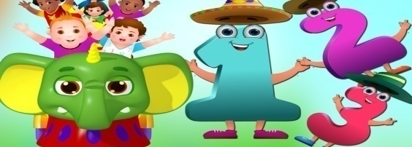 | Motivate your child in counting objects and learning tables.
Drawing | Rectangle / Circle / Square
G.K. | Oral : Tasty fruits :Apple , Mango , Orange , Grapes , Banana  Beautiful Flowers: Rose , Lotus , Tulip , Marigold , Sunflower | PPT on Flowers & Fruits | Help your child to recog. the colours
Music / Dance | Music: Alankar –sa , re , ga , ma …………………  Western Dance  Song: Boogie Woogie | PPT on ABC Song
V.E. | 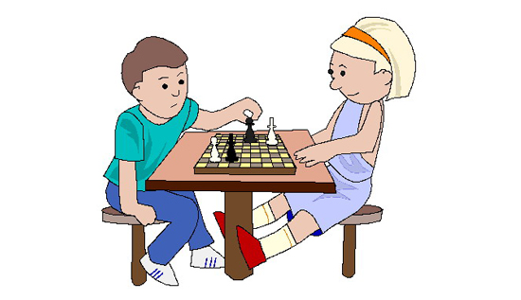  I love my school | PPT on School | Talk to your child about the school
Physical Education | Indoor games |  | Take your child to a park and play some games.
Language Development | This is my classroom |  | Help your child talk in English
Conversation | English Conversation  1. How are you?  Ans-I am fine thank you  2. What is your name?  Ans-My name is ………..  3. How old are you?  Ans-I am 3 years old.  4. In which class do you study?  Ans-I am in nursery class. | Hindi Conversation  प्रश्न 1- आप कैसे है ?  उत्तर - मैं अच्छा / अच्छी हूँ !  प्रश्न 2- आपकk uke D;k gS ?  उत्तर - मेरा नाम …………. हैं !  प्रश्न 3- आप कितने वर्ष के हैं ?  उत्तर - मैं तीन वर्ष का / की हूँ !  प्रश्न 4- आप किस कक्षा मेँ पढ़ते हैं ?  उत्तर - मैं नर्सरी मेँ पढ़ता / पढ़ती हूँ ! | Help your child in learning Conversation Que/Ans
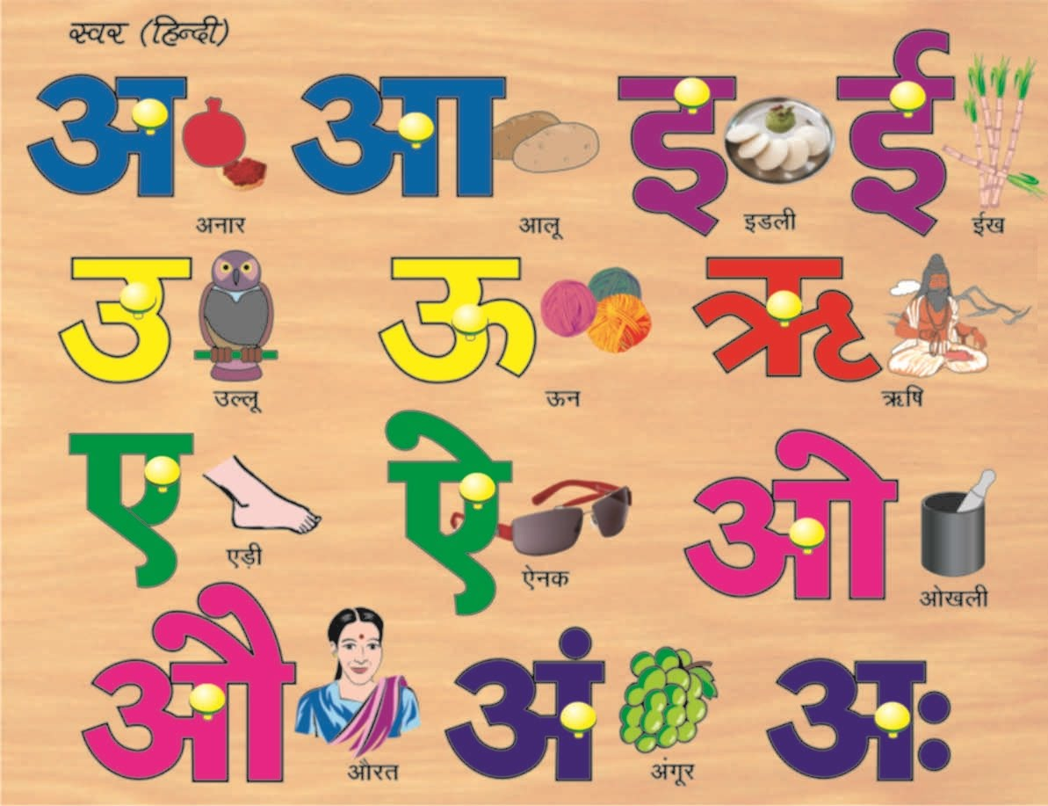
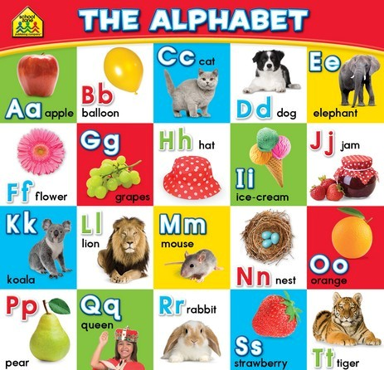

GREENWOOD PUBLIC SCHOOL, ADITYAPURAM
OUR MOTTO - DEVELOPMENT WITH DELIGHT
SYLLABUS FOR THE MONTH OF JULY (2018-19)
CLASS-L.K.G.
SUBJECTS |  | ACTIVITY+USE OF ICT | PARENTS INVOLVEMENT
English | Oral :Rhymes-When I was one , Baa , Baa Black sheep.  Reading : Pre-Primary page 12.Vowels and consonants and Revision of April month syllabus.  Written : Small Cursive letters (a - e) , Match the following , what comes after .Write the first letter of the picture, Dictation  Vocabulary Building: I my , we , he , she , you , am , boy , girl. | PPT on letters a-i (small cursive)  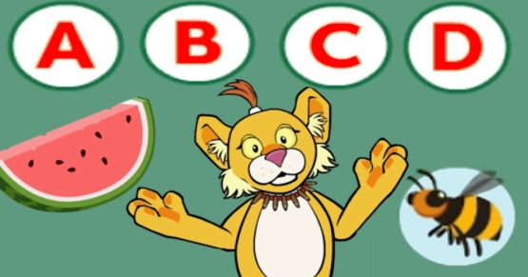 | Help your child in learning rhymes and written work
Hindi | Oral : dfork,¡ & भारत माता ] चार नौकर  Reading – व्यंजन वर्ण क से तक और स्वर अ से अ: तक का पुनः अभ्यास !  Written : व्यंजन वर्ण क से तक ] जोड़ी बनायें , चित्र पहचानकर अक्षर लिखें ,Jqrys[k और स्वर वर्णो का पुनः अभ्यास ! | 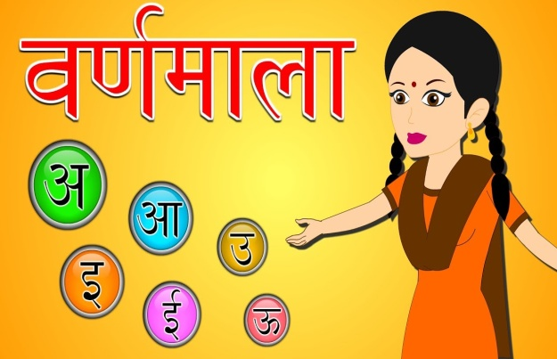 | dfork,sa ;kn djok,Wa rFkk o.kksaZ dh igpku fp=ksa +}kjk djok,W!
Maths | Oral : Number names 1-10 , Table of 2 & 3 , Counting 1-50  Written : Counting 1-50 , Dictation , Reverse counting from 20-1 , count and match count and write , what comes after. | Extra Marks  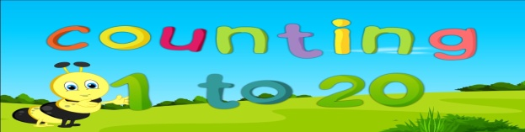  Videos on Number Names | Help your child in learning tables.
G.K. | Oral : Family tree , Parts of the body, Fruits | PPT on Parts of the body & Fruits | Make your child learn Myself.
Music | गायत्री मंत्र , अलंकार सा, रे ,ग, म, प ..............!  Song: Boogie Woogie
V.E. | We should respect our elders |  | Teach Good manners to your child
Drawing | Colour the yacht and cylinder page no 4,5
Physical Education | Frog race and jump to cone , Indoor games
Art & Craft | Umbrella and cloud
Language development | Action Words :– Writing , eating , singing , jumping , drinking , bathing , running , skipping , talking.
Conversation | English Conversation  Q.1 What is your name?  Ans-My name is…………….  Q.2 What is your father’s name?  Ans-My father’s name is…………….  Q.3 What is your Mother’s name?  Ans-My Mother’s name is…………….  Q.4 In which class do you study?  Ans-I study in L.K.G. class. | Hindi Conversation  1- vkidk D;k uke gS\  m0 esjk uke ---------------- gSA  2- vkids ikik dk D;k uke gS\  m0 esjs ikik dk uke ----------------------- gSA  3- vkidh eEeh dk D;k uke gS\  m0 esjh eEeh dk uke -------------------- gSA  4- vki fdl d{kk esa i<+rs gSa\  m0 eSa d{kk L.K.G. esa i<+rk gw¡@ i<+rh gw¡A | Help your child in learning conversation Que/Ans
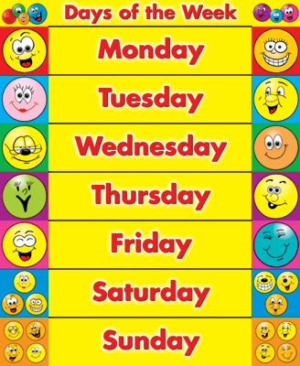
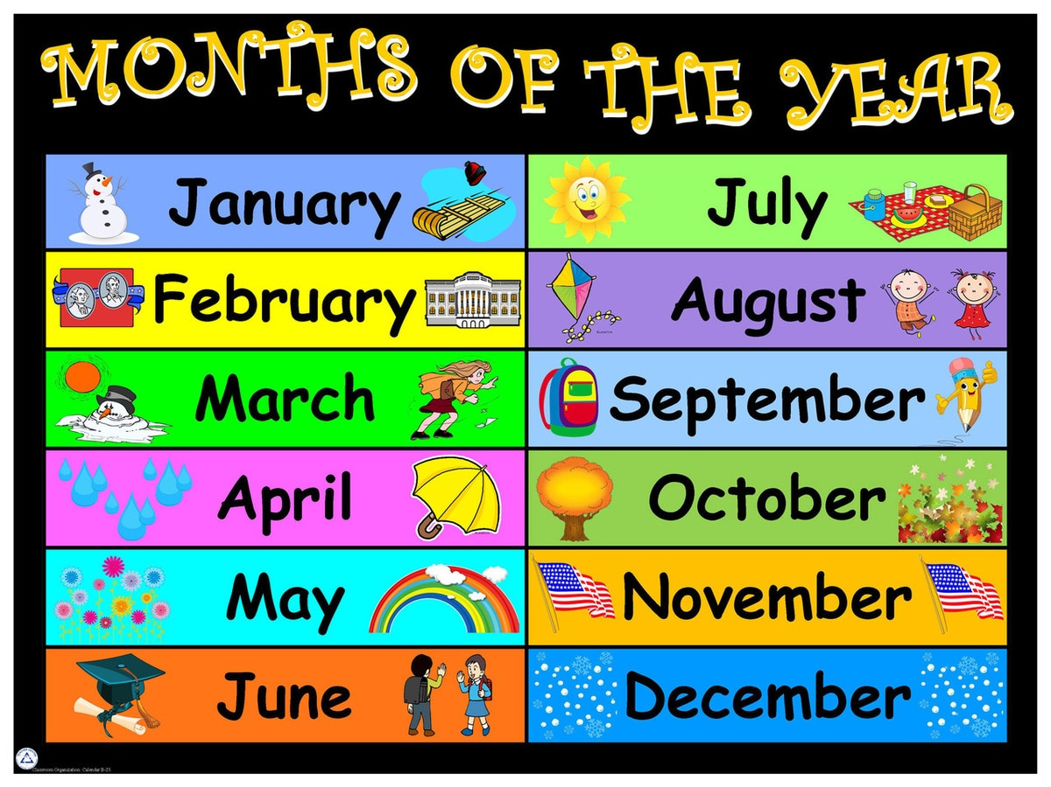

GREENWOOD PUBLIC SCHOOL, ADITYAPURAM
OUR MOTTO - DEVELOPMENT WITH DELIGHT
SYLLABUS FOR THE MONTH OF JULY 2018-19
CLASS-U.K.G.
SUBJECTS |  | ACTIVITY+USE OF ICT | PARENTS INVOLVEMENT
English | Oral:-Rhymes- one , two , three , four , five ………… ! Puppet clown…………!Little Boy sunny ……….  Reading –Phonic sounds of vowels, page no.- 7,8,9,10  Written : Opposites , Phonic sounds of vowels (a,e,i) words with (a,i) sound , vowel “a” with “e” Dictation words , fillips , complete the spellings of the text book page no 9,10,11.  Recognition:- Words with ‘ee’ sound.  Vocabulary Building:- School , class room , table , duster , chalk , Board , Teacher.  Revision of small and capital cursive letters. | 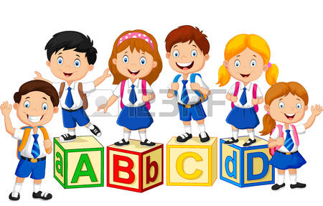 | Help your child in learning rhymes and written work
Hindi | Oral : dfork,sa & पहिया ] गुब्बारे ] परियों की सहजादी  Reading – Page No- 4 ,5,6,7,8,9,10  Written : स्वर एवं व्यंजन दो ,तीन ,चार बिना मात्रा वाले शब्द पाठ-३ मात्राएँ एवं उनका प्रयोग, पाठ -४ ‘आ’ की मात्रा , Jqrys[k ] खाली स्थान !  Recognition:- o.kZekyk  Workbook : page no 9……..16. | Extra marks  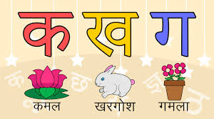  dfork,sa! | dfork,sa ;kn djok,Wa rFkk o.kksaZ dh igpku fp=ksa +}kjk djok,W!
Maths | Oral : Number names (1-20), Table of 2,3 Counting 1-100  Written : Chapter -1 Number names (1-20), Table of 2,3 , Backward counting (30-1)  Workbook :Page no 5………18. | 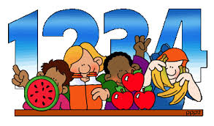 | Motivate your child in counting objects and learning tables.
EVS | Oral: Lesson-1- My family  Celebrations- Birthday Party , Wedding Party , Diwali . Holi , Eid…… !  Written : L-1 My family complete page no 4,5,6 in text book. | PPT on given topics. | Help your child to recog. the colours, fruits & flowers.
G.K. | Colours name , Fruits name & Flowers name. | 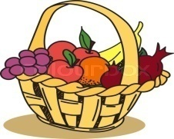 | Help your child read the calendar.
Art / Craft | Umbrella , clouds
Music / Dance | Music:- सरस्वती वंदना , अलंकार - सा रे ग म……………  Classical Dance  Song: Boogie Woogie
V.E. | Keep your environment clean |  | Motivate your child to help others
Drawing | Starfish , Bird , Igloo
Sports | Indoor games / outdoor games
Language Development | Dialogue conversation – Rainy Season
Conversation | English Conversation ( Myself )  1. What is your name?  2. What is your father’s name?  3. What is your mother’s name?  4. How old are you?  5. Where do you live?  6. In which class do you study?  7. What is the name of your school?  8. What is your favourite food / fruit?  9. What is your favourite colour? | Hindi Conversation  - vkidk uke D;k gS \  - vkids ikik dk uke D;k gS \  - vkidh eEeh dk uke D;k gS \  - vki fdrus o’kZ ds gS \  - vki dgkW jgrs gS \  - vki fdl Dykl es iMrs gS \  - vki ds fo|ky; dk uke D;k gS \  - vkidh tUe frFkh D;k gS \ | Help your child in learning conversation Que/Ans
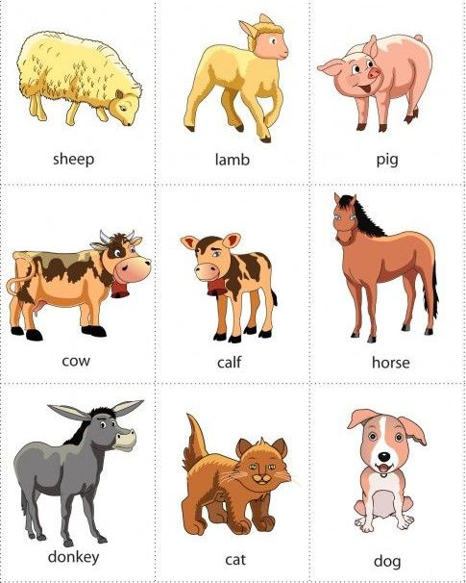
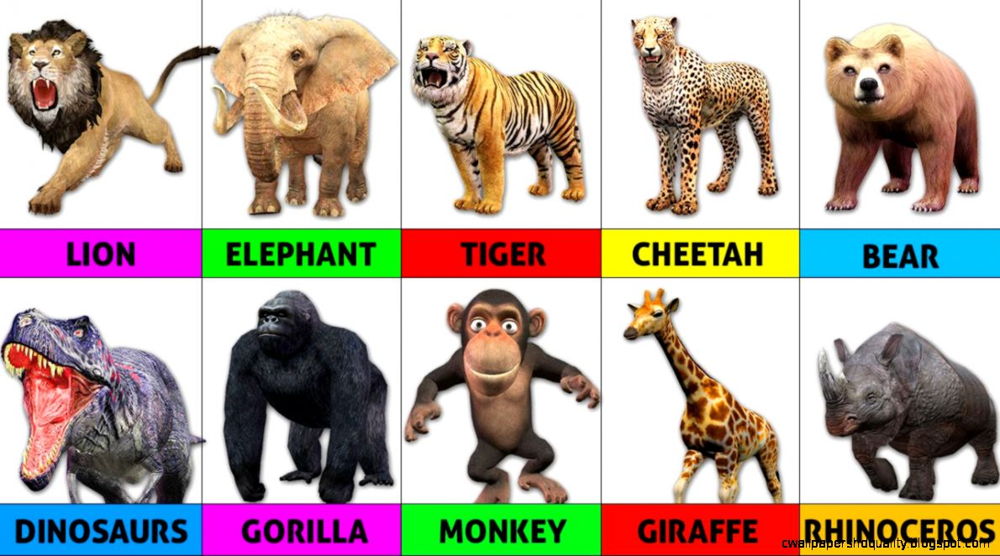
Wild Animals Pet Animals

