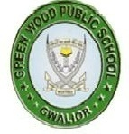
GREENWOOD PUBLIC SCHOOL, ADITYAPURAM
OUR MOTTO - DEVELOPMENT WITH DELIGHT
SYLLABUS FOR THE MONTH OF JANUARY (2018-19)
CLASS-NURSERY
SUBJECTS |  | ACTIVITY+USE OF ICT | PARENTS INVOLVEMENT
English | Oral : Rhymes - Engine –Engine, Chubby Cheeks , Jack & Jell  Written : Alphabets T-Z (Revision)  Recog –Alphabets A-Z | 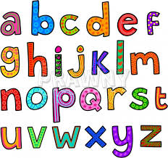 | Help your child in learning rhymes and written work
Hindi | Oral : dfork,¡ & तोता , रेल ] तितली ] रानी  Written : अक्षर & v &v% (Revision)  Recog : अक्षर – v ] v% rd | 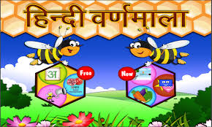 | dfork,sa ;kn djok,Wa rFkk o.kksaZ dh igpku fp=ksa +}kjk djok,W!
Maths | Oral : Counting 1-50 , Table of 2  Written : Digits 19 , 20 / (Revision) | 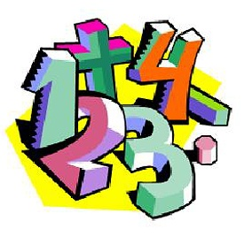 | Motivate your child in counting objects and learning tables.  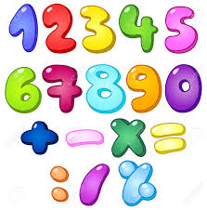
Drawing | Page no. 21-38
G.K. | Good Habits –  - Get Up Early  - Brush Your Teeth  - Take a bath daily  - Wear Clean Clothes  - Comb Your Hair |  | Help your child to recognise. the colours
Music / Dance | Patriotic Song & Dance
V.E. | Be polite |  | Motivate your child to help others
Sports | Races
Language Development | Have a nice Day |  | Help your child to develop good habits
Conversation | English Conversation  1.Which month is running now?  Ans-January  2.When do we celebrate Republic Day?  Ans-26th January  3.What is the name of our state?  Ans-Madhya Pradesh  4.How many seasons do we have?  Ans-There are four seasons | Hindi Conversation  प्रश्न 1-यह कौन सा महीना है ?  उत्तर - जनवरी  प्रश्न 2- हम गणतंत्र दिवस कब मानते है?  उत्तर - 26 जनवरी  प्रश्न 3- हमारे राज्य का नाम क्या है?  उत्तर - मध्य प्रदेश  प्रश्न 4- एक वर्ष में कितनी ऋतुएँ होती है?  उत्तर - चार | Help your child in learning Conversation Que/Ans  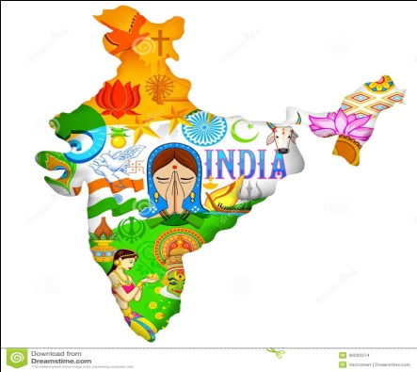

Activity Planner
Work Education  Health and Wellness  Performing Arts  Eco-club Activity | Best Out of Waste  Yoga  Patriotic Song  How to clean table after lunch | Literary and Creative | Alphabet Test

